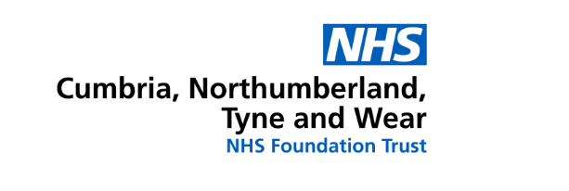

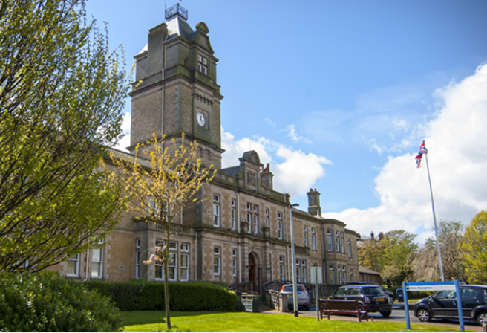

CNTW Estates Strategy
2023-2028

1 Executive summary

1.1 Introduction

This document sets out the Cumbria, Northumberland, Tyne and Wear NHS Foundation Trust (Trust) Estates Strategy for the period 2023 – 2028.

The aim of this Estate Strategy is to provide a user-friendly working document that clearly identifies the changes required to the Estate to enable the services provided by the Trust to be delivered in accordance with their strategic objectives. It sets out the long-term plan for developing and managing the Estate in an optimum way in order to meet the Trusts vision of being a “leader in the delivery of high-quality care and a champion for those we serve” and its underpinning values, strategic ambitions and quality goals. The strategy is aligned to both National and Local Strategies and those of the Integrated Care System (ICS).

This strategy will address three strategic questions; where are we now? where do we want to be? and how do we get there? In answering these questions, the strategy will also take into account the following:
- The Trust’s existing estate, including an analysis of its overall condition and suitability and a reflection of the developments that have been carried out over the last few years providing a context of where we have come from and an understanding of where we want to be.
- How the service development strategies of the clinical and support services teams along with relevant external factors influence the way in which the estate is provided and needs to be developed.
- The proposed changes to the Estate, providing an environment suitable for the delivery of the Trusts services over the next 5 years and beyond, supported by an investment programme which includes rebuilding, upgrading and delivery of the changes required.
- The significant challenges faced by the organisation in respect of access to capital funds and the restrictions imposed on CNTW as they operate to the capital departmental expenditure limit (CDEL) in place across the ICS.

1.2 Where are we now?

Overview

Cumbria, Northumberland, Tyne and Wear NHS Foundation Trust (CNTW) was formed on the 1st of October 2019 following the transfer of mental health and learning disability services from Cumbria Partnership NHS Foundation Trust to Northumberland, Tyne and Wear NHS Foundation Trust. Northumberland, Tyne and Wear NHS Trust (NTW) was established on 1st of April 2006 following the merger of three Trusts: Newcastle, North Tyneside and Northumberland Mental Health NHS Trust, South of Tyne and Wearside Mental Health NHS Trust and Northgate and Prudhoe NHS Trust. The Trust achieved authorisation as an NHS Foundation Trust on 1 December 2009.

Since its inception in 2006 the Trust has undergone significant changes both in the makeup of its Estate and the expansion of its geographical area to provide care in North Cumbria and a CAMHS service in Middlesbrough. The Trust now operates from over 75 sites across serving a population of approximately 1.7 million and providing services across an area totalling 4,800 square miles.

Clinical and Operational Service Delivery

The Trust provides a range of mental health, learning disability and specialist services across the north east and north Cumbria, with wards and day services; a number of community teams, including drug and alcohol, psychosis, autism and ADHD, homelessness and street triage with Northumbria Police.
The clinical services provided by the Trust are organised into 4 Clinical Business Units (CBU’s) covering each of the geographical locations, with each CBU incorporating access, community, in-patient and specialist services teams.
The majority of corporate services are based at St Nicholas Hospital, including finance, workforce, informatics, and the executive team. It is also a base for the Trusts subsidiary company - NTW Solutions.

Care Quality Commission (CQC) Rating

The CQC, the independent regulator of health and social care, have rated the Trust as “Outstanding” in their last inspection report published in August 2022. Inspections have identified some areas where environmental or estates related safety improvements are required and these have either been addressed or plans are in progress.

PLACE Inspections (2019 last assessment)

PLACE is an assessment programme run by NHS Digital on behalf of NHS England and NHS Improvement (NHSE/I) which is completed on an annual basis.
The PLACE assessments indicate that within patient areas the main focus for potential improvements were in areas of privacy & dignity, dementia and disability.

Past Estate Developments

Previous estate strategies have focused on a range of key priorities which are summarised as:
- Reprovision of facilities to replace poor quality accommodation
- Reduction in the backlog maintenance position
- Optimisation of the estate; right size, place, cost effective and meeting user needs
- Ensuring the patient environment is at an acceptable level.

Since the last Estates Strategy and the period thereafter, the above priorities were addressed through a number of significant projects and initiatives which have been delivered, including:
- Ferndene children’s inpatient accommodation
- Hopewood Park
- Roker, Mowbray and Cleadon on the Monkwearmouth site
- Tyne - Long Term Low Secure re-provision (Villa 19 Replacement, Northgate Site)
- Alnwood improvements at St Nicholas Hospital
- Mitford - autism unit replacing Villa’s 11 and 16 at Northgate
- Community transformation project
- Edenwood modular building at Carleton Clinic
- Development of a Medical Education Facility on the St Nicholas Hospital site
- Disposal of surplus land and assets

Current Estate Developments (Under Construction / Planning)

In addition to the above there are a number of significant capital schemes which are currently underway, including.
- The CEDAR programme; established to undertake the service planning and implementation of three major capital developments:
  - The development of an integrated adult mental health and learning disability secure services centre of excellence at Northgate Hospital.
  - The re-provision of Newcastle and Gateshead adult inpatient services onto the St Nicholas Hospital.
  - The re-provision of Children and Young People’s (CYPS) medium secure inpatients services into Ferndene.
- Backlog maintenance schemes in 22/23 totalling £0.5M
- Energy Efficiency schemes in 22/23 totalling £0.5M
- Hadrian Unit at Carleton Clinic major upgrade (underway)
- Upgrades to Yewdale Ward at Whitehaven Hospital (underway)
- Monkwearmouth Hospital major redevelopment (underway)
- Relocation of Older Peoples service from the CAV site (Planning)
- Inpatient safety schemes including the roll out of En-suite door replacement and installation of Oxehealth patient monitoring systems.
- Urgent and Emergency Care (UEC) developments across the Trust to be delivered in 22/23 & 23/24.

Estate Portfolio

The Trust has an extensive estates portfolio comprising some 280 buildings spread across 75 sites with ages ranging from the 1870’s to the present day and with a number of different types of tenure. These consist of 9 principal sites with the remainder being made up of satellite properties across a large geographical area, the principal sites are:

- Northgate Hospital, Morpeth
- St George’s Park, Morpeth (PFI)
- St Nicholas Hospital, Gosforth, Newcastle upon Tyne
- Walkergate Park, Newcastle (PFI)
- Ferndene, Prudhoe
- Campus for Ageing and Vitality (Leased)
- Hopewood Park, Sunderland
- Monkwearmouth Hospital, Sunderland
- Carleton Clinic, Carlisle

The accommodation is provided via a mix of tenures including owned, leased, informal tenancies, licence, PFI and service level agreements, the approximate tenure split of the overall gross internal area is as follows:

- 66% is owned
- 17% is operated under a PFI agreement
- 12% is formally leased
- 6% is by way of informal tenancies, licence, SLA

Services are also provided from a wide range of settings, including A&E Departments, wards based on acute hospital sites, community premises, health centres, GP Surgeries and clinics, Police Stations and patient homes. The Trusts full property schedule and location plans are contained in Appendix 1.

Current Land Sales

Surplus land at Northgate Hospital and St Georges Park is currently in progress with expected completion in 2023. These two land sales represent the major asset disposals at this time, there are other assets that have been identified in this strategy that may be considered in the future for disposal.

Estate Metrics

The following sub-sections provide an overview as to the make-up, condition and other metrics related to the Estate:

Age Profile

The age profile of the estate has changed following a programme of replacing outdated and unsuitable accommodation with modern purpose-built facilities. The Trust now has 38% of its Estate constructed after 2005, this is an increase from 28% in 2012 and this position will improve further when current projects are delivered.

Bed Numbers and Occupancy

The bed numbers in the Trust and the associated occupied bed days had seen a steady year on year drop which was reflective of changes to the services provided by the Trust and operational efficiencies that have been made. The inclusion of the North Cumbria and Acklam Road beds in 2019 and 2021 respectively have had the impact of reversing the bed reduction trend and bed numbers in the enlarged Trust are now comparable with NTW in 2018. The planned bed number prediction for the end of the 22/23 FY is as follows:
- 791 commissioned beds.

Net Book Value

The net book value of the estate is £221 M and this attracts capital charges of £11 M / annum.

Six Facet Survey

The six-facet survey is a long-established set of metrics used in the NHS. The six facets take into account physical condition, safety, functional suitability, quality, space utilisation and the environment. So, between them we can build up a picture of the estate which can be scored at a point in time and then compared against previous scores to determine the trend but can also be used to create a target for improvement. The facets are generally rated on a simple scale of A-D (Excellent – Poor) with space utilisation being graded according to occupancy.
The current performance of the overall Trust Estate against each of these facets is detailed in table 1 below, note that this takes into account the completion of the Northgate adult MSU.:

ALL SITES
Facet | % Ranking
Facet | A | B | C | D
Physical condition | 7.5 | 81.5 | 10.7 | 0.3
Quality | 5.6 | 82.3 | 12.1 | 0
Functional suitability | 24.5 | 70.5 | 5 | 0
Fire, health and safety | 21.9 | 73.2 | 4.9 | 0
Environmental management | 0 | 60.5 | 36.6 | 2.7
 | Full | Underused | Overcrowded | Empty
Space Utilisation | 85.8 | 9.4 | 0.8 | 4.1
Table 1 Overall Six Facet Survey Summary

Backlog Maintenance

The Trust’s backlog maintenance is intrinsically linked to overall condition of the Estate. As of Q4 22/23 the backlog maintenance figure is approximately £5M. This figure represents the expenditure needed to bring the existing Estate up to a minimum of condition B standard, however, this sum would not address the problems of poor functional suitability, safety issues and quality.

The trend over the last 4 years has been increasing and this was due to a deteriorating position at Northgate Hospital, Monkwearmouth Hospital and the addition of the Carleton Clinic and other North Cumbria Estate. Whilst the current capital program is addressing Northgate and Monkwearmouth Hospitals there remains pockets of backlog maintenance issues across the estate.

1.3 Where do we want to be?

This section considers the potential estates implications associated with key drivers for change and service development strategies of the organisation.

Internal Drivers

Trust Strategy

The Trust is in the process of updating its strategy. The current strategy has set out a framework for its Vision, Values, Quality Goals, Strategic Ambitions and Plans and this is illustrated below in figure 1.
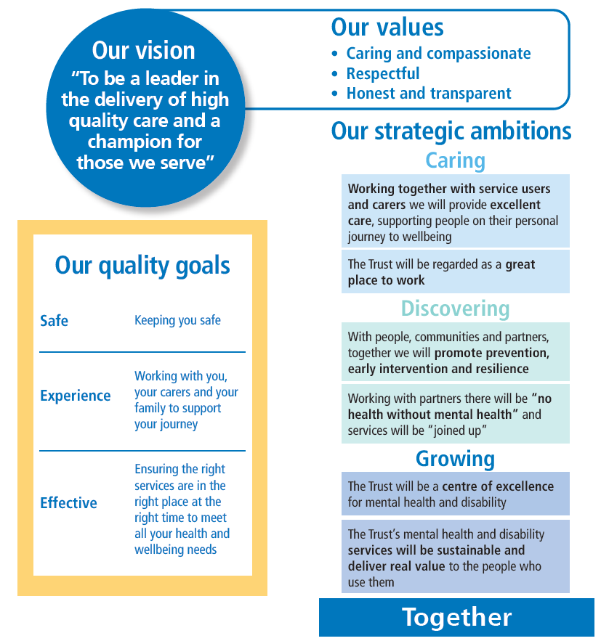
Figure 1 Trust Vision, Values, Quality Goals and Strategic Ambitions

The estate plays a significant role in the delivery and support of the Vision, Values, Quality Goals, Strategic Ambitions and Plans and underpins day to day work activities and the care of the patients and needs to deliver in a number of areas including:

- Therapeutic, homely, peaceful
- Safe, but not overly restrictive
- Be located in the right place
- Access to outdoor space
- Be functionally suitable
- Deliver value for money
- Be environmentally friendly and sustainable
- Be in good condition
- Provide for suitable personal space

Each of points above encompasses a wide range of often interconnected factors that need to work together to deliver an effective estate.

CNTW Climate Health Green Plan


Sitting alongside the above will be other Trust wide plans, local plans and service delivery strategies. Of particular note for the Estate is the launch of the Trusts Green Plan which sets out how the Trust aims to reduce carbon emissions to ‘net zero’ by 2040 and includes a wider set of actions required to meet several other sustainability goals by 2026. These plans support the overall ambition for the NHS to achieve ‘net zero’ by 2040, as set out in the recently published report ‘Delivering a ‘Net Zero’ National Health Service’.
The Green Plan is built on the premise that as a large ‘anchor’ institution, we have a responsibility to improve the health of our local population, and to use both our influence and £380 million purchasing power wisely to support the social and economic success of our local communities.
A survey of the estate has identified that significant capital investment will be required in order to achieve net zero and this equates to an investment requirement of £30M, which over the remaining 18 years prior to 2040 amounts to £1.7M / annum.

Key External Drivers

There are a number of external reviews, Acts, strategies, Inspections etc. which contain estates related items which in turn can set out requirements which either need to be followed or represent good practice. These drivers may need to be incorporated into clinical models and the new Trust strategy, and any estates requirements can be duly considered. The following are some of the current key drivers:

Independent Review of the Mental Health Act 2018

The Independent Review of the Mental Health Act made a clear statement about the need for significant improvements to the inpatient environments across the NHS Estate around a number of key areas, specifically:
- Access to outdoor space
- Ward design that promotes care, safety and has reasonable adjustments for disabled people
- The balance between infection and risk averse design and not creating an institutional atmosphere
- Facilities should be acoustically calm, clean and functional with adjustable light and temperature
- Single sex accommodation where the definition of single sex accommodation should be tightened up to ensure a genuinely single sex environment with separate access to any shared daytime space

Operational productivity and performance in English NHS acute hospitals: Unwarranted variations, 2016

In the report produced by Lord Carter a number of recommendations were made:
- unused floor space should not exceed 2.5%,
- floor space used for non-clinical purposes should not exceed 35%.

Since the Carter report was published before the COVID 19 Pandemic has had a significant impact on the working patterns of staff in particular those who provide administrative support and back-office functions. The opportunity is likely to come from reducing the demand for additional space as teams expand as opposed to taking estate out of use.

NHS England 2023/24 Priorities and operational planning guidance

This guidance identifies there needs to be a reduced reliance on inpatient care, while improving the quality of inpatient care, so that by March 2024 no more than 30 adults with a learning disability and/or who are autistic per million adults and no more than 12–15 under 18s with a learning disability and/or who are autistic per million under 18s are cared for in an inpatient unit. The clinical strategy will need to determine how these impacts on the Trust estate requirements.

Care Quality Commission Inspections

Various CQC inspections have identified a range of environmental that are categorised as “must do’s” for the organisation to undertake. These include a range of requirements for example to install nurse call systems, upgrade of environments, removal of dormitory accommodation etc. Generally, these requirements are a mixture of improving the patient environment and safety improvements.

Summary of Where do we Want to be

The various internal and external drivers are creating a number of strategic themes against which future estates requirements can be identified and these themes are illustrated in figure 2 below. The schemes that are identified in the capital program link back to one or more of these themes.

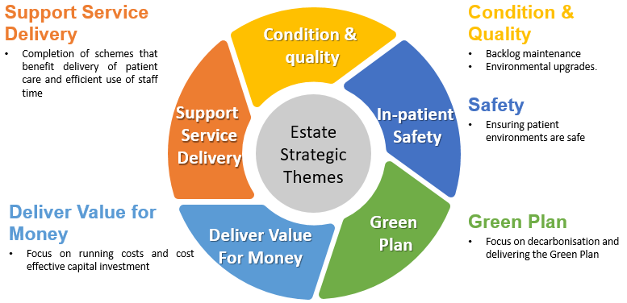
Figure 2 Estates Strategy - Strategic Themes

1.4 How Do We Get There?

This section describes the Trusts proposals for the Estate over the coming five-year period which will deliver on the “where do we want to be”. The key developments listed in this section are divided into those where current funding exists and those where no funding has been identified. It must be recognised that the available capital funding is limited and the plans that have been drawn up reflect this.

Funded Developments

Completion of Major Developments Currently Underway

A number of work programs and estates initiatives which form part of the key Estates changes for the next 2 years, have in part been developed prior to the writing of this strategy document, this includes:

Care Environment Development and Re-provision (CEDAR)

The work associated within the following areas has been brought together under one program known as CEDAR which commenced the major elements of the construction program in 2020:
This scheme will result in adult secure services located on a single site at Northgate Hospital and young people’s secure services relocated onto Ferndene. These moves will enable site rationalisation, improved service productivity, a greater critical mass of clinical expertise and expansion to enable repatriation in line with national strategy and the Mental Health 5 Year Forward View.
Following the transfer of secure beds from Bamburgh Clinic, the building will be extended and upgraded to allow for the adult acute admission facilities from the CAV site to move into the vacated space.
The development will also free up space on the St Nicholas Hospital site, specifically Alnwood and Lennox wards, which could be utilised as an option for the relocation of the Older Peoples in-patient services from the CAV site.
The CEDAR development will deliver against each of the five strategic themes and at the Northgate site will remove a range of buildings that have high levels of backlog maintenance are of a poor quality and poor functional suitability.

Monkwearmouth Hospital and South of Tyne Developments

Demolition of some of the older parts of Monkwearmouth Hospital has occurred (Dec 2022) and redevelopment of the site is underway and will be complete early 2024. The development will also see Boldon Lane Clinic, which is currently vacant, demolished and rebuilt and this will provide a new base for the CYPS service which is currently utilising high cost rented accommodation at Cleadon Park.

An artist’s impression of the redeveloped Monkwearmouth Hospital is shown below.

The Monkwearmouth and South of Tyne Developments will deliver against each of the five strategic themes and will remove a range of buildings that have high levels of backlog maintenance are of a poor quality, poor functional suitability and had associated safety issues related to structural deficiencies and asbestos contamination.

Benton House

Benton House in Newcastle is a leased community property which has been utilised by the Trust for almost 20 years. In 2022 the Trust agreed with the new Landlord to extend the lease and occupy the whole of the building. The building has been refurbished in order to accommodate other teams, and this work will be complete in early 2023.
The additional space will provide an opportunity for services to relocate to Benton House. Work is currently underway with the CBU’s to identify and finalise those teams where relocation will deliver benefits, and it is anticipated this will result in the building being fully occupied by the summer of 2023. The teams currently being considered for relocation include the community service based in the Molineux centre who are in high cost rented accommodation, the CYP CEDS North of Tyne (formerly EDICT) service who are looking to consolidate into a single location and the creation of a CYPS crisis team assessment centre which forms part of the UEC bid.
The Benton House scheme will deliver against a number of the strategic themes, in particular improvements to the quality and suitability of the estate following refurbishment, the delivery of cost savings associated with relocation from the Molineux Centre and is supporting service delivery through the relocation of teams.

Hadrian Unit – Carleton Clinic

The Hadrian Unit was a 22-bed mixed sex adult acute in-patient ward. The unit had a significant number of environmental and safety shortfalls, and these are being addressed as part of a comprehensive upgrade. The original plan was to reduce the beds to 20 and provide bedrooms with en-suite facilities along with other environmental and safety improvements and return the ward back to a mixed sex unit. During the upgrade the service moved the male patients into the former PICU unit and the CBU have decided they will operate this split service moving forward. The upgrade has been modified and now a number of bedrooms will not be upgraded and will instead be mothballed.

There is an opportunity to look at the bed model on the Carleton Clinic site to see if it can be used as a single site for North Cumbria bed-based services and facilitate the relocation of the Yewdale beds.

The Hadrian Unit upgrade will deliver against a number of the strategic themes, in particular improvements to the safety, quality and suitability of the estate following refurbishment and supporting service delivery.

Other Minor Schemes in 2022/23

At the time of writing this strategy a number of other smaller schemes are underway in the current financial year, and these are identified in the capital program. Collectively these schemes will contribute to the five strategic themes.

Prioritised Estates Work Streams – Business as Usual

A number of work streams which form part of the key estate developments that meet the strategic themes of this strategy for the next 5 years have been identified and are detailed below.

Management of Backlog Maintenance

There is a continuing focus on reducing the backlog maintenance position. The capital programme has identified funding of £0.5M per annum to reduce backlog maintenance, focusing on significant and moderate risk adjusted backlog. Backlog will also be addressed through disposals of old estate in particular for the Northgate and Monkwearmouth sites.

The expenditure on backlog will deliver against a number of the strategic themes, in particular improvements to the safety, quality and suitability of the estate

Improving the Patient Environment

The quality of the patient environment and patient safety has been highlighted as a priority by the organisation. In order to address any minor deviations or areas for specific improvement which may be outside of a planned refurbishment program an allowance needs to be made in the annual capital program, and this will ensure issues can be addressed promptly.
The capital programme has identified funding of £1.2M/annum to improve the patient environment.
The expenditure on the patient environment will deliver against a number of the strategic themes, in particular improvements to the quality and suitability of the estate

Safety Improvements

The Trust needs to provide facilities for service users that are safe and minimise the opportunity for harm to be caused. Furthermore, facilities need to comply with legislation and CQC requirements which evolve over time.
Within the Trust the Clinical Environmental Safety Group (CESG) review the standards in place across the Estate with a view to identifying where safety improvements need to take place. The key areas include en-suite doors, CCTV standardisation, seclusion room upgrades and Oxehealth along with a number of other areas.
The capital programme has identified on-going funding of £0.8M/annum to improve safety for patients.
The expenditure in this area will deliver against the strategic theme of safety and will also contribute to the quality and suitability of the estate.

Carbon Reduction, Energy Efficiency and Green Plan Initiatives

A survey of the estate has identified that significant capital investment will be required in order to achieve net zero by the Government target date of 2040 and this equates to an overall investment of around £30M.
The capital programme has identified on-going funding of £1.5M/annum to invest in decarbonisation energy efficiency, building adaptation and improving biodiversity.
The expenditure in this area will deliver against the strategic theme of delivering elements of the Green Plan and will also contribute to the quality and suitability of the estate.

Unfunded Developments

In addition to the funded developments there are a number of schemes which have been identified by the Trust where a funding stream does not exist. These schemes include the relocation of the OPS service from the CAV site and the relocation of Rose Lodge onto a main hospital site.
The OPS service presents a significant risk to service delivery as the service are based at the Centre of Aging Vitality (CAV) which is owned by Newcastle University and leased to CNTW. The current lease expires at the end of March 2023; however, assurances have been sought from the University that these service can remain on site until autumn 2024. A business case has been developed which presents 2 principal options for the bed-based services; move into Alnwood following the CYPS move to Ferndene or construct a new build on the Collingwood Court footprint. Both options are unfunded and would not be complete until 2025.
The Rose Lodge scheme has not been considered in any depth in this strategy.

Potential Rationalisation and Disposal of Assets

The potential of asset realisation to create capital receipts for service development and reduce expensive overhead costs associated with property ownership, has been the subject of considerable work over the last few years. The Trust has a number of assets / surplus land that have been identified for disposal or potential disposal, these include:

Identified Asset Sales & estimated values

- Craigavon & land - £285k (sale underway)

Potential Asset Sales (or development opportunities)

- Hillview Clinic
- Rose Lodge
- Alexandra Lodge
- The Grange
- Land to the North of Carleton Clinic
- Portland Square

Land Sales & estimated values

- Surplus land at St Georges Park is part of the planned disposal strategy - £1.8M (sale underway)
- Northgate Hospital - surplus land not required under the CEDAR development, or for future needs - £7M (sale underway)
Where land sales or asset disposals are being considered a feasibility report will be completed and detailed action plans for each site disposal will be prepared. These plans include timetables for full business case preparation, internal & external consultation (where appropriate), planning applications and marketing. Each disposal will be the subject of an individual business case which will ensure that each disposal achieves best value, and the Trust will utilise relevant experts to ensure maximum value is delivered.
Funding Summary

A plan for the delivery of the estates strategy with phasing of key schemes between 2022/23 - 2027/28 is shown in Table 2. At the front end of the programme, schemes have been prioritised which fit in with the current capital programme and the anticipated works associated with the completion of the CEDAR program. The plans are in some cases subject to the approval of individual business cases as appropriate, the availability of required capital and the outputs of more detailed operational planning to minimise the impact on service disruption.

Trust Capital Funding | Period
Trust Capital Funding | 22/23 | 23/24 | 24/25 | 25/26 | 26/27 | TOTAL
Trust Capital Funding | £'000 | £'000 | £'000 | £'000 | £'000 | £'000
Major Schemes | 35,150 | 8,755 | 0 | 0 | 0 | 43,905
Other Developments | 1,407 | 1,213 | 0 | 0 | 0 | 2,620
Recurring Estate Investment | 2,559 | 4,500 | 4,500 | 4,500 | 4,500 | 20,559
Contingency | 0 | 0 | 1,500 | 1,500 | 1,500 | 4,500
PDC Funded Schemes
UEC - North Cumbria | 467 | 2,664 |  |  |  | 3,131
UEC - Newcastle Gateshead | 1,000 |  |  |  |  | 1,000
UEC - North Tyneside | 500 |  |  |  |  | 500
Total | 5,933 | 8,377 | 6,000 | 6,000 | 6,000 | 32,310
Table 2 Capital Program

1.5 Summary

When formed in 2006, the new organisation inherited a large diverse property portfolio much of which was in a poor condition and had low levels of quality and functional suitability. That position has significantly improved over the last 16 years as a result of sustained and targeted capital investment. Whilst there still remains a range of accommodation which does not enhance the patient experience and is in need of improvement or replacement there are plans in place to address the majority of these areas.

The Trust is rightly proud of the significant advances in improving the quality of the patient environment it has made since its formation with many award-winning innovative capital developments which have been recognised for the contribution they make toward clinical care.

The Trust remains committed to a program of continuous development and improvement in the services it provides and this needs to be reflected in the environments provided for both patients and staff.

By ensuring the Estate Strategy is aligned with the Service Development Strategies, the Trust is confident that its substantial investment programme will deliver further improvements to ensure environments that are fit for purpose which will support the Trust in realising its vision to move forward as a market leader in the provision of mental health, learning disability and neuro rehabilitation services. These developments are also in line with the Department of Health’s guidance on how to efficiently manage estate, which combines the three strands of improving operational efficiency, improving construction efficiency and actively seeking opportunity through surplus land disposal.

The Estate Strategy has taken into account the Trust’s vision, core values and strategic objectives, in addition to the service-specific requirements as set out in the Trusts Strategy and to have ‘facilities fit for purpose’ that complement the service needs of the organisation.

The Estate Strategy provides a framework from which we will be able to monitor and measure our progress in ensuring that the Trust estate performance meets the expectations of the organisation in line with the substantial investment being made over the next 5 years. However, it will be imperative that the Trust ensures that any future investment is in keeping with the Trust’s strategic objectives and goals, core service requirements, models of care and best practice for estate management. The strategy is a dynamic document outlining a programme of work that will be reviewed regularly as service priorities change and development opportunities arise.

2.0 Introduction to the Estates Strategy
To deliver a modern NHS, fit for the 21st century, buildings and equipment are required in the right place, in the right condition, of the right type and which will be able to respond to future service needs. The COVID pandemic has illustrated that even with careful planning unforeseen factors can have a profound impact on the demands of our services.
The Estate Strategy will seek to identify the steps which can be taken by the Trust to maximise the use of its assets in order to provide a productive, efficient, safe, and fit for purpose estate which will support existing and future clinical requirements.
This strategy document is one of a number of enabling strategies that work in partnership to support the Trust’s Annual Plan and Clinical Strategy.
This Estates Strategy has been developed in accordance with the Department of Health and Social Care (DHSC) guidance document ‘Developing an Estates Strategy’, and is structured to reflect the following three key questions:
- Where are we now?
- Where do we want to be?
- How do we get there?

Its aim will be to describe the current condition of the estate, (identifying its suitability, occupancy, tenure, physical condition, service and organisational constraints, capital investment decisions and occupancy costs), highlighting how the existing supply of capital assets meets current services and the needs of the community.

A recent Kings Fund review of strategic estate development has identified the following as important core components to a robust estate strategy document:
- A strategic overview – estates strategies should align with and reflect the aims of any wider organisational or strategic planning
- Alignment with clinical strategy – as part of the above, estates strategies should align with the clinical strategy (at all levels), rather than being developed in isolation, driven by cost concerns, or based on existing buildings
- Customer focus – a clear understanding of what ‘customers’ require and value. This includes those who currently use the estate and those who may use the estate in the future
- Clear case for change – linked to the above, and key to implementation
- Understanding of the estates value – an understanding of the role and value of the estate within the context of other strategies, e.g. funding and sustainability, social value, value to the taxpayer
- Flexibility – any estates strategy needs to be able to respond to potential changes in demand or requirements over time. Where this does not happen, the estate becomes a constraint
- Understanding risk – understanding the risk appetite of the stakeholders involved
- Governance – a strategy should include clear systems of governance and responsibilities. This includes relevant government, and organisational bodies
- Clarity on outcomes – estates strategies should include desired outcomes (specific and wider benefits) and set out the approach that will be used to measure performance

The Estate Strategy is a prerequisite to ensuring that these requirements are met in an effective and sustainable manner.
For a number of years, the Government’s overall aim for healthcare has been to improve the health and wellbeing of the population by:
- Tackling the root cause of ill health and cutting health inequalities
- Breaking down the barriers and focusing services on people’s needs
- Making services more efficient and more convenient

Services should therefore be delivered in well-designed environments suitable for the needs of patients and staff.
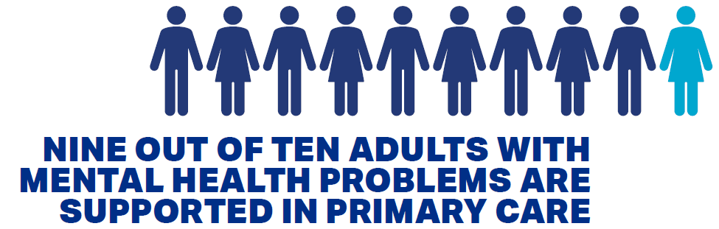
The changes in estate that have been successfully delivered over the last 17 years have been achieved by using the overarching estates strategies that were in place at the time to give direction to the key priorities. Not only do buildings impact on patient perception, they can provide a holistic care environment by ensuring good functionality, meeting expectations in terms of privacy and dignity, providing good access for all.

The Estate is a significant area of expenditure for the Trust with approximately 15% of annual income being spent on its infrastructure. This is a significant financial commitment, which needs to be managed effectively, and this underpins the necessity of having an overarching Estate Strategy which sets out to ensure the following:
- An assurance that investment identified to ensure the quality of clinical services provided will be supported by a safe, secure and appropriate environment
- A method of ensuring that Capital investments and rationalisation/expansion reflect service strategies and plans
- A plan for change that enables progress towards goals to be measured
- A strategic context in which detailed business cases for all capital investment can be developed and evaluated, however funded
- A clear statement by the Trust to the public and staff that it has positive plans to maintain and improve services and facilities
- A clear commitment to complying with sustainable development and environmental requirements and initiatives
- An assurance that asset management costs are appropriate, and that future investment is effectively targeted
- Assurance that risks are controlled, and that investment is properly targeted to reduce risk
- A clear commitment that surplus assets are and will be identified over time, and will be either disposed of or used for future service needs

An Estate Strategy is the starting point for the implementation of performance management measures to improve the performance and utilisation of the Estate. In this, consideration will need to be given to procurement and disposal issues as well as operational issues.
“The provision of safe, high-quality care to patients and the public is the primary concern of any health provider and NHS employee. Carter 2018”

The development of an Estate Strategy is a complex process that must reflect service need and the foreseeable changes in pattern of service delivery. However, due account needs to be taken of the existing asset base and infrastructure which cannot be adapted or replaced overnight.

The longer-term plans for services and the Estate should:
- Meet the needs of the population
- Make the best use of available resources
- Be technically achievable
- Be financially affordable
- Be fit for purpose

This Estate Strategy has been developed to respond to the vision, values, quality goals and strategic ambitions of the Trust as a whole. This is to ensure that the buildings and infrastructure are managed and developed in such a way as to best support the Trust’s clinical service delivery.

3.0 Where Are We Now?

3.1 Introduction

This section provides an overview as to “where are we now” in terms of the clinical services provided by the Trust and an assessment of the current estate. To support this, information including an overview of the services provided, progress made on actions identified in the last Estates Strategy, a detailed assessment of the current estate and a summary identifying future estate development needs will be provided.

3.2 A Trust Overview

3.2.1 Services
Cumbria, Northumberland, Tyne and Wear NHS Trust (CNTW) was originally established on 1st April 2006 as following the merger of the former Newcastle, North Tyneside and Northumberland Mental Health NHS Trust; South of Tyne and Wearside Mental Health NHS Trust; and Northgate and Prudhoe NHS Trust, a specialist disability Trust. The Trust became an NHS Foundation Trust on the 1st December 2009. The Trust provides a range of assessment, treatment, recovery / rehabilitation and continuing care services. It also provides some specialist national services and a range of specialist regional services for the North East of England. The geographical coverage is illustrated on the map below with the Trust providing services across Northumberland, North Cumbria and the Tyne and Wear conurbation, a service at Acklam Road in Middlesborough is also operated by the Trust.

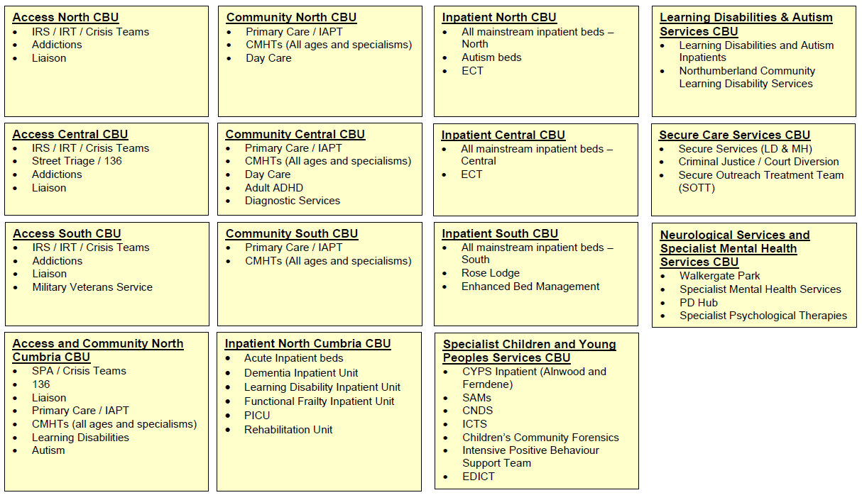
The clinical teams are organised into four geographically located Clinical Business Units – North, Central and South, each covering in-patient services, community and access services with additional specialist services distributed across the groups. Figure 3 below shows how the CBU’s are organised and the services they run.

Figure 3 CBU Structure

The majority of corporate services are based at St Nicholas Hospital, including finance, workforce, informatics, and the executive team. It is also a base for the Trusts subsidiary company - NTW Solutions.
The following sections give more detail on the specific services delivered by each CBU.

Specialist Children and Young Peoples Service CBU

The services which support Children and Young People include assessment, treatment and ongoing support for those with a range of mental health problems and learning disabilities aged from 0 to 18 years.
The Trust’s services are provided on a community basis (tier 3) and on a specialist basis (tier 4) to all CCG’s within the region and to others across the country on a cost per case basis. The tier 4 provision involves working with children and young people who have highly specific and complex issues requiring intensive outpatient, outreach, day patients and inpatient care.

The Trust’s services also include medium and low secure services for those children and young people who have mental health problems and learning disabilities who are in contact with the criminal justice system or who display serious offending behaviour.
Forensic provision includes the Alnwood and Lennox Units at St Nicholas Hospital which are commissioned via the National Commissioning Group. The Lennox Unit is the only NHS service in the country to offer care to adolescent men with a learning disability in a medium secure environment.

Specialist Adult Services- Secure Care and Neurological Services

Specialist Adult Services predominantly consists of two specialities – Neurological Services and Secure Care Services.

Neurological Services provides a range of assessment, treatment and rehabilitation interventions on an inpatient, outpatient, day hospital and community basis to patients who have mental health and/or physical health needs. The majority of the inpatient care is provided from Walkergate Park.

The Adult Forensic Services provides a range of assessment, treatment and rehabilitation services at medium and low levels of security. These are supported by community-based services. The patient group comprises individuals with a range of mental disorders including those with learning disabilities, mental illness and personality disorder, and who have committed serious offences or who are at risk of doing so.
In addition to the Neurological Services and Forensic services, hospital-based assessment and treatment services are also provided within specialist care services to adults with a learning disability who have been diagnosed with autistic spectrum disorders who require intensive support, as well as bed-based services for eating and affective disorders.

In-patients

Inpatient Services are covered by each of the four CBU’s and include all in-patient beds with the exception of those listed under specialist services. The services for adults are primarily provided to people aged over 18, who have a range of mental health or LD conditions ranging from moderate to severe, complex and enduring.

The focus of the inpatient and crisis services has been aligned to the continued development of more specialist community-based provision with the aim of reducing reliance on inpatient care, focussing on the development of integrated pathways of care that provide a seamless route to recovery.

To support this, the Trust has invested in the development of facilities for Psychiatric Intensive Care and Section 136 Place of Safety accommodation. A number of quality improvement initiatives have also taken place which involved staff, service users and external organisations. These include work with the Royal College of Psychiatrists programme for the Accreditation of Inpatient Mental Health Services (AIMS).
In-patient Services for older people aim to offer a timely and appropriate admission to hospital for the purpose of assessment and treatment for individuals generally over the age of 65 with a mental health need where such assessment and treatment cannot be managed effectively in the community. Inpatient Services for older people provide specialist mental health assessment and treatment in hospital for two main groups:
- Functional mental health - conditions such as depression, anxiety or psychosis
- Organic mental health - with progressive conditions such as dementia

Community Services

Community services are covered by four CBU’s located across the geographical areas with the community team merged with the access services in the North Cumbria CBU. The community CBU’s incorporate a range of services including IAPT, Primary Care support, Community Mental Health Teams and day care services. The Community teams operate from a range of premises and in different settings ach

Access Services

The Access services are provided by four CBU’s located across the geographical areas with the access services team merged with the community services in the North Cumbria CBU. The Access CBU’s incorporate a range of services including IRS, IRT, Crisis Teams, Street Triage Section 136 services, addictions services, liasion and Military Veterans services. The aim of the access services is to facilitate access into the services provided by the Trust.

3.2.2 Trust Vision, Values, Quality Goals, and Strategic Ambition

At the time of writing this strategy the Trust is in the process of updating its overarching strategy and this will be known as “We are CNTW”. As such a future revision of the estates strategy may be required in order to reflect any significant changes.

The current strategy was set out in its Caring, discovering, growing: Together, Northumberland, Tyne and Wear NHS Foundation Trust Strategy 2017 – 2022, which set out the vision, values, quality goals and strategic ambition.
The vision set out by the Trust is:
“To be a leader in the delivery of high-quality care and a champion for those we serve”

The vision is underpinned by a set of core values and quality goals. The values aim to provide the best care, delivered by the best people, to achieve the best outcomes and the quality goals to help the Trust achieve its vision by providing an overarching framework to its strategy. The three quality priorities for 2022-23 are:
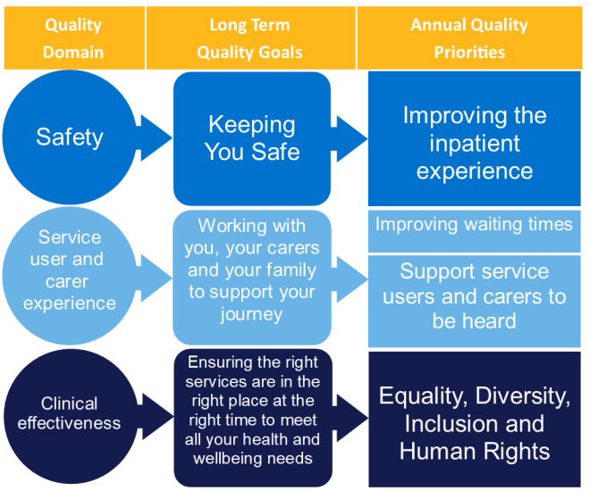
Figure 4 Quality Goals

The six strategic ambitions of the Trust are:
1. Working together with service users and carers we will provide excellent care, supporting people on their personal journey to wellbeing.
2. With people, communities and partners, together we will promote prevention, early intervention and resilience.
3. Working with partners there will be “no health without mental health” and services will be “joined up”.
4. The Trust’s mental health and disability services will be sustainable and deliver real value to the people who use them.
5. The Trust will be a centre of excellence for mental health and disability.
6. The Trust will be regarded as a great place to work.

3.3 Delivery of the previous Estates Strategy

The Trust Board agreed a five-year Estate Strategy which focused on a range of key priorities including:
- Reprovision of facilities to replace poor quality accommodation
- Manage backlog maintenance
- Optimisation of the estate; right size, place, cost effective and meeting user needs
- Ensuring the patient environment is at an acceptable level across the Trust estate.
The above priorities were addressed through a number of projects / initiatives in particular:
- Deliver the PRIDE project, replacing Cherry Knowle and delivery of the Dementia Unit / Older peoples’ re-provision
- Long Term Low Secure re-provision (Villa 19 Replacement, Northgate Site)
- Alnwood improvements
- Replace Villa’s 11 and 16 at Northgate with a purpose-built Autism Unit
- Re-provision of Ward 21 based on the North Tyneside General Hospital site
- Reduced reliance on in-patient beds
- Community transformation project
- Backlog maintenance reduction of £4.2M
- Asset Realisation £20M
The following details a selection of some of the key estate developments that have been delivered over the last 10 years and were identified as key developments.

Ferndene

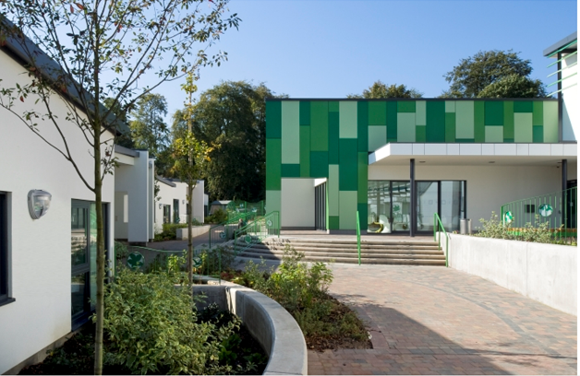
Ferndene, the Trust’s £27 million facility located on the Prudhoe Hospital site combines learning disability and mental health care for children and young people and is the first such integrated service of its kind in the country.
The modern facilities provide accommodation for children and young people from the north east of England and Cumbria.
The unit has 40 beds in four different wards with en-suite facilities. A wide range of therapy, educational, social and recreational facilities are available as well as accommodation for visiting families and office accommodation for staff.
The design of the new unit was developed in conjunction with the young patients with regular meetings with staff, the architects and construction partners throughout the process.

Hopewood Park

Hopewood Park, opened in 2014, is an assessment and treatment centre providing adult psychiatric intensive care. The hospital also delivers a ‘moving on’ service for people with complex care needs who require short term intensive rehabilitation.
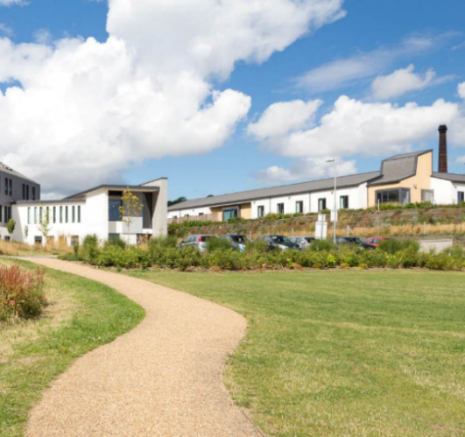
As well as providing inpatient and community care the hospital is also home to the Street Triage team which is delivered in partnership with Northumbria Police, a carers’ information hub, and the Initial Response Service for Sunderland and the South of Tyne.
Service users and their carers are supported by around 390 staff working in nursing, occupational therapy, peer support, catering and in community service

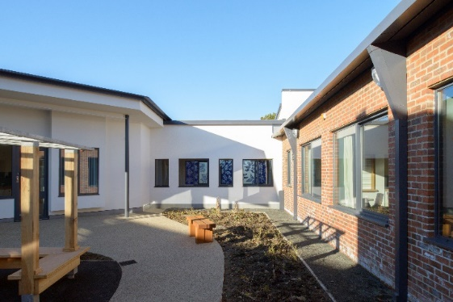
Tyne

The Tyne Unit, on Northgate Hospital site in Morpeth is a 24-bed ward which provides locked forensic rehabilitation services exclusively for male patients over 40 years old with learning disabilities.
The ward is split into four flats, each with six en-suite bedrooms, a living room, dining area, training kitchen, treatment rooms and also group and activity rooms.
Tyne Unit forms part of the wider forensic Learning Disability service and provides specialist multidisciplinary care and treatment for men who are vulnerable and or at risk to themselves or others, and offers a comprehensive treatment programme, incorporating a wide range of needs based individual and group treatments.

Mitford Unit
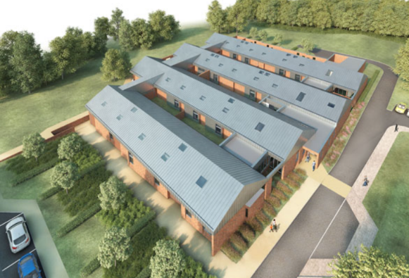
Mitford Unit on the Northgate site was opened to patients in November 2016. The unit is tailored specifically to be as welcoming as possible to adults with an autism spectrum disorder. It is a bespoke centre designed in partnership with service users, families, and NHS staff to offer time limited support at times of mental ill health.
The unit provides highly personalised inpatient care, should it be needed. At Mitford’s centre is a concentrated focus on working together with service users, families and carers.
Areas such as the sensory room, activity room and even the corridors, have all been designed to reduce anxiety and support patients. Specialist features include:
- Curved walls and seating areas and doors and cupboards that can be hidden into walls to create smooth lines and reduce anxiety.
- Precise temperature and lighting controls for each living area to adjust the environment depending on patients’ needs.
- Sound-proofing throughout the unit to help reduce noise sensitivity.
- High ceilings and windows to maximize natural light.

Cleadon Ward

Cleadon Ward is an 18-bed assessment and treatment unit providing modern purpose-built accommodation for older people who primarily are experiencing mental health issues but also have physical frailty.
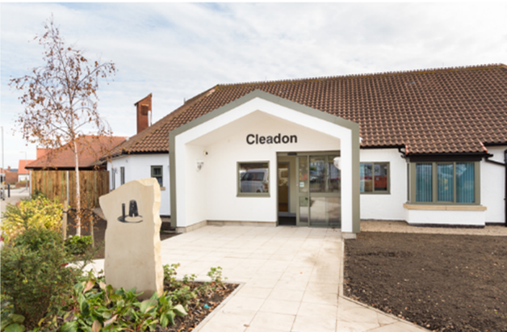
The unit is part of the specialist Older Persons Centre working alongside the dementia units of Mowbray and Roker Ward, and the challenging behaviour unit of Marsden.
The bedrooms provide a safe environment for patients encouraging the healing process for people who are physically frail. The attractive outdoor courtyard offers patients the opportunity to indulge in a passion for gardening by tending to the raised flower beds.
The unit features artwork which was developed with the involvement of staff and patients. It provides a welcoming and pleasant environment and features a number of bespoke art installations such as artwork windows and wall papers featuring local landmarks.

3.4 The Current Estate

The Estate covers a large geographical area of over 4800 square miles with an estate portfolio comprising over 260 buildings spread across 9 principal sites and 74 satellite locations. Our services are provided from a wide range of settings, including in-patient sites, community premises, health centres and clinics as well as patient homes.
Properties range in age from the 1870’s to the present day and ownership of these properties is mixed, with the Trust occupying space owned or leased by a number of organisations including:
- PFI
- NHS Property Services Ltd
- Local Authorities
- General Practitioners (GPs); and
- Private landlords.
The following sections provide a detailed overview of this information so that a clearer understanding of the estate and its benefits and shortfalls can be put into context. The information will then be used to underpin the estates strategy as it will help to inform the organisation as to where the priorities for development should be.

3.4.1 Locations and Principal Site Information

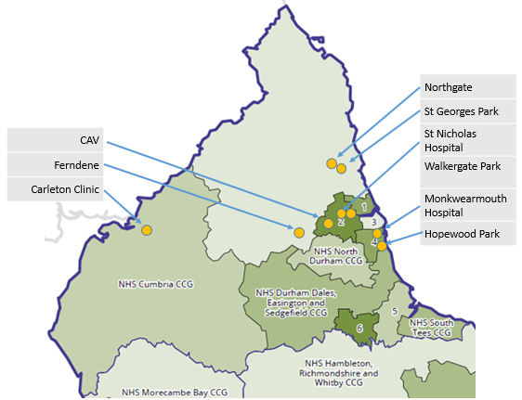
The geographical area covered for the both the principal hospital sites and others where inpatient accommodation is provided are shown in figures 4 - below:
Figure 4 bed based services CNTW main sites

The principal hospital sites account for the majority of the inpatient beds managed by the Trust, with the remaining inpatient services being provided in the six stand-alone units whose locations are shown in the figure above.

A summary of the services provided from each site is detailed in the sections below, a full property schedule and location plan is contained in Appendix 1.

Northgate Hospital

Northgate Hospital is situated on the outskirts of Morpeth in Northumberland set in approximately 28 hectares of land. Over the last 20 years the site has seen significant change with several villas demolished and in 2015 a substantial part of the site was sold to Taylor Wimpey for housing development.

The site currently provides a range of clinical services including Medium and Low Secure, Mental Health, Autism Services, Assessment and Treatment for Patients with Learning Disabilities, Adult Forensic Medium and Low Secure.
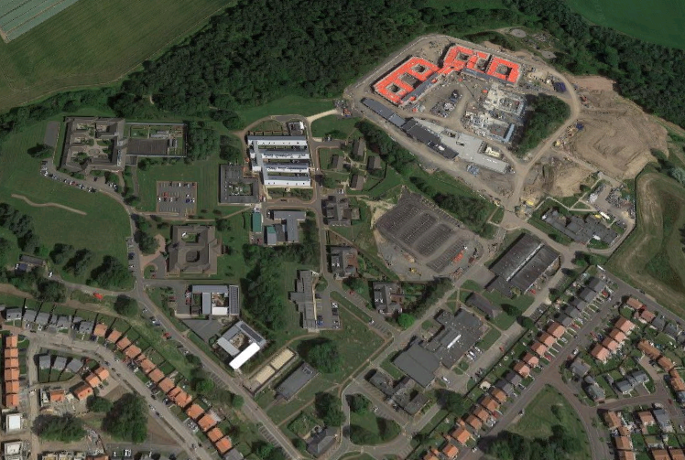
Figure 5 Aerial photograph of Northgate site

The photograph shows an aerial view of the current site. The site is currently reaching the end of a major redevelopment which will see the consolidation of adult forensic in-patient services onto the site and will also result in a further land sale.
The following summarises the current estate at Northgate:
- The elements of the CEDAR program on this site are currently under construction and will be completed in March 2023
- The Tweed Unit does not provide the same standard of accommodation as other areas across the Trust, areas of deficiency include no en-suite facilities, poor outdoor space.
- The high level of backlog maintenance associated with numerous buildings across the site will be addressed as part of the identified land sale.
- The area for land sale which has been incorporated into the CEDAR project

St George’s Park

St George’s Park consists of in-patient facilities built via the PFI initiative on part of the former St George’s Hospital site in Morpeth and opened in 2006. The layout of the site consists of central in-patient facilities with additional detached villa type accommodation within a village complex. The concession period is 30 years inclusive of construction, at the end of which, the facility transfers to the ownership of the Trust. The site provides a range of clinical services which includes
- Adult Urgent Care and Rehabilitation,
- Mother and Baby Unit,
- Older People’s Functional, Organic and Specialist Long Term Care beds.
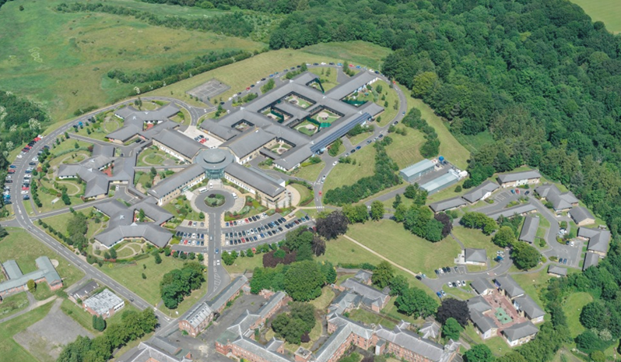

Figure 6 Aerial photograph of St George’s Park
The following summarises the current estate at St George’s:
- The condition, quality and functional suitability are all rated as good
- Significant additional investment has been made on the acute wards in the last 5 years to improve safety, security and resilience
- One of the elderly wards remains vacant
- Space utilisation in the offices on the first floor is in parts considered low
- A parcel of land to the north of the site is currently in the process of being sold
- The acuity of patients in the Village is increasing and plans are being considered to move them into the empty Druridge ward - this would then present an issue with the Village which could be used for a range of purposes or disposed of

St Nicholas Hospital

St Nicholas Hospital site is situated in the centre of Gosforth, Newcastle. The site comprises 12 hectares of land with mainly refurbished Victorian style buildings (66%), some newer facilities being constructed in the last 15 years (20%) and a number of other buildings of varying ages located across the site. The site provides a range of clinical services (approximately 100 beds), including Adult Forensic Medium and Low Secure, a PICU and Children and Young People’s Medium Secure units. In addition to clinical services, the majority of corporate services for the Trust are also provided from this site. The majority of the site is subject to a conservation order through the local Planning and Development Framework.
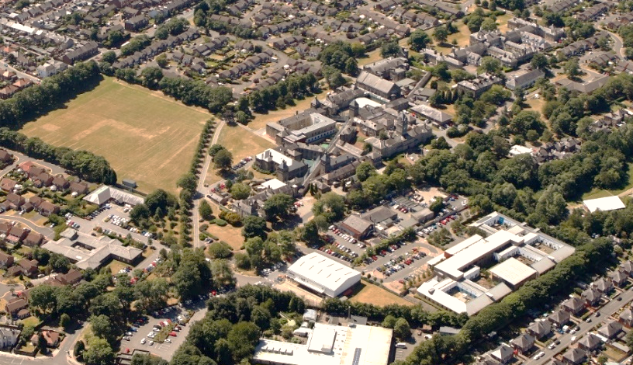

Figure 7 Aerial photograph of St Nicholas Hospital
The following key issues are associated with the current estate at St Nicholas Hospital
- The Alnwood Unit is not considered functionally suitable. Its replacement is included as part of the CEDAR program, and they will be moving to Ferndene in 2022.
- There are a number of buildings across the site with vacant space and the move from Alnwood will create additional space
- There is some high level of backlog maintenance associated with a small number of buildings and services
- The site performs poorly in relation to energy consumption
- Bamburgh Clinic forms part of the CEDAR program and the Forensic services will relocate to Northgate in 2023, the building will then be extended and modified to facilitate the transfer of Adult acute in-patients currently located on the Hadrian Clinic.
- Historically car parking has presented a significant challenge for this site and would impede any significant expansion of services. The COVID pandemic has seen a significant reduction in car parking demand and this proabably reflects the higher proportion of corporate staff on this site working from home.

Ferndene

Ferndene is based at the former Prudhoe Hospital site and provides an inpatient regional and national service for children and young people aged up to 18 years of age.
Ferndene comprises of four inpatient wards (Fraser, Redburn, The Riding and Stephenson) providing a total of forty beds.

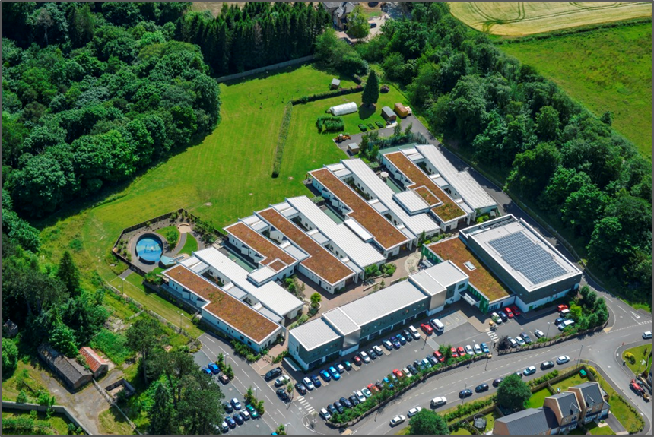

Figure 8 Aerial photograph of Ferndene site
The following key issues are associated with the current estate at Ferndene
- Ferndene was a new build completed in 2012
- The condition, quality and functional suitability are rated as high. However, serious defects in the roof structure and in some internal wall detailing were found during the building modifications to accommodate the Alnwood moves. Extensive repairs were carried out in 2022, and these defects have been remedied as part of the CEDAR program.
- The building is currently being modified to accommodate the secure Forensic services located on the Alnwood Unit at St Nicholas Hospital, this work forms part of the CEDAR program.

Campus for Ageing and Vitality

The Trust occupies a number of wards on the Campus for Ageing and Vitality site. These include three adult assessment and treatment wards (54 beds) located in the Hadrian Clinic building.

The Trust also currently provides assessment, treatment and rehabilitation for functional and organic disorders for older peoples services for Newcastle from two wards in the Centre for the Health of the Elderly (20 beds).
The figure below shows an aerial view of the site including the Hadrian Clinic and the Centre for the Health of the Elderly building.
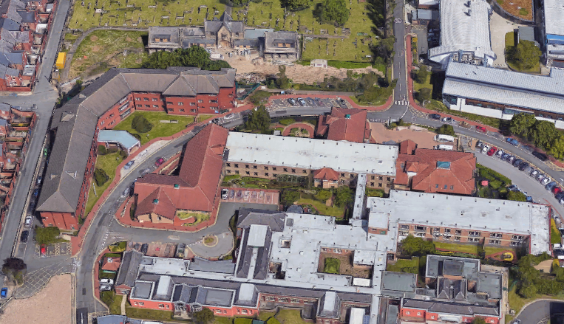

Figure 9 Aerial photograph of the CAV site
The following key issues are associated with the current estate at the CAV site
- The condition, quality and functional suitability is generally poor, although a partial upgrade was undertaken in the in-patient areas of Hadrian Clinic
- Buildings are not owned by CNTW and there is limited opportunity to bring them up to a standard enjoyed elsewhere in the Trust
- NuTH has sold the site to Newcastle University and there now exists a lease between NuTH and the University, with CNTW having a sub lease. This lease will terminate in 2024.
- There is currently no agreed solution for the reprovision of Castleside which is an organic old age psychiatry ward or Akenside which treats inpatients with functional mental health problems. A business case will be prepated in early 2023 to set out the options for the OPS reprovision.
- The in-patient services in Hadrian Clinic will move to Bamburgh Clinic on the St Nicholas site as part of the CEDAR program.

Walkergate Park

Walkergate Park consists of an in-patient facility built via PFI on part of the Walkergate Hospital site in the east end of Newcastle, opened in 2007. The facility consists of Neuroligical Services inpatient facilities for 65 patients with an outpatients department. There is also a North East drive mobility – a 200m specialist driving track for mobility assessments.
This is a PFI site with a concession period of 32 years inclusive of construction, at the end of which, the facility transfers to the ownership of the Trust.
At the North end of the site there is a 2-storey office building, Benfield House, which is owned and used by the Trust. There is also an adjacent single storey building, which was leased to IBM but is now vacant.

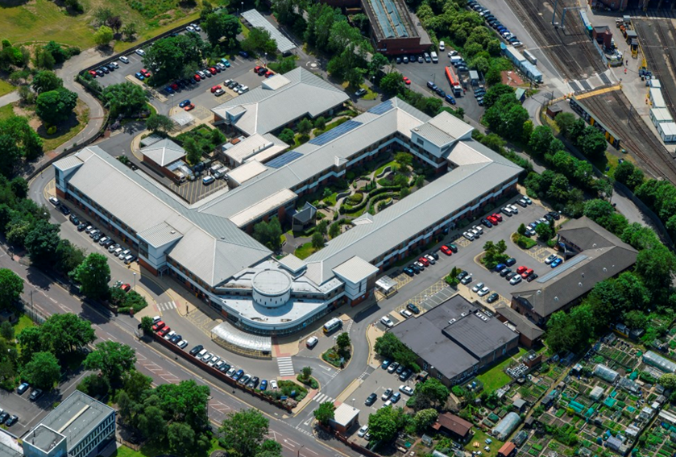

Figure 10 Aerial photograph of Walkergate Park
The following key issues are associated with the current estate at Walkergate Park
- The condition, quality and functional suitability are all rated as high
- The former IBM building is vacant.

Hopewood Park

Hopewood Park is an assessment and treatment centre providing psychiatric intensive care. The hospital also delivers a ‘moving on’ service for people with complex care needs who require short term intensive rehabilitation.
As well as providing inpatient and community care the hospital is also home to the Street Triage team which is delivered in partnership with Northumbria Police, a carers’ information hub, and the Initial Response Service for Sunderland and the South of Tyne.
The new hospital opened in September 2014 on the site of the former Ryhope General Hospital and replaced the majority of the Trust’s Cherry Knowle Hospital and the mental health wards in South Tyneside General Hospital.
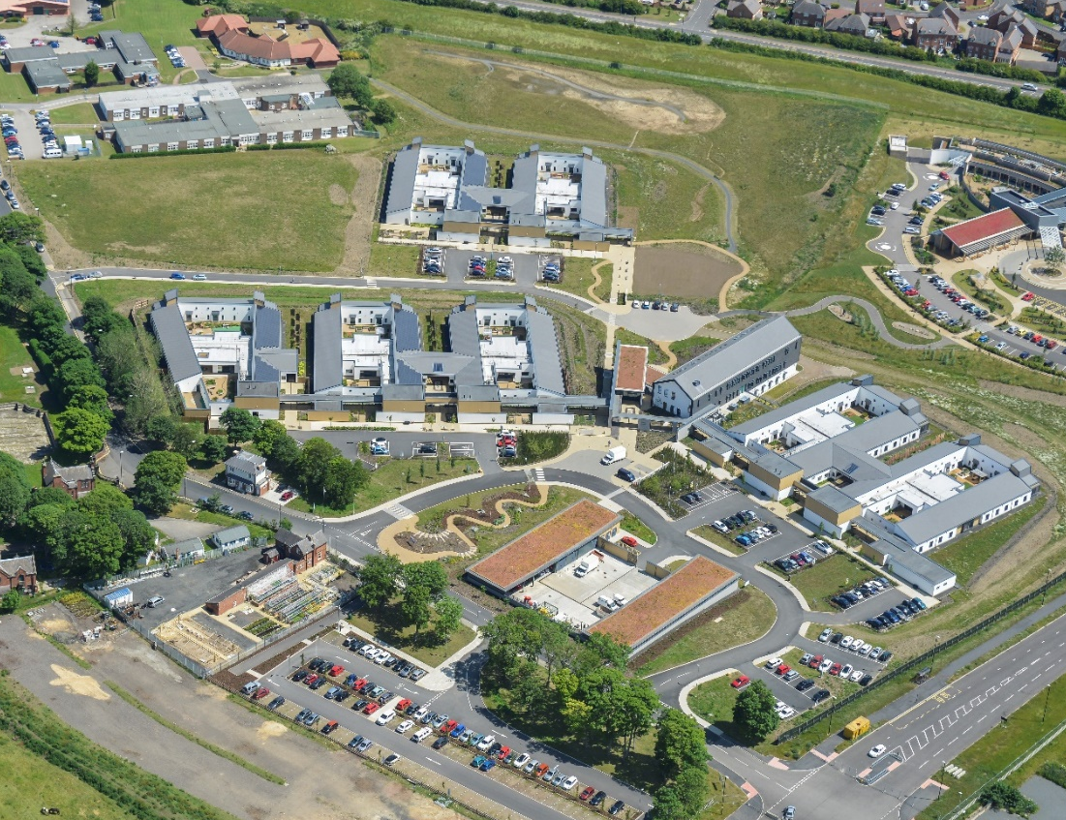

Figure 11 Aerial photograph of Hopewood Park
The following key issues are associated with the current estate at Hopewood Park
- The condition, quality and functional suitability are all rated as high across the new build facilities
- Meadow View is identified as a decant emergency ward, however this ward has significant limitations in terms of of its condition, safety and functional suitability for a range of clinical in-patient service.
- Wellfield Day unit has moderately high levels of backlog maintenance issues

Monkwearmouth Hospital

Monkwearmouth Hospital is situated on the northern outskirts of Sunderland. The site provides a range of clinical services (approximately 40 beds), which include, Adult Learning Disability Services, Older People’s Continuing Care Services, Adult Rehabilitation Services, CABIS, North Team Community facilities and CYPS community facility.
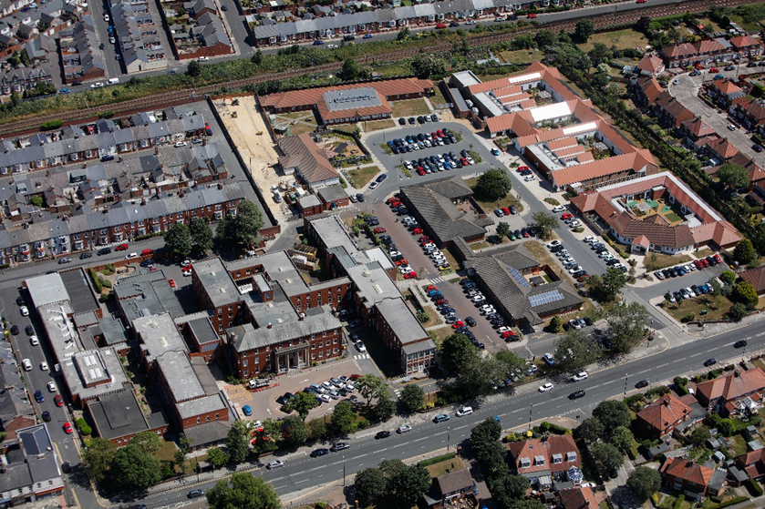
The figure below shows an aerial view of the site; however, it should be noted that since this photograph was taken the demolition and reprovsion of the main block has begun.

Figure 12 Aerial photograph of Monkwearmouth Hospital
The following key issues are associated with the current estate at Monkwearmouth Hospital
- The condition, quality and functional suitability are all rated as high across the new build in patient facilities of Roker, Mowbray and Cleadon
- Marsden ward is currently being used as decant space and not for in-patients.
- Blocks 1,2, 5 & 6 have been demolished, and a new build will be constructed along with a replacement car park.

Carleton Clinic

Carleton Clinic is located to the South of Carlisle and prvides a range of mental health facilities including acute adult admission/treatment, Psychiatric intensive care, wards for older people, wards for people with learning disabilities or autism, community services and crisis services. The site forms part of the transfer of services from the former Cumbria Partnerships Foundation Trust into NTW at the time of the creation of CNTW in 2019.
The original site formed part of a landsale agreement with Taylor Wimpey and sections have been developed for housing.
The figure below shows an aerial view of the site.

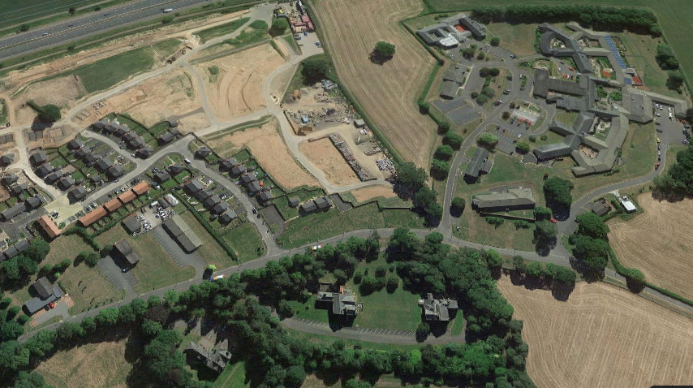

Figure 13 Aerial photograph of Carleton Clinic
The following key issues are associated with the current estate at Carleton Clinic
- The condition, quality and functional suitability are mixed
- Hadrian ward is undergoing a refurbishment
- Acorn ward is to be converted into a crisis centre
- The site is fragmented with some buildings seperated from the main site by a new housing estate
- There is a parcel of land circa 4 acres to the North of the main site which could be utilised in the future

Other In-patient Sites

In addition to the principal sites, in-patient services are provided across the organisation in a number of other locations, these are detailed in the table 3 below.

Site name | CBU | Speciality | Comments
Lotus Ward, Acklam Road, Middlesborough | North Cumbria Locality Care Group | 10 bed Children & Young People | Good quality accommodation on a non CNTW site. Ward was upgraded for commencement of service in 2021
Brooke House  Houghton | Inpatients South | 10 bed, Rehab and Continuing Care | CNTW owned Community facility
Elm House, Gateshead | Inpatients Central | 14 bed Rehab and Continuing Care | CNTW Leased Community facility
Rose Lodge  Hebburn | Inpatients South | 10 bed, learning Disability Inpatient | CNTW facility. Service have indicated a rationale to operate the service from a main hospital site due to operation as an isolated service.
Ward 31a, based at RVI in Newcastle. | Neurological and Specialist Services | 5 bed, eating disorders | Suggestions continue to circulate that NuTH require this space to be used for their clinical services.
Yewdale Ward, West Cumberland Infirmary, | Inpatients Cumbria | 16 bed, acute urgent care in-patients | An isolated service. Historically quality and fuctional suitability have been poor. Recent investment has remedied some of the deficiencies.
Table 3 No main site bed based services

Other Sites

The Trust utilise a number of other buildings located across the North East of England and North Cumbria. These buildings have a mix of tenures including owned, leased, occupied under licence, service level agreements and other informal agreements. These buildings represent a significant part of the estate and a detailed summary of them is shown in Appendix 1.

3.5 Current Assessment of the Estate
An analysis of the existing estate has been undertaken using assessment criteria commonly used for NHS buildings, this will include an age profile, occupancy costs, physical condition, space utilisation, quality assessment, functional suitability, compliance with statutory requirements, backlog maintenance position and environmental management.

3.5.1 Age Profile

The age profile of the estate has changed over the last few years following a programme of replacing outdated and unsuitable accommodation with modern purpose-built facilities. The main changes have occurred because of the replacement of large sections of estate on the Cherry Knowle and Prudhoe sites which predated 1948. Table 4 below shows the how the % distribution has changed over the last 11 years.

CNTW Age Profile of Estate
Period | 2012 | 2018 | 2023
Pre 1948 | 30% | 24% | 24%
1948 - 74 | 18% | 11% | 14%
1975-2005 | 24% | 23% | 24%
Post 2005 | 28% | 42% | 38%
Table 4 Age Profile Change over time

The age profile reflects the sustained development in new facilities that has been delivered by the Trust. This strategy has resulted in facilities that are not only fit for purpose and are of a high quality, but they also have addressed many of the shortcomings associated with the older estate which could not be resolved economically or practically, for example first floor inpatient accommodation and lack of en-suite facilities.
The profile reflects the estate that was transferred from North Cumbria in 2019 and also the changes on the Northgate site which are due to be handed over in the early part of 2023.

3.5.2 Bed Numbers

The figures below show the overall available bed provision across each of the principal and community sites and the the change over the last 11 years. The figure clearly shows how numbers have reduced since the previous Estates Strategy in 2012, with the most significant change being the reduction in social and residential beds. This bed reduction is reflective of the Trusts operational strategy to reduce in-patient beds and provide treatment in community or other settings. Table 5 below shows the bed number change over the last 11 years.

CNTW Inpatient Beds
Period | 2012 | 2018 | 2023
Beds | 1305 | 857 | 791
Table 5 Bed number change over time

3.5.3 Tenure

Whilst the Trust owns the majority of its main sites (either freehold or through the PFI Project Agreements), there remains a significant number of buildings which the Trust occupies under either lease, licence, informal tenancy or service level agreements. The breakdown of tenure is shown in table 6 below.
Tenure | No of sites | Floor area m2
Freehold | 46 | 114521
PFI | 2 | 28988
Lease | 53 | 20610
SLA / Informal tenancy / Licence to occupy | 13 | 10038
Total | 114 | 174157
Table 6 Number of sites and Tenure

3.5.4 Estates Occupancy Costs

For the main sites a summary of the principal elements of expenditure is shown in table 7 below and this is then shown as a £/m2 for illustrative purposes. The figures illustrate the range of estates costs necessary to provide accommodation on main hospital sites. Several factors contribute to the wide variation in costs which makes a direct comparison of value for money difficult to calculate.

The overall site costs show that the two PFI sites have the highest costs per occupied floor area, this makes it imperative that space utilisation of those sites is maximised as there is no scope to reduce costs by mothballing space.

Site | CAP Charges PFI  £000 | Rent / Rates  £000 | Utilities  £000 | Maintenance / Other  £000 | Total  £000 | Floor area m2 | £000/m2
Northgate | 862 | 87 | 372 | 1228 | 2549 | 19,692 | 129
SGP | 3613 | 216 | 345 | 1658 | 5832 | 19,353 | 301
Ferndene | 214 | 54 | 136 | 512 | 916 | 5,374 | 170
SNH | 1049 | 186 | 669 | 2128 | 4032 | 31,813 | 127
WGP | 2025 | 138 | 222 | 1051 | 3436 | 12,661 | 271
CAV | 496 | 65 | Incl | 79 | 640 | 6,296 | 102
MWH | 433 | 216 | 227 | 1345 | 2221 | 13,466 | 165
HWP | 1259 | 412 | 389 | 1296 | 3356 | 16,692 | 201
Rose Lodge | 38 | 22 | 26 | 52 | 138 | 1,252 | 110
Carleton Clinic | 311 | 114 | 356 | 612 | 1393 | 11,237 | 124
Table 7 Principal Elements of Expenditure

3.5.5 Six Facet Survey and Backlog Maintenance

This section details the condition of the estate which has been assessed using the Department of Healths ‘Risk Based Methodology for Establishing and Managing Backlog’, to create a series of detailed six facet surveys.

This enables an assessment of the Trusts current estate with regard to fitness for purpose in terms of use, condition and compliance. The six facets which are assessed and ranked are:-
- Physical Condition
- Fire, Health and Safety
- Quality
- Space Utilisation
- Functional Suitability
- Environmental Planning
Following site surveys and desk top reviews, the appropriate scores are made against each building for the various elements. Tables 8 – 19 below detail the scores for each of the facets followed, showing the overall total followed by the main sites and a summary of the smaller sites. This is followed by a summary of the key findings.

ALL SITES
Facet | % Ranking
Facet | A | B | C | D
Physical condition | 7.5 | 81.5 | 10.7 | 0.3
Quality | 5.9 | 83.2 | 10.9 | 0
Functional suitability | 25.5 | 63.7 | 10.8 | 0
Fire, health and safety | 23 | 75.5 | 1.5 | 0
Environmental management | 0 | 60.5 | 36.6 | 2.7
 | Full | Underused | Overcrowded | Empty
Space Utilisation | 85.8 | 9.4 | 0.8 | 4.1
Table 8 Facet Surveys

NORTHGATE HOSPITAL (POST – MSU DEVELOPMENT)
Facet | % Ranking
Facet | A | B | C | D
Physical condition | 64.4 | 35.4 | 0 | 0
Quality | 43.8 | 50.1 | 6.1 | 0
Functional suitability | 56.4 | 43.6 | 0 | 0
Fire, health and safety | 33.3 | 66.7 | 0 | 0
Environmental management | 0 | 77.5 | 22.5 | 0
 | Full | Underused | Overcrowded | Empty
Space Utilisation | 90.7 | 5.2 | 0 | 4.1
Table 9 Facet Surveys

FERNDENE
Facet | % Ranking
Facet | A | B | C | D
Physical condition | 0 | 100 | 0 | 0
Quality | 0 | 100 | 0 | 0
Functional suitability | 0 | 100 | 0 | 0
Fire, health and safety | 0 | 100 | 0 | 0
Environmental management | 0 | 100 | 0 | 0
 | Full | Underused | Overcrowded | Empty
Space Utilisation | 73.9 | 0 | 0 | 26.1
Table 10 Facet Surveys

ST NICHOLAS HOSPITAL
Facet | % Ranking
Facet | A | B | C | D
Physical condition | 0 | 86.5 | 13.5 | 0
Quality | 0 | 90.8 | 9.2 | 0
Functional suitability | 0 | 98.5 | 1.5 | 0
Fire, health and safety | 21.3 | 74.7 | 4 | 0
Environmental management | 0 | 96 | 4
 | Full | Underused | Overcrowded | Empty
Space Utilisation | 77.5 | 21.4 | 0 | 1.1
Table 11 Facet Surveys

WALKERGATE PARK
Facet | % Ranking
Facet | A | B | C | D
Physical condition | 0 | 93.6 | 6.4 | 0
Quality | 0 | 100 | 0 | 0
Functional suitability | 89 | 11 | 0 | 0
Fire, health and safety | 89 | 11 | 0 | 0
Environmental management | 0 | 100 | 0 | 0
 | Full | Underused | Overcrowded | Empty
Space Utilisation | 94 | 0 | 0 | 6
Table 12 Facet Surveys

HOPEWOOD PARK
Facet | % Ranking
Facet | A | B | C | D
Physical condition | 0 | 86.5 | 13.5 | 0
Quality | 0 | 88.2 | 11.8 | 0
Functional suitability | 0 | 92.6 | 7.4 | 0
Fire, health and safety | 58.3 | 41.7 | 0 | 0
Environmental management | 0 | 69.4 | 30.6
 | Full | Underused | Overcrowded | Empty
Space Utilisation | 88.2 | 7.4 | 0 | 4.5
Table 13 Facet Surveys

MONKWEARMOUTH HOSPITAL
Facet | % Ranking
Facet | A | B | C | D
Physical condition | 0 | 93.6 | 6.4 | 0
Quality | 0 | 70.5 | 29.5 | 0
Functional suitability | 0 | 100 | 0 | 0
Fire, health and safety | 0 | 92.3 | 7.7 | 0
Environmental management | 0 | 0 | 100 | 0
 | Full | Underused | Overcrowded | Empty
Space Utilisation | 87.9 | 12.1 | 0 | 0
Table 14 Facet Surveys

ST GEORGE’S PARK
Facet | % Ranking
Facet | A | B | C | D
Physical condition | 0 | 100 | 0 | 0
Quality | 0 | 100 | 0 | 0
Functional suitability | 100 | 0 | 0 | 0
Fire, health and safety | 0 | 100 | 0 | 0
Environmental management | 0 | 100 | 0 | 0
 | Full | Underused | Overcrowded | Empty
Space Utilisation | 99.1 | 0.9 | 0 | 0
Table 15 Facet Surveys

CAMPUS FOR AGEING & VITALITY
Facet | % Ranking
Facet | A | B | C | D
Physical condition | 0 | 60.8 | 39.2 | 0
Quality | 0 | 60.8 | 39.2 | 0
Functional suitability | 0 | 100 | 0 | 0
Fire, health and safety | 0.6 | 99.4 | 0 | 0
Environmental management | 0 | 0 | 100 | 0
 | Full | Underused | Overcrowded | Empty
Space Utilisation | 100 | 0 | 0 | 0
Table 16 Facet Surveys

COMMUNITY
Facet | % Ranking
Facet | A | B | C | D
Physical condition | 8.9 | 82.1 | 7.2 | 1.8
Quality | 8.1 | 84.4 | 7.5 | 0
Functional suitability | 11.1 | 82.7 | 6.2 | 0
Fire, health and safety | 19.6 | 78.8 | 1.7 | 0
Environmental management | 0 | 21.8 | 63.4 | 0
 | Full | Underused | Overcrowded | Empty
Space Utilisation (Wards) | 80.3 | 0 | 19.7 | 0
Space Utilisation (Ex Wards) | 77.4 | 10.9 | 0 | 11.7
Table 17 Facet Surveys

CARLETON CLINIC
Facet | % Ranking
Facet | A | B | C | D
Physical condition | 0 | 79.4 | 20.6 | 0
Quality | 0 | 80.3 | 19.7 | 0
Functional suitability | 0 | 100 | 0 | 0
Fire, health and safety | 0 | 100 | 0 | 0
Environmental management | 0 | 0 | 100 | 0
 | Full | Underused | Overcrowded | Empty
Space Utilisation | 96.1 | 3.9 | 0 | 0
Table 18 Facet Surveys

WEST CUMBERLAND HOSPITAL
Facet | % Ranking
Facet | A | B | C | D
Physical condition | 0 | 66.8 | 33.2 | 0
Quality | 0 | 67.6 | 32.4 | 0
Functional suitability | 0 | 67.6 | 32.4 | 0
Fire, health and safety | 0 | 100 | 0 | 0
Environmental management | 0 | 60.5 | 36.7 | 2.8
 | Full | Underused | Overcrowded | Empty
Space Utilisation | 100 | 0 | 0 | 0
Table 19 Facet Surveys

Key factors identified in the analysis are:

Physical Condition

11% of building stock required improving to bring the buildings up to a minimum condition of category B - this includes the building, electrical and mechanical components of a building and site wide infrastructure - elements falling into those categories consist of structure, roofs, drainage, sewerage, roads and footpaths, boiler plant, steam systems, hot and cold water systems, lifts, electrical systems, fire alarms, telephony and building management systems.

Quality

12% of the Trusts estate is below the quality standard which the Trust would wish to attain identifying problems with the aesthetic and environmental conditions of the building. Criteria used to assess the quality include is it an attractive and pleasing area for patients and staff, is it well lit, heated and cooled, is it noise and odour free and attractively designed with good colour schemes and well furnished

Functional Suitability

5% of the overall estate is considered to be functionally unsuitable for its purpose - this includes in-patient environments that do not allow for easy operation of the ward and do not have the interactive space to deliver therapeutic activities, day space needs, external space and support the privacy and dignity agenda for patients. For non in patient environments this is in relation to the ability of a building to effectively support the function being carried out in the building.

Fire, Health and Safety

1.5% of the estate does not meet statutory and non statutory compliance including fire – this includes some elements associated with DDA compliance, asbestos, site security and aging fire systems. In addition to the building elements of health and safety, the NTWS Estates team have been working with the Trust safety team to establish areas where safety improvements can be made to in-patient environments, these improvements are not captured in this facet however they are identified in Section 5.

Space Utilisation

This facet explores how well space is being used across location and time. To gain a more acurate understanding of space utlisation, properties are subject to on-going surveys using Occupeye, a mobile sensor-based system located in rooms. The sensors allow a real time analysis of occupancy, and the information is used to suggest ways of using space more effectively and therefore save money. The information captured by Occupeye is revealing that space in some locations is significantly underutilised. Basesd on the Occupeye data and checks by the Property Team, 14% of the estate is not being optimised for space utilisation.
The COVID pandemic has had a significant impact on the utilisation of the estate in terms of space utilisation, in particular for corporate teams. Some staff are able to work from home and the demand for meeting space has dropped due to many meetings using TEAMS on-line technology, the full impact of these changes on future estate is not fully understood.

Sustainability and Environmental Management

Historically this facet has been measured against energy consumption / heated volume and the majority of our estate would achieve an “A” category as performance is less than 55GJ/100m³. For this assessment, the sustainability and energy management facet has taken into account a varirty of factors including,energy and water consuption performance indicators, % of renewable technologies, carbon emissions, biodiversity, building adaptation, transport and waste management and wheter there are robust policies covering each of the aforementioned areas.
The assessment has shown that whilst the overall performance on energy is good there remains a significant way to go in order to achieve net zero carbon emissions, bulding adaptation and implementing a robust bio-diversity strategy. Taking these factors into account the scores reflect the challenges that the organissation faces with respect to sustainability and environmental management.
With the exception of sustainability and environment the figures show an improvement when compared against the previous estates strategy and this is attributed to the developments that have occurred over the last 12 years. The assessments also indicate where opportunities exist where improvements can be made to the estate which would bring benefits both to patient care and the staff that use the buildings.

Backlog Maintenance

Sitting alongside the six-facet survey information is the assessment of backlog maintenance associated with the physical estate, and which reflects the overall condition of the estate and is shown as a cost element. Backlog maintenance reflects the capital cost required to bring the facets of physical condition, fire or health and safety up to condition ‘B’. The assessment does not address any deficiencies in functional suitability or aspects of quality improvement.
The Trust owns and occupies a diverse estates portfolio, which includes a wide range of building stock. Backlog has been substantially addressed through investment over the period however there are still backlog remaining which can only be dealt with through a sustained investment programme.

The 2019 increase reflects transfer of the North Cumbria estate and the creation of CNTW. The 2023 figure reflects the reduction associated with the Northgate development, the repairs to Ferndene and the Monkwearmouth demolitions.

The significant reductions in the value associated with backlog maintenance have largely been made not by directly addressing the backlog works, but by providing new build or replacement facilities. Whilst it is possible to improve the physical aspects of an asset to condition ‘B’, this seldom impacts on quality or functional suitability without wholesale redevelopment.

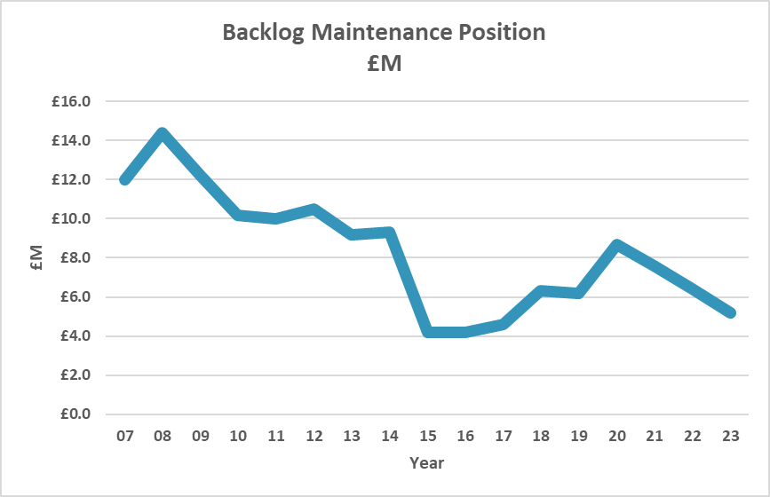
Figure 14 below shows the data starting in the year following the formation of NTW.

Figure 14 Backlog maintenance change

Table 20 below shows the category of backlog maintenance for each of the main sites.

Site | High risk backlog | Significant risk backlog | Moderate risk backlog | Low risk backlog
Northgate Hospital | £0 | £0 | £0 | £0
St Georges Hospital, | £0 | £0 | £0 | £0
St Nicholas Hospital, | £0 | £80,000 | £350,000 | £485,476
Ferndene | £0 | £0 | £0 | £0
Walkergate Park | £0 | £0 | £0 | £206,000
Monkwearmouth | £0 | £0 | £0 | £100,000
Hopewood Park | £0 | £0 | £30,000 | £350,000
Carleton Clinic | £0 | £226,509 | £1,368,440 | £217,601
Other Sites | £0 | £625,003 | £269,979 | £673,787
Total | £0 | £931,512 | £2,018,419 | £2,032,864
Table 20 Backlog Position by Site

3.6 External Perspective

The Care Quality Commission have undertaken a number of comprehensive inspections of the Trust and continue to give an overall rating of outstanding.

Care Quality Commission – Former NTW Services
- The Trust must ensure patients have access to a nurse call system in the event of an emergency, this was identified on a number of wards.
- The need to address the environmental issues associated with the Newcastle adult acute wards
- The environment at Alnwood did not support children and young people’s recovery and is linked to high levels of mechanical restraint, concerns were raised about access to external space.

Care Quality Commission – Former Cumbria Services

The CQC identified a number of estates issues in the Cumbria estate including.
- The Trust must ensure patients have access to a nurse call system in the event of an emergency, this was identified on a number of wards.
- Poor environment at both Carleton Clinic and Yewdale ward

PLACE

A patient led assessment of the care environment (PLACE), has been carried out covering a wide range of patient and public areas including wards and outpatients departments.

The aim of the PLACE assessments is to provide a snapshot of how an organisation is performing against a range of non-clinical activities which impact on the patient experience of care. This includes cleanliness, the condition appearance and maintenance of healthcare premises, the extent to which the environment supports the delivery of care with privacy and dignity, the quality and availability of food and beverages, whether premises are equipped to meet the needs of dementia sufferers and how well hospital environments support those with disabilities.

The last assessment was carried out in 2022, the previous assessment being in 2019 with a gap occuring due to COVID. At the time of writing this strategy we are waiting for the scores to be published. In the 2019 assessment we scored above the national MH/LD average for “condition, appearance and maintenance“ but slightly below in the areas of: privacy and dignity, dementia and disability. These scores reflect the good condition of our estate but suggest we need to focus on aspects of quality and functional suitability in order to improve scores.

3.7 Summary

The Trust operates a diverse estate providing a range of accommodation types spread across a large geographical area. The accommodation is also subject to a wide range of tenure including freehold, PFI, leasehold, licence and service level agreement.
Since the last Estate Strategy there have been significant improvements across the 6 facets.

Reductions in backlog maintenance position, bed numbers and number of sites has also helped to create an environment more suited to delivering fit for purpose healthcare.

However, the information also reveals a number of shortfalls in the condition of some Trust accomodation which will need to be targeted over the next 5 years, including:
- Improve any remaining areas of poor physical condition and high levels of backlog
- Improve functional suitability and quality of parts of the estate
- Address areas of under-utilised space
- Develop a strategy to exit poor quality / high-cost leasehold properties and re-provide
- Address asset sale potential for a range of properties
- Improve the safety of our in-patient estate to reduce risks
- Reduce carbon emissions and implement the Green Plan

4.0 Where do we want to be?

4.1 Introduction

There are a number of local and national strategies, plans, assessments and initiatives etc. that shape both the Clinical and Operational services delivered by the Trust. In turn these influencing factors impact and help shape various aspects of the estate ranging from location, optimum tenure, size of estate, quality etc.

Over the years, these influencing factors have driven significant change in the way the estate has been configured and will continue to do so in the future and by effectively reacting to these factors in a strategic way the Trust can deliver effective care in cost effective accommodation that positively supports the care provided. These local and national strategies, plans, assessments and initiatives include:
- Trust Strategies
- Care Quality Commission
- Cost improvement programs
- CCG requirements
- NHS England requirements
- Legislative change
- Technological advancement
The following sections provide more detail on the above and how they are likely to shape the strategic demands required of the estate over the next 5 years so that the aspirations of the service can be effectively met.

4.2 Trust Strategies, Priorities and Drivers

4.2.1 Caring, discovering, growing: Together

The trust is currently in the process of updating its operational and clinical strategies of which this Estates strategy is classed as an enabling strategy. In developing this strategy, utilisation of the previous Trust strategy, Caring, discovering, growing: Together, has been utilised along with updated quality priorities and other relevant Trust guidance.

The strategy, ‘Caring, discovering, growing: Together’ developed 6 strategic ambitions which are:
- Working together with service users and carers we will provide excellent care, supporting people on their personal journey to wellbeing.
- With people, communities and partners, together we will promote prevention, early intervention and resilience.
- Working with partners there will be “no health without mental health” and services will be “joined up”.
- The Trust’s mental health and disability services will be sustainable and deliver real value to the people who use them.
- The Trust will be a centre of excellence for mental health and disability.
- The Trust will be regarded as a great place to work.

Each of CNTW’s strategic ambitions are underpinned by high level, measurable goals. These focus on Trust-wide issues for example care models, changes to the estate and partnership working.

A further element to CNTW’s strategy is the major change programme of work. This sets out the significant service developments (including estates programmes) which will contribute to the different strategic ambitions. These include:
- Delivering excellence in in-patient care: In-patient care is provided in fit for purpose facilities, with common standards of care and support, responsively, 7 days per week, within the constraints of the resources available to us
- Great care in the community: Roll out new community evidence-based care pathways and ensure that our community services work alongside our partners to ensure people’s holistic needs are met. We will deliver community services which demonstrably deliver value for money in terms of productivity and outcomes
- Building the right support: Transforming services for people with learning disabilities and autism: We will close the agreed number of adult beds, in line with the national programme. We will work to ensure a patch wide approach to improving services for people with a learning disability and autism, using our expertise alongside partners to transform the services across the whole pathway in all localities. We will develop our provision of world class in-patient services for people with autism with the most complex needs
- Building resilience for people and communities: We will, as an integral part of local integrated care systems, play a leading role with partners in developing a patch wide approach to building resilience for people and communities. We will work with all partners and agencies to enable people, their families, carers and communities to better manage mental illness, including its precursors, and disability
- Our Future for Children and Young People- improved access to community services: We will promote and play an integral part in delivering a system wide approach to improving services for children and young people, collaborating with all partners
- Enabling the system to support your whole needs: We will promote a patch wide approach to better supporting people’s whole needs, working with all local acute hospitals and community service providers to integrate mental health into physical health pathways
- Our Future for Children and Young People-Care for the most vulnerable: We will not provide young people’s specialist inpatient services from the current location of Alnwood in the medium term and will re-provide those services from alternative accommodation or exit from the market. We will develop a sustainable model of care for children and young people requiring specialist in-patient support.

The proposals in this estates strategy are directly related to the support of the Trusts strategic ambitions.

4.2.2 Trust Quality Priorities

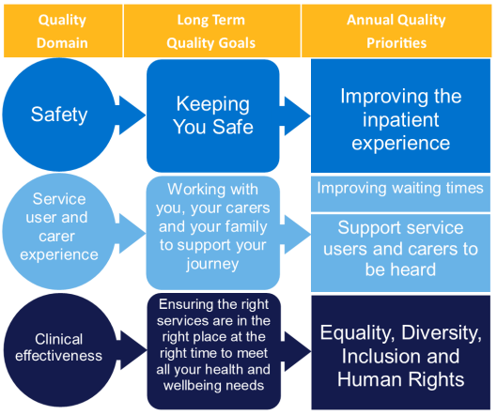
The Trusts Quality Priorities relating to improving the service user and carer experience are shown in figure 15 below. The overall aspiration of the Trust is to ensure that people with a mental illness or disability can access consistently good quality care and treatment services that meet their individual needs.

Figure 15 Trust Quality Priorities 2022/23

The quality priorities have a direct link to the quality of the estate, specifically around safety, quality and service delivery.

4.2.3 North East and North Cumbria Integrated Care Partnership Draft Integrated Care Strategy 2022

This document sets out the Integrated Care Strategy for the North East and North Cumbria Integrated Care Partnership (ICP), in the context of existing partnership working arrangements and the national guidance. The document is currently in draft stage.

The document sets out a number of estates related commitments that
- Consolidating services onto fewer sites to maximise the use of existing infrastructure and to promote joint working where it is in the best interests of service users
- Adopt ‘one public estate’ principles at Place level, including the potential to use shared estates to deliver jointed up clinical and care services
- Prioritising capital investment to effectively meet need
- Promoting opportunities to reduce cost within the estate and maximises capital
- Working from the ground up at neighbourhood, Place and local ICP level
- Support to Primary Care Networks and provider collaboratives to ensure well planned and prioritised capital investments.
The CNTW Estates strategy follows similar principals to this draft strategy and opportunities to deliver value for money with other ICP providers can be accommodated.

4.2.4 Clinical Business Unit and Corporate Services Feedback

The three Trust CBU’s and Corporate services have been involved in the development of this estates strategy, this includes an engagement session at CDT-B and discussions with teams to understand future needs. The themes they identified are listed below, some of the issues have been addressed through recent or on-going estates developments.

South
- Poor condition of Monkwearmouth Hospital older buildings
- Elements of the OPS for South Tyneside are based at Monkwearmouth
- Uncertainty over long term future / sustainability of Rose Lodge in its current location
- Poor medical staff accommodation and links to admin staff
- Community teams in Sunderland - teams are suggesting a need to merge / co-locate, in order to provide a better service and cost benefits, however the team configuration has not been evolved.
- Community transformation model needs to be reviewed in order to address shortfalls
- Poor accommodation for Psychiatric Liaison teams on acute hospital sites
- Brooke House - could it be a consideration to move it to Meadow View
- Meadow View is not considered suitable for a wide ranging decant ward
Central
- Community provision in the West end of Gateshead is considered poor
- Dryden Road needs to be upgraded
- Need more bookable space for group work
- Safe space for staff to see clients
- Accessibility for clients to attend community facilities needs to be considered for future developments
- Crisis team should be located on the SNH site
- Poor facilities for staff across most sites
- Poor accommodation for Psychiatric Liaison teams
- Older peoples beds need to be resolved on the CAV site as a priority following sale to University and impending site development
- Poor accommodation on the CAV site
- Benton House generally does not meet team needs and car parking is poor
North
- Trust is moving to a more specialist type of service in the Autism sector with increasing demand for bespoke packages of care
- The need for flexible / adaptable estate
- Future moves out of “main stream services” into specialist / challenging areas of care
- Homeworking - how can this be supported
- More robust accommodation will be required to cater for a challenging patient group
- Druridge on the SGP site is underused
- The client group on the SGP Village is becoming more challenging and consideration should be given to moving them to alternative accommodation - perhaps Druridge ward as it is empty
- Major redevelopment for Northgate is welcomed
- Not all services impacted by CEDAR have a plan to relocate the services
- They need greater CCTV coverage
West
- Future of Yewdale ward needs to be considered as it is in poor accommodation
- Carleton Clinic accommodation is poor- lack of en-suites, poor layouts,
- Overuse of mixed sex accommodation
- Layout of accommodation on the Carleton Clinic site is poor and issues with NCIC and shared space need to be resolved
- 136 Suite not fit for purpose
- Fragmented site at Carleton Clinic due to house building
- PICU closure with
Safer Care
- Lack of standardisation across the estate
- Provision of safe environments incorporating safety features varies between buildings, these safety features include:
  - CCTV
  - Seclusion room standards
  - Metal detection
  - En-suite doors
  - Bedroom door alarms
  - Nurse call
  - Standardised Staff Attack System
  - Patient monitoring
Corporate
- Location of corporate services – on hospital sites or off site
- Working from home model following COVID needs to be explored, and this may reduce need for space
- Outside space for recreational use is not fully utilised.
- Ventilation in some areas is reliant on windows that have limited opening, and this problem has been magnified due to COVID
- Need to focus on the environment

In summary the issues raised by the CBU’s and Corporate Services fall into a number of key themes:
- Focus on Quality
- Accessibility
- Bed Reductions
- Specialist Requirements
- Location
- Car Parking
- Future Proofing
- Safety
- Standardisation
- Robustness
- Standardisation
- Space use and having adaptable flexible space
- Being environmentally friendly

4.2.4 Green Plan

With climate change labelled the greatest threat to health in the 21st century by medical journal The Lancet, in March 2020 CNTW’s Board joined a growing number of NHS organisations in declaring a ‘climate and ecological emergency’.

The Green Plan sets out a number of Estates related actions that CNTW will achieve. Initial targets were set for March 2022; however, the plan will be updated on an on- going basis to reflect a new set of actions for working towards the key goals. These actions cover a wide range of topics and include:
- Reducing our own carbon emissions to net zero by 2040.
- Making the most of our green spaces for service users, carers, staff and local communities to enjoy, encouraging biodiversity and connection with nature.
- Minimising waste and inefficiency as much as possible.
- Ensuring we consider the social and environmental impact of any decisions we make.
- Working with our partner organisations to ensure a co-ordinated regional response to the impact of climate change.

4.3 National Strategies and Policies

In view of the extensive range of services provided by the Trust a significant number of National Strategies and Policies relate to our services, the most notable National Strategies and Policies underpinning the Trust’s strategic direction over the next five years, the key ones being as follows:

4.3.1 Mental Health Act – Draft Bill 2022

The government has published a draft Mental Health Bill for pre-legislative scrutiny, to modernise the Mental Health Act for the 21st century.
The draft Bill establishes that its proposals are expected to bring significant benefits to patients interacting with the MHA through increasing patient choice and autonomy over their treatment, ensuring they are treated with dignity and respect, improving inpatient therapeutic environments and promoting equality throughout the process.
The draft Bill proposes that further limits to the extent to which the Act can be applied to people with learning disabilities and autistic people, most notably by not permitting detentions under Section 3 where the patient in question does not have a co-occurring mental health condition that requires hospital treatment. This may impact on the services provided by CNTW.

4.3.2 The NHS - Five Year Forward View (2016)

During 2015/16, work began to lay the foundations for better, more responsive and accessible mental health services. The Immediate priorities for service redesign are:
- To increase access to specialist perinatal care
- To reduce the number of out of area placements for children, young people and adults through the provision of more care closer to and at home.
- To increase access to crisis, care liaison services in emergency departments and inpatient wards.
- Suicide prevention

The NHS - Five Year Forward View (2016) sets out a vision for the future of the NHS Services and articulates why change is needed, what that change might look like and how it can be achieved. It acknowledges that “one size does not fit all” and describes various models of care which could be provided in the future, defining the actions at local and national level to support delivery.
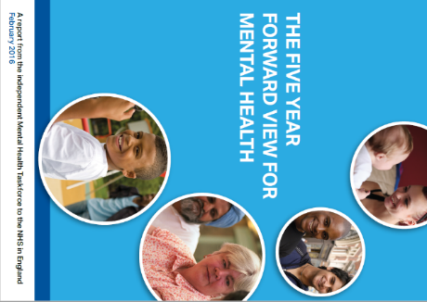
The Forward View covers areas such as disease prevention; new flexible models of service delivery tailored to local populations and needs; integration between services; and consistent leadership across the health and care system.

In terms of mental health, The Forward View recognises that physical and mental health are closely linked - people with severe and prolonged mental illness die on average 15 to 20 years earlier than other people.

The strategy states that the NHS must drive towards an equal response to mental and physical health and towards the two being treated together the ambition being to achieve genuine parity of esteem between physical and mental health.

4.3.2 NHS Mental Health Implementation Plan 2019/20 – 2023/24

This implementation plan followed the NHS Long Term Plan. The implementation plan sets out a number of priorities aimed at transforming mental health services towards a more integrated, population-level health systems which will support more localised and personalised responses to health inequalities across the prevention and treatment spectrum.
The core ambitions set out in the Implementation Plan are summarised in the table below.
Specialist Community Perinatal Mental Health
- Greater access to community services
- Maternity outreach clinics

Children and Young People’s (CYP) Mental Health

- Increased services and access to community teams
- 24/7 crisis provision
- Comprehensive 0–25-year-old offer that reaches across mental health services for CYP and adults
- Target of 95% CYP with eating disorders accessing treatment within 1-4 weeks depending on urgency
Adult Common Mental Illnesses
- Increase access to IAPT services
Adult Severe Mental Illnesses (SMI) Community Care
- New integrated community models for adults with SMI (including care for people with eating disorders, mental health rehabilitation needs and a ‘personality disorder’ diagnosis) spanning both core community provision and also dedicated services will ensure adults and older adults per year have greater choice and control over their care, and are supported to live well in their communities

Mental Health Crisis Care and Liaison

- provide crisis resolution and home treatment (CRHT) functions that are resourced to operate in line with recognised best practice, delivering a 24/7 community-based crisis response and intensive home treatment as an alternative to acute inpatient admission
Therapeutic Acute Mental Health Inpatient Care
- Deliver against STP-level plans to eliminate all inappropriate adult acute out of area placements
- The therapeutic offer from inpatient mental health services will be improved by increased investment in interventions and activities, resulting in better patient outcomes and experience in hospital. This will contribute to a reduction in length of stay for all services to the current national average of 32 days (or fewer) in adult acute inpatient mental health settings

Suicide Reduction and Bereavement Support
- Deliver against multi-agency suicide prevention plans, working towards a national 10% reduction in suicides by 2020/21. This includes working closely with mental health providers to ensure plans are in place for a ‘zero suicide’ ambition for mental health inpatients
Problem Gambling Mental Health Support
- There will be a total of 15 new clinics providing NHS specialist treatment for people with serious gambling problems. This will include piloting provision for under 18s
Provider Collaboratives (formerly ‘New Care Models’) and Secure Care
- All appropriate specialised mental health services, and learning disability and autism services, will be managed through NHS-led provider collaboratives over the next five years
- NHS-led Provider Collaboratives will become the vehicle for rolling-out specialist community forensic care

4.3.3 Closing the Gap: Priorities for essential change in mental health (2014)

The report highlights that people who use Mental Health Services, and those that care for them, continue to report gaps in provision and long waits for services. It also highlights that there is still insufficient support within communities and that there is as yet little impact on the enormous gap in physical health outcomes for those with mental health problems.
The report identifies 25 aspects of mental health care and support where government, along with health and social care leaders, academics and a range of representative organisations, expect to see tangible changes in the next few years. The impact of these changes is not fully understood, however as an organisation the Trust recognises the need for change and will react accordingly when service change is required.
4.3.4 Transforming Care for People with Learning Disabilities - Next Steps (2015)
The Government and leading organisations across health and social care are committed to transforming care for people with learning disabilities and / or autism who have a mental illness or whose behaviour challenges services. The report produced by Sir Stephen Bubb outlines how to accelerate the transformation of these services including developing a clearer model for health and care services, describing outcomes and associated performance indicators.

As the provider of a comprehensive range of services for people with learning disabilities and / or autism the Trust is working with stakeholders to review and, where appropriate, reshape services.

Guidelines reflect on the investigation into the abuse at Winterbourne View and other similar hospitals and the commitment to transform care and support for people with a learning disability and/or autism who display behaviour that challenges, including behaviour that can lead to contact with the criminal justice system. This is focused on building up community capacity and reducing inappropriate hospital admissions.
4.3.5 Learning disabilities and behaviour that challenges: service design and delivery. NICE guideline [NG93]: March 2018
This guideline covers services for children, young people and adults with a learning disability (or autism and a learning disability) and behaviour that challenges. It aims to promote a lifelong approach to supporting people and their families and carers, focusing on prevention and early intervention and minimising inpatient admissions.
The guidance is clear that, children, young people and adults with a learning disability and behaviour should only be admitted to inpatient units if assessment and care planning show that their needs cannot be met safely in the community, and all possibilities for doing so have been considered and exhausted. This may therefore impact on the provision of services offered by CNTW.
4.3.6 Lord Carter: Review into Unwarranted Variations in Mental Health and Community Health Services: May 2018
This review followed a similar piece of work which looked at the acute care sector. The report made a number of findings relating to estates and facilities management:
- Of the £1.3 billion spend per year by mental health and community trusts there was significant variation in the running costs per square metre, from about £30 to over £230, and in the use of space.
- There is scope for trusts to rationalise their estate, building on good practice demonstrated by a number of trusts across the sectors, and in line with ongoing work in STPs. One trust found it could dispose of 14% of its properties.
- The review found that on average 3.7% of space in the community and mental health sectors is left empty, with a further 2.2% underused. In terms of leasing property, the report recommends that NHS Property Services and Community Health Partnerships arrangements should be reviewed.
- NHS Improvement will provide a more comprehensive set of benchmarks for the sectors, and trusts should review their estate to identify opportunities for consolidation and rationalisation.
- NHS Improvement will also review the current arrangements for estates leased from property companies.

The Estates Strategy for CNTW must therefore be mindful of the findings of the Carter review recognising the value of the Estate and the impact on positive patient outcomes along with the challenges of ensuring estate is efficiently operated and delivers value for money..
4.3.7 NAYLOR Report NHS Property and Estates - Why the Estate matters for Patients: 2017
The Naylor report followed a high-level review considering the options open to the NHS to achieve best value, from NHS property, in alignment with the delivery of the vision set out in the 5YFV.
The Naylor report was clear that the “NHS estate is one of the key enablers to change in the health system and directly contributes to the delivery of high-quality healthcare to patients”. However, it also acknowledged the general consensus that the current NHS capital investment is insufficient to fund transformation and maintain the current estate. It was estimated that in England the capital requirements might total around £10bn, with a conservative estimate of backlog maintenance at £5bn and a similar sum likely to be required to deliver the 5YFV. The view was that this could be funded through property disposals, private capital (for primary care) and from HM Treasury. However, the NHS needs to develop a robust capital strategy to determine the final investment requirements through the STP plans. This review was predicated on widely accepted assumptions that the NHS estate is not currently configured to maximise benefits for patients or taxpayers. It considered:
- the size of the opportunity – building on the Carter Report on efficiency
- the mix of incentives and sanctions required for delivery
- how to strengthen capacity and capability across the system
The Estates Strategy for CNTW must therefore be mindful of the findings of the Naylor Report, recognising the value of the Estate and the impact on positive patient outcomes along with the challenges of funding capital investment and the need to innovatively look to extract value out of the residual estate including the sale and disposal of surplus estate.

4.4 Local Health Economy Drivers

On a local basis there are a number of factors that are driving the current estates development, these include:
- Former CCG Strategy for Newcastle & Gateshead Adult Acute Mental Health Inpatient Services
- Strategy for Adolescent Medium Secure Services
- Strategy for Adult Medium Secure Services
The above strategies resulted in the creation of the current CEDAR program which will deliver against each of the above.

4.5 Cumbria Transfer of Services

The transfer of clinical services and the creation of CNTW took place in October 2019.
North Cumbria became another CBU within the Trust’s portfolio of services. The Locality would focus on the population base and have direct links with its local statutory and non-statutory partner organisations.
At the time of transfer the Estate at Cumbria was in need of significant short- and medium-term investment. Following on from the merger some investment has taken place on the Carleton Clinic and Yewdale sites to improve inpatient environments.
Future capital expenditure is required on the estate, these areas and associated capital expenditure (based on 2018 values) are as follows, note these are indicative dates and costs:
- Medium term - relocation of services such as Yewdale Ward to Carleton Clinic
£4M
- Long term redevelopment of the estate to bring it in line with the accommodation provided by the NTW Trust - this will be dependent on a range of factors
£40-50M

4.6 Summary

This section has looked at the influencing factors shaping healthcare provided by the Trust, both internally and externally. What is apparent, is that the Trust’s service strategy is for the delivery of high-quality community and in-patient services, this requires appropriate facilities which are fit for purpose and support the clinical care model.
It has been shown in section 3, through both internal and external assessment that some services are currently provided from facilities that do not meet the high standard met in other parts of the organisation and addressing these issues is considered as a priority for the Trust.
A summary of the key issues that need to be addressed through Estate modifications are as follows:
- The Older Peoples Service on the CAV site needs to be considered as a top priority and funding will have to be secured to facilitate its relocation
- The work associated with CEDAR needs to be completed in order to realise the benefits across a number of sites and services.
- The Ferndene phase 3 works, incorporated in the 2023 business case which sets out the model for future service delivery is considered a priority and funding will need to be secured to facilitate its implementation.
- Challenges of having in-patient accommodation currently located on non CNTW Hospital sites, specifically Yewdale present an opportunity to make improvements, however funding will need to be identified to facilitate implementation.
- Consideration to move Rose Lodge onto a mainstream hospital site, funding will need to be secured to facilitate its implementation.
- The Trust’s service strategy focuses on the delivery of planned care services for patients who do not need in-patient care but need more intervention in a community setting. This will potentially involve an increase in activity undertaken in the community and the creation of more community consultation space, however this could be provided by partner organisations as part of the UEC program in 22/24.
- An increasing problem on some sites to meet car parking demands.
- Providing appropriate Doctors and administrative staff accommodation
- There is a need to invest in improving the safety of patient environments
- There is a need to invest in delivering against the Green Plan, specifically around decarbonisation, building adaptation for climate change and improving biodiversity and how we use our green spaces.

5.0 How Do We Get There? Estate Developments 2023-28

5.1 Introduction

The extensive investment in the estate over the last 17 years has resulted in significant improvements to the estate which have benefitted both patients and staff, however as buildings get older and services evolve there is an on-going need to continue with an investment plan.

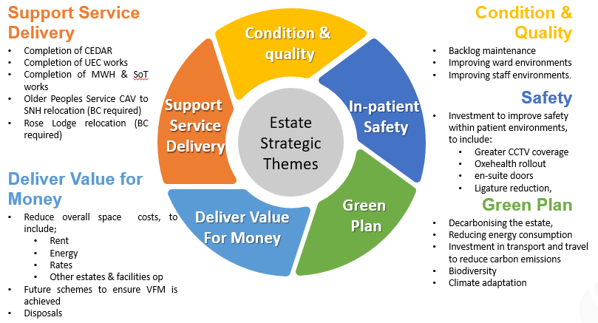
Based on a review of the existing Estate (Section 3) and the internal and external strategic drivers that impact on the services provided by the Trust (Section 4) it is clear that on-going investment and development of the estate is required. These requirements fall into five common strategic themes which are illustrated in figure 16 below, showing some of the detail behind each of the themes, and these will be detailed in the following sections:
Figure 16 Estate Strategic Themes

5.2 Completion of Major Developments Currently Underway

A number of work programs and estates initiatives which form part of the key Estates changes for the next 2 years have in part been developed prior to the writing of this strategy document, specifically.

Care Environment Development and Re-provision (CEDAR)

The work associated within the following areas has been brought together under one program known as CEDAR
- New Care Models for Adult Secure Services
- NHS England National Adolescent MSU review
- Newcastle & Gateshead Delivering Together
This scheme will result in adult secure services located on a single site at Northgate Hospital and young people’s secure services relocated onto Ferndene. The new facility at Northgate will be occupied in the spring of 2023 (see figure 17 below). These moves will enable site rationalisation, improved service productivity, a greater critical mass of clinical expertise and expansion to enable repatriation in line with national strategy and the Mental Health 5 Year Forward View.
Figure 17 Artist’s impression of the new MSU at Northgate

Following the transfer of secure beds from Bamburgh Clinic, the building will be extended and upgraded to allow for the adult acute admission facilities from the CAV site to move into the vacated space in Bamburgh Clinic. This will result in all acute adult in-patient beds being located on the one site. The expected move from the CAV site to Bamburgh Clinic is the summer of 2024.
The development will also free up space on the St Nicholas Hospital site, specifically Alnwood and Lennox wards, which could be utilised as an option for the relocation of the Older Peoples in-patient services from the CAV site.
The Ferndene element of the CEDAR project has been subject to a recent review (Nov 2022) and approval has been given modify the clinical service delivery as identified in the original CEDAR Business Case. The original model known as the “Integrated Model” would see the wards reduce from 4 to 2, delivering; 14 GAU beds (10 MH and 4 LD), 4 PICU beds and 6 LSU beds (3MH, 3LD). When implementing the integrated model, it quickly became apparent that there is added clinical complexity and safeguarding challenges when managing this complex and vulnerable client group from different pathways in the same environment. The review recommended a different approach with the preferred option to create 5 discrete clinical areas that take into account diagnostic criteria, clinical presentations, and security levels, these being: MSU – 7 MH beds (a reduction of 7), GAU – 10 MH beds, PICU – 4 beds, LSU – 3 MH beds and Specialist LD & Autism – 7 beds. This work has been incorporated into a Phase 3 package of work which will deliver against this revised business case, and it is expected the work will be complete in the spring / summer 2024.

The CEDAR development will deliver against each of the five strategic themes and at the Northgate site will remove a range of buildings that have high levels of backlog maintenance are of a poor quality and poor functional suitability.

Monkwearmouth Hospital and South of Tyne Developments

Demolition of some of the older parts of Monkwearmouth Hospital has occurred (Dec 2022) and redevelopment of the site is underway and will be complete early 2024. The development will also see the vacant site at Boldon Lane Clinic, demolished and either disposed of or rebuilt as a new base for the CYPS service which is currently utilising high cost rented accommodation at Cleadon Park.
The South Tyneside Older Peoples Service that was previously located out of area at Monkwearmouth Hospital will either return to MWH or be relocated into alternative rented accommodation or a refurbished Alexandra Lodge which is adjacent to Rose Lodge.

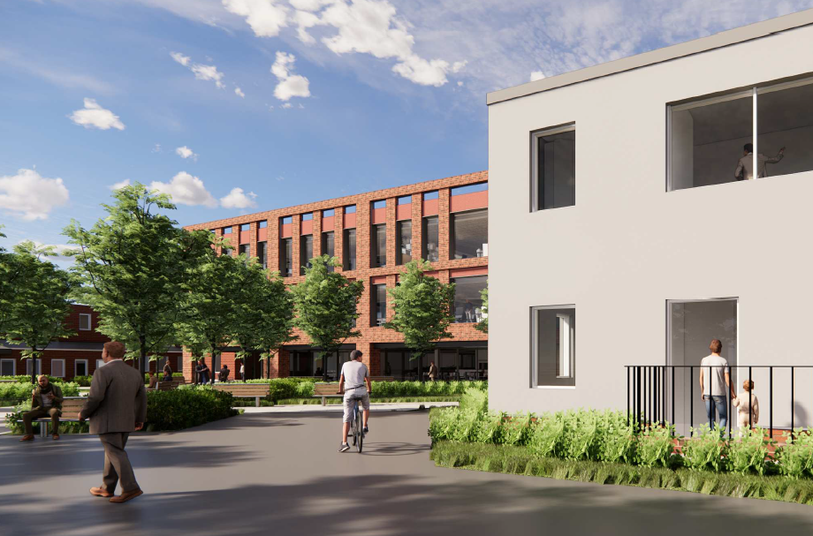
An artist’s impression of the redeveloped Monkwearmouth Hospital is shown in figure 18 below.

Figure 18 Artist’s impression of the redeveloped Monkwearmouth Hospital

The Monkwearmouth and South of Tyne Developments will deliver against each of the five strategic themes and will remove a range of buildings that have high levels of backlog maintenance are of a poor quality, poor functional suitability and had associated safety issues related to structural deficiencies and asbestos contamination.

Benton House

Benton House in Newcastle is a leased community property which has been utilised by the Trust for almost 20 years. In 2022 the Trust agreed with the new Landlord to extend the lease and occupy the whole of the building. The building has been refurbished in order to accommodate other teams, and this work will be complete in early 2023 (see figure 19 below).
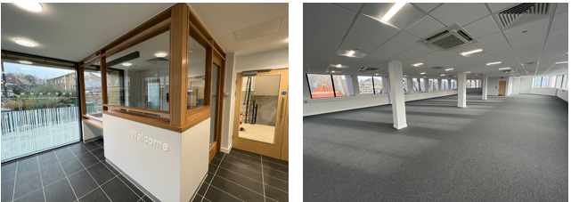
Figure 19 Refurbished space at Benton House

The additional space will provide an opportunity for services to relocate to Benton House. Work is currently underway with the CBU’s to identify and finalise those teams where relocation will deliver benefits, and it is anticipated this will result in the building being fully occupied by the summer of 2023. The teams currently being considered for relocation include the community service based in the Molineux centre who are in high cost rented accommodation, the CYP CEDS North of Tyne (formerly EDICT) service who are looking to consolidate into a single location and the creation of a CYPS crisis team assessment centre which forms part of the UEC bid.
The Benton House scheme will deliver against a number of the strategic themes, in particular improvements to the quality and suitability of the estate following refurbishment, the delivery of cost savings associated with relocation from the Molineux Centre and is supporting service delivery through the relocation of teams.

Hadrian Unit – Carleton Clinic

The Hadrian Unit was a 22-bed mixed sex adult acute in-patient ward. The unit had a significant number of environmental and safety shortfalls, and these are being addressed as part of a comprehensive upgrade. The original plan was to reduce the beds to 20 and provide bedrooms with en-suite facilities along with other environmental and safety improvements and return the ward back to a mixed sex unit. During the upgrade the service moved the male patients into the former PICU unit and the CBU have decided they will operate this split service moving forward. The upgrade has been modified and now a number of bedrooms will not be upgraded and will instead be mothballed.
There is an opportunity to look at the bed model on the Carleton Clinic site to see if it can be used as a single site for North Cumbria bed-based services and facilitate the relocation of the Yewdale beds.
The Hadrian Unit upgrade will deliver against a number of the strategic themes, in particular improvements to the safety, quality and suitability of the estate following refurbishment and supporting service delivery.

Urgent and Emergency Care Works

It was identified nationally that there are MH priorities in the UEC pathway. Funding was made available for schemes that would relieve pressure on the pathway, by either:
  - Diverting people away for Emergency Departments
  - Improving experience in Emergency Departments
  - Allowing for timely transfer to an appropriate MH service
Examples of
  - Safe spaces and sanctuaries (including Health Based Places of Safety)
  - Dignified spaces in or near EDs, this may include adapting existing spaces or bays
  - Dedicated mental health response vehicles to add capacity to ambulance services and divert people from ED.
  - Crisis beds or intermediate step up/down services to support flow
  - Specific types of MH inpatient beds to address gaps in certain areas
The Trust was successful in a number of bids to be delivered in 22/23 and 23/24, these are summarised as follows:

Cumbria

This scheme seeks to expand the capacity of the current S136 facility to two and improve the standard of the suite in terms of patient safety and experience. It will reduce the frequency of the inappropriate holding of patients in police facilities and emergency departments. It will also enhance the layout and facilities within the suite to support de-escalation, improve safety for patients and staff and promote earlier recovery.
The works will be carried out on the Acorn Ward and will require some enabling works to be undertaken to relocate the LD patients back into Edenwood.
The value of the scheme is £3.1M

Newcastle and Gateshead

Upgrade the 136 Suite located at St Nicholas Hospital.
The value of the scheme is £65k
Create a CYPS Crisis Team assessments on the ground floor of Benton House with a separate entrance into the building to allow for separation of children and adults as they enter the building.
The value of the scheme is £150k

Northumberland

Upgrade the 136 Suite located at St Nicholas Hospital.
The value of the scheme is £30k

System Wide – Non CNTW

In addition to the bids submitted by CNTW, a number of partner organisations have submitted bids and are carrying out works to provide a range of facilities to support patients. These schemes include the provision of crisis cafes, crisis housing, safe spaces, and autism cafes.
The UEC works will deliver against a number of the strategic themes, in particular improvements to the quality and suitability of the estate following refurbishment, and in supporting service delivery and delivering value for money by ensuring patients in crisis are seen in the most appropriate setting.

5.2.2 Completion of Other Minor Schemes in 22/23 & 23/24

At the time of writing this strategy a number of other smaller schemes are underway in both this and the next financial year, these are identified in the capital program and are shown in table 21 and 22 below. Collectively these schemes will contribute to the five strategic themes.

Major Schemes | 22/23 | 23/24
Major Schemes | £000 | £000
CEDAR | 24,868 | 3,255
Additional CEDAR Schemes | 2,260
Approved CEDAR Increase | 2,614
Hadrian Unit Carleton Clinic | 3,609
Monkwearmouth / Boldon Lane Clinic | 800 | 2,200
Ferndene - Phase 3 | 1,000 | 3,300
Total | £35,151 | £8755
Table 21

Other Developments | 22/23 | 23/24
Other Developments | £000 | £000
Eating Disorders Service, Newcastle |  | 250
Park Lane, Cumbria - Phase 2 | 210
Tweed Courtyards |  | 222
Metal Detectors | 100
Oxehealth Implementation | 259 | 541
En-suite doors Implementation | 100 | 100
Yewdale Improvements & Roof Repairs | 197
Newton Enhanced Care Area | 8
Blue Bell Court Ph2, SGP | 24
Blue Bell Court/Kinnersley, SGP CCTV | 6
Elm House – Staff Room | 4
SGP – Anti-Barricade Doors | 9
Woodhorn, SGP – Low Stimulus Soft Room | 10
SNH - Absence line moves | 80
Hopewood Pipe Replacement | 150
Storage/Food bank | 150
Nurse Call | 100 | 100
Total | £1,407 | £1,213
Table 22

5.3 Targeted Investment to deliver against Strategic Themes

There is an allocated capital investment program for the next 5 years which delivers against the strategic themes, this is shown in table 23 below and described in the following sections.

Scheme | Annual allocation £000
CCTV | 300
Equipment | 100
Backlog/Carbon Reduction/Sustainability | 2,000
Safety/Clin Environment Safety | 500
Minor under £25k schemes | 200
Refurbishment patient areas | 500
Refurbishment Non-Inpatient Areas | 500
Internal Fees | 400
Total | 4,100
Table 23 Annual Capital Allocation- 5 Year Forward plan

5.3.1 Investment in Delivering the Green Plan

In Section 4 of this strategy, reference is made to the Trusts Green Plan which was developed following the Trusts declaration of a Climate Emergency. The Green Plan sets out a number of Estates related actions that CNTW will need to achieve, which includes decarbonisation, improving biodiversity and ensuring we make adaptations to buildings to allow for climate change.

A high-level decarbonisation assessment of the Trust estate was carried out by an external consultancy in 2022, the data from this study coupled with other site intelligence identifies that the costs of decarbonising the estate will be up to £30M.
Full decarbonisation is unlikely to be achievable with current technologies, therefore the strategy should be to invest in schemes which reduce both energy consumption and carbon emissions and also to increase the proportion of energy consumption generated from renewables.
Investment is not limited to decarbonisation but also in improving the biodiversity of our sites and adapting buildings and sites to cope with climate change.

What needs to be done and when?
- A detailed decarbonisation plan needs to be developed on a site-by-site basis to determine what is feasible in respect of reducing carbon emissions. Plans should take into account the construction elements of the buildings, configuration of engineering services, building use and if there are any opportunities to partner with other organisations who we can partner with on area wide initiatives. This should be completed by the end of 2023 and will need to be reviewed on an on-going basis.
- Invest in the short-, medium- and long-term decarbonisation schemes addressing those areas where elements of the Green Plan can be delivered, in particular reducing our own carbon emissions towards net zero by 2040. Focus will be given to:
  - A move away from steam heating systems on the St Nicholas Hospital site
  - Maximise potential for solar PV generation
  - Improvements to building and engineering services insulation levels
  - Optimising control of energy using equipment including heating systems
  - Full implementation of LED lighting with associated smart controls
  - Ongoing awareness campaigns for staff in energy efficiency
  - Maximise suitable use of renewable heating technology such as air source heat pumps.
  - Enhance the Electric Vehicle charging infrastructure to facilitate staff changing to EV’s and their adoption for Trust vehicles.
- Making the most of our green spaces for service users, carers, staff and local communities to enjoy, encouraging biodiversity and connection with nature. This will require a detailed biodiversity plan to be developed on a site-by-site basis. This should be completed by the end of 2023 and will need to be reviewed on an on-going basis.
- Invest in the short-, medium- and long-term biodiversity schemes addressing those areas where elements of the Green Plan can be delivered where biodiversity can be implemented. Focus will be given to:
  - Transforming areas of outdoor space into across the main sites into wildflower meadows.
  - Develop wellbeing gardens across
  - Create outdoor walking routes across the main sites
  - Explore opportunities to utilise the large field at SNH in a way that promotes biodiversity

- Climate change is posing a risk from weather changes that may impact on the Trusts ability to deliver services, in particular risks from flooding and extreme weather. A detailed site and building adaptation plan need to be developed to determine what is required to ensure our estate is suitable for use in future years as a result of climate change. This should be completed by the end of 2023 and will need to be reviewed on an on-going basis.
- Invest in the short-, medium- and long-term adaptation schemes addressing those areas where the risk and need is greatest. Focus will be given to:
  - Reducing flood risk
  - Mitigating against high temperatures in clinical areas without resorting to installing cooling, unless absolutely necessary.

The above areas for action is not an exhaustive list and it is acknowledged that there is a lot of work to do in terms of developing a detailed decarbonisation plan.
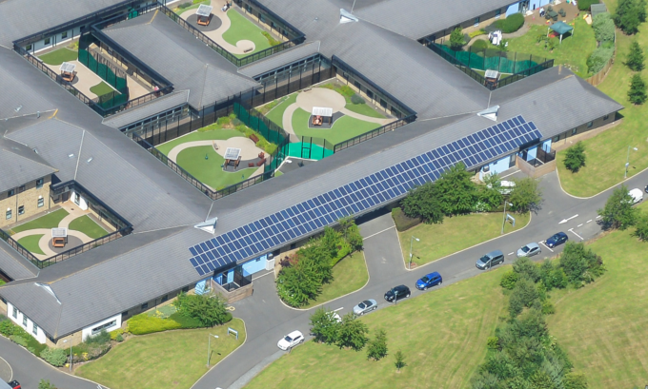
A capital allocation of £1500k per annum from 23/24 onwards has been identified in the capital program. The management of this budget and the prioritisation of schemes will be done via the sustainability, waste and transport committee (SWAT) with oversight on expenditure managed through the Capital Group meeting. Progress on carbon reduction and general delivery against the Green Plan will be monitored via Trust Leadership Team and also reported to RBAC.

5.3.2 Investment in Condition and Quality and Management of Backlog

In Section 4 of this strategy, reference is made to the Trusts Strategy and other drivers that emphasise the need to ensure the condition and quality of the Estate is maintained at acceptable levels. This is reinforced by the CQC Fundamental Standards which state that “the places where you receive care and treatment, and the equipment used in it must be clean, suitable and looked after properly”.

Over the last 17 years the Trust has invested substantially in improving the estate and eradicating areas of poor condition and quality, however as the Estate ages it is necessary to maintain investment to ensure standards are maintained. Section 3 of this strategy identifies through elements of the six-facet survey and the PLACE inspections that there are pockets of estate where standards could be improved.

The backlog maintenance position is intrinsically linked to poor quality estate. The Trust has managed its backlog position over the last 17 years primarily through asset replacement supported by a targeted investment program. This Strategy has been usefully employed by the Trust for a number of years for example the replacement of St Georges, Hunters Moor, Prudhoe and Cherry Knowle Hospitals and more recently with the development at Northgate Hospital.

Currently the main pockets of backlog maintenance have been at Northgate and Monkwearmouth Hospitals, and this has been addressed through the current investment program. There are a small number of assets that account for the majority of the backlog position, and these include site steam infrastructure at SNH, Collingwood Court at SNH, Meadow View and Wellfield Clinic at Hopewood Park, Carleton Clinic and Portland Square in Carlisle.

Without investment the backlog maintenance position will continue to grow year on year, increasing operational risks and leading to a decrease in the quality of the estate. In order to address the backlog maintenance position a targeted approach of investment is required over the next 5 years and an allowance of £0.5m/annum has been made in the capital program. In future years, as assets begin to age, the requirement to invest in asset replacement will grow and appropriate capital allocation will be required to prevent the backlog position growing.

In order to maximise value from the capital available, the Estates Department will submit annual plans for approval by the Trust for specific investment in backlog maintenance schemes.

What needs to be done and when?
- Continued investment across the whole Estate to ensure those areas that are currently rated in condition C/D are managed to ensure their condition is maintained to those standards and does not deteriorate – this is a continuous process
- Invest in the short-, medium- and long-term schemes addressing those areas where improvements can be made within the capital allocation.
- Target investment in backlog maintenance reduction

A capital allocation of £1.2M per annum from 23/24 onwards has been identified in the capital program for minor schemes under £25k, refurbishment of patient and non-inpatient areas. The management of this budget will be via the Capital Management Group. A further £0.5M per annum from 23/24 onwards has been identified in the capital program for backlog maintenance. The management of this budget will be via NTWS and reported into the Capital Management Group.

    - Investment in Patient Safety
In section 4 of this strategy document the case for prioritising patient safety is made clear. The Trust needs to provide facilities that are safe and minimise the opportunity for harm to be caused and Facilities need to comply with legislation and CQC requirements. There are currently a number of schemes that are in progress listed in the section below.

What needs to be done and when?
- Continued investment across the whole Estate to ensure those areas that are currently rated as safe are maintained to those standards, this is a continuous process
- Invest in the short-, medium- and long-term schemes, addressing those areas where safety can be enhanced, a number of schemes are underway and other safety improvements have been identified, in particular:
  - Replace en-suite doors within inpatient wards that are deemed to present a ligature risk to that patient group. This will require circa 500 en-suite doors to be replaced. This work is included in the current capital program and will be completed in the 23/24 FY.
  - Extend the roll out of nurse call systems to those wards where it is deemed necessary affecting around 500 beds. This work is in part included in the current capital program.
  - Extend the roll out of CCTV on wards and grounds. This will cost circa £1.6M plus an on-going revenue. There is an on-going capital allocation to address CCTV needs.
  - Standardise the seclusion rooms to increase the robustness of the building fabric. This will affect 37 seclusion rooms at a cost of circa £1.8M
  - Roll out Oxehealth. For 600 bedrooms this will cost circa £850k plus an on-going revenue. This work is included in the current capital program and will be completed in the 23/24 FY.
  - Metal detection to all wards and S136 Suites. This will cost circa £700k. This work is included in the current capital program and will be completed in the 23/24 FY.
  - Standardise wash hand basins in en-suite areas to remove a potential ligature issue associated with the drain size – cost circa £500k
  - Safe window design – to install circa 300 windows to create a safer solution – cost circa £1M
  - Standardise staff attack systems to one system in order to improve operational reliability and safety, cost circa £300k
  - Review access control systems with the aim of improving operational reliability, increasing access and reducing impact of lost keys,

The above list is not exhaustive, it is also the case that safety improvements can be identified following inspections, learning from incidents and the availability of new technology.

A capital allocation of £800k per annum from 23/24 onwards has been identified in the capital program. The management of this budget and the prioritisation of schemes will be done via the Clinical Environmental Safety Group with the work undertaken by NTWS.

5.3.4 Supporting Service Delivery (Funded and Unfunded Schemes)

In section 4 of this strategy the case for supporting service delivery is clear. The Trust needs to provide facilities that functionally suitable and in the right location in order to provide an efficient and high-quality service. There are currently a number of schemes that are in progress which will improve service delivery.

There are also a number of schemes which have been identified by the Trust as being a priority, but where no funding is in place. These schemes include the relocation of the OPS service from the CAV site and the relocation of Rose Lodge onto a main hospital site, the options for both these schemes are detailed as follows:

Older Peoples Service (Unfunded)

The CNTW Older Adult In-Patient, Community & Day Services in Newcastle, are currently located at the Centre of Aging Vitality (CAV) which is owned by Newcastle University and leased to CNTW.
The current lease expires at the end of March 2023; however, assurances have been sought from the University that these service can remain on site until Autumn 2024.
There have been on-going discussions across the Newcastle system, around the long-term vision for the Older Adult services in Newcastle. One option being the development of an Integrated Well-being Hub on the CAV site, which would include services from CNTW, Newcastle Hospitals, Local Authority and independent Sector. The vision of what this Integrated Hub would look like and how it would function has evolved over time and somewhat digressed from the initial scope and plans. Rising capital requirements and access to capital funding for the overall Integrated Hub project has proved challenging, this and other factors have resulted in a delay on the project, and it is now unlikely that the original planned timescales of this project, will be delivered by 2026.

CNTW have therefore scoped out alternative options to bring the Older Adult Services onto the St Nicholas Hospital site and ensure in-patient and community services remain co-located. This supports a 1 site model for Central Locality in-patient services, similar to that in other localities. There are two options in the draft business case:

- The short to medium term proposal is to The Ashby, Lennox and Wilton wards are currently occupied by Children’s Services, and these services are due to relocate to Ferndene in May 2024. Work would commence immediately upon vacation, and it is envisaged that this work would take 12 months to complete, which would be complete by May 2025.
- This option would result in the in-patient services remaining on the CAV site for potentially a further 8 months, after the lease extension expires in Autumn 2024. This would therefore need to be renegotiated with the University.
- The capital cost of this option is circa £5.5M
- The long-term proposal, which is the preferred option should funding be available, is for a purpose new build development on the SNH site, where Collingwood Court and Stephenson Court are located. This would be for in-patient services and Community Team staff base, and Day Services would move into Keswick under this option. However, the funding required for this financial and time restrictions around this proposal.
- This option would result in the in-patient services remaining on the CAV site for at least 12 months, after the lease extension expires in autumn of 2024. This would therefore need to be renegotiated with the University.
- The capital cost of this option is circa £20M

Rose Lodge (Unfunded)

Rose Lodge is a learning disability specialist assessment and treatment inpatient unit based in Hebburn, South Tyneside. Rose Lodge has 10 beds providing acute assessment and treatment by a multi-disciplinary team.
The service has voiced concerns over the isolation of the service and that they would benefit from being located on a main site.
A business case would be required to develop the options, including what happens to the Rose Lodge site. A new unit on a hospital site would cost around £8M and there is no available capital funding in the current capital program.

Yewdale to Carleton Clinic Consolidation of Services (Unfunded)

The Yewdale ward is a 16-bed mixed sex standalone unit in the West of North Cumbria based at Whitehaven in the West Cumberland Hospital. Should the CBU wish to consolidate services onto a single site this can be achieved at Carleton Clinic.
The existing accommodation would need investment to create a circa 17 bed male ward on Hadrian by continuing with the bedroom upgrades and by extending Rowanwood by circa 5 beds a 15-bed female ward can be created. This work would cost around £3M and there is no available capital funding in the current capital program.

5.4 Land sales and asset disposals
At its formation in 2006 the Trust had significantly more land than it required to undertake its clinical functions. This allowed for the rationalisation of the estate which led to significant capital receipts from disposals which has then been reinvested in the estate - notably on the autism project at Northgate. In addition to the surplus land, the Trust has also disposed of buildings which were no longer strategically required for the delivery of clinical services or for staff accommodation.
This strategy of land and space rationalisation will continue, and known plans are detailed below.

St Georges Park

The Trust owns a parcel of land to the North of the existing St Georges Park Hospital. This land is surplus to the needs of the Trust and is located on the former hospital site that is currently undergoing extensive development for residential housing. The intention is to sell this for residential development.
It is intended this sale will be completed in 2023 and is estimated to generate a capital receipt of £3M

Northgate

The Trust disposed of a large part of the Northgate Estate in 2014 for residential housing development. Further retraction from the site has resulted in the opportunity to dispose of more land and this will be done as part of the wider site redevelopment under the CEDAR program of works. It is intended this sale will be completed in 2023 and is estimated to generate a capital receipt of £7.8M

Property Disposals

The Trust has a number of smaller properties which depending on a range of circumstances have the potential to be sold or developed for on-going Trust use, these include:

Other Potential Asset Sales

Boldon Lane Rose Lodge (subject to service relocation)
Hillview Clinic Alexandra Lodge (packaged with Rose Lodge)
The Grange Lobley Hill Clinic

Each disposal will be the subject of an individual business case which will ensure that best value is achieved, values will be determined at the time of the sale.

5.5 Site Development Plans
A number of the sites across the Trust have some form of development requirement which has been and these cover a wide range of issues and In order to understand these requirements, site development plans have been developed to illustrate the opportunities and challenges on a site by site basis (see figures 20 - 28 below).
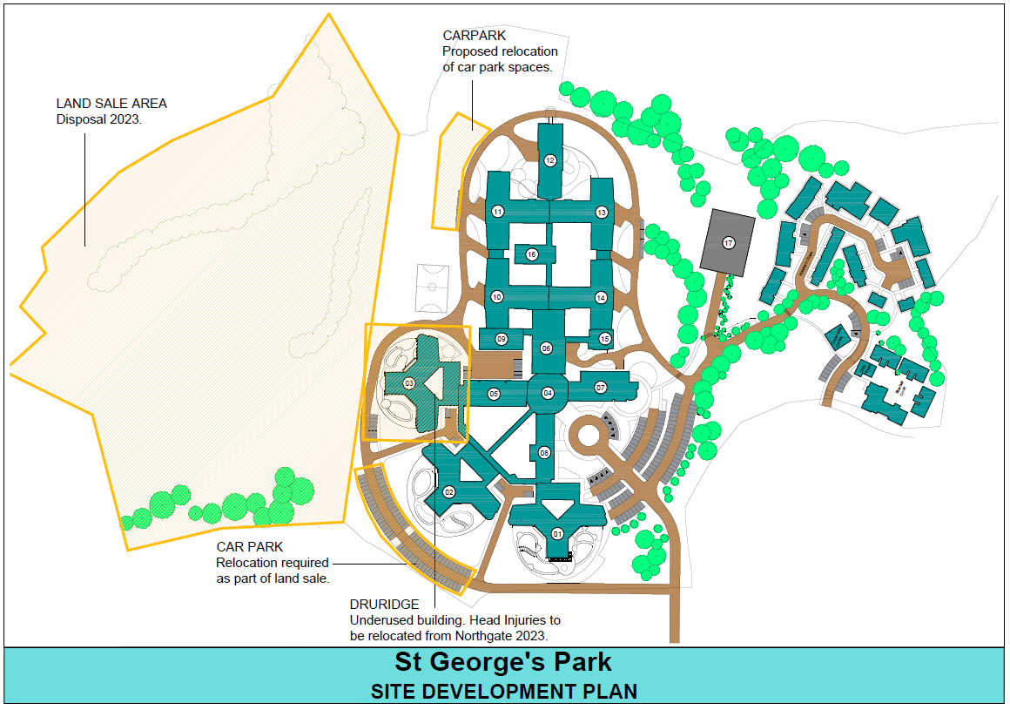

Figure 20

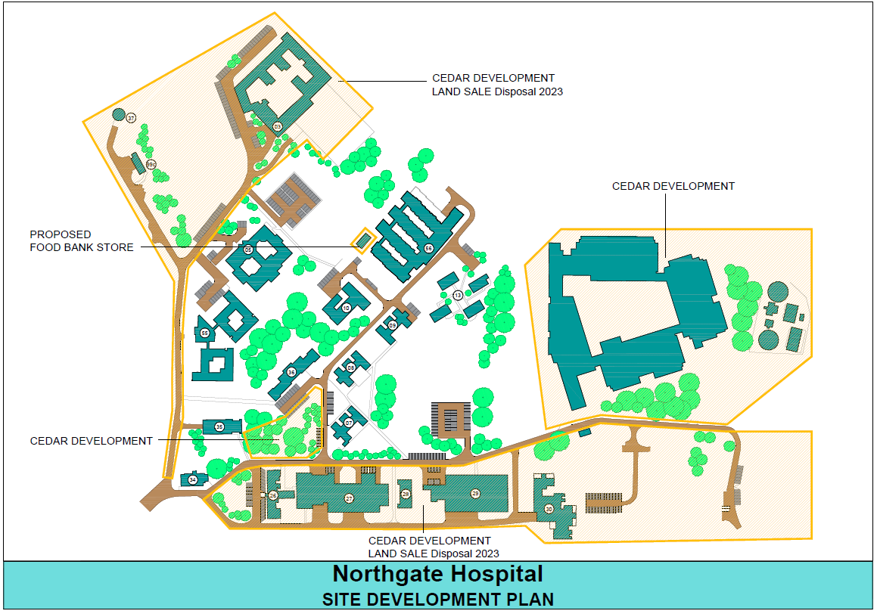

Figure 21

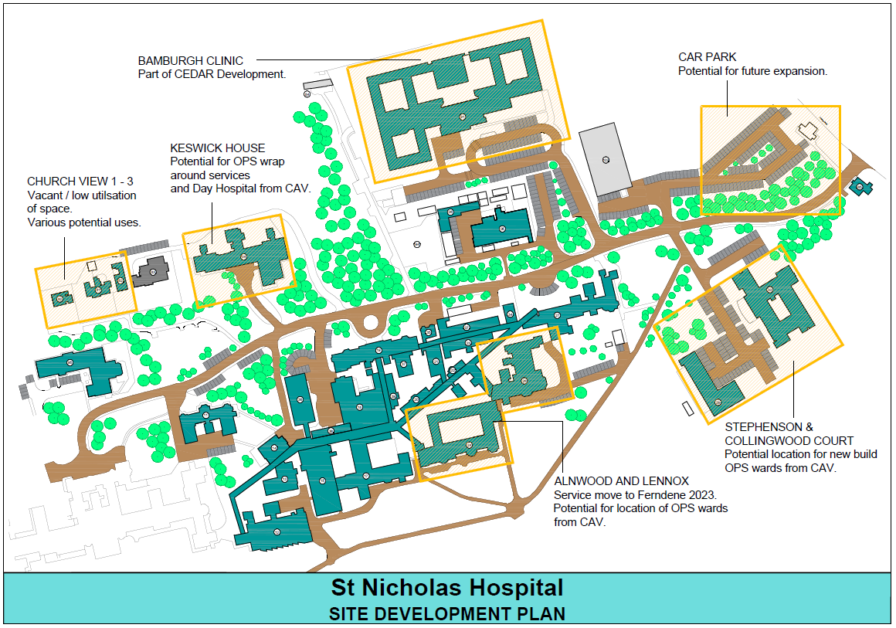
Figure 22

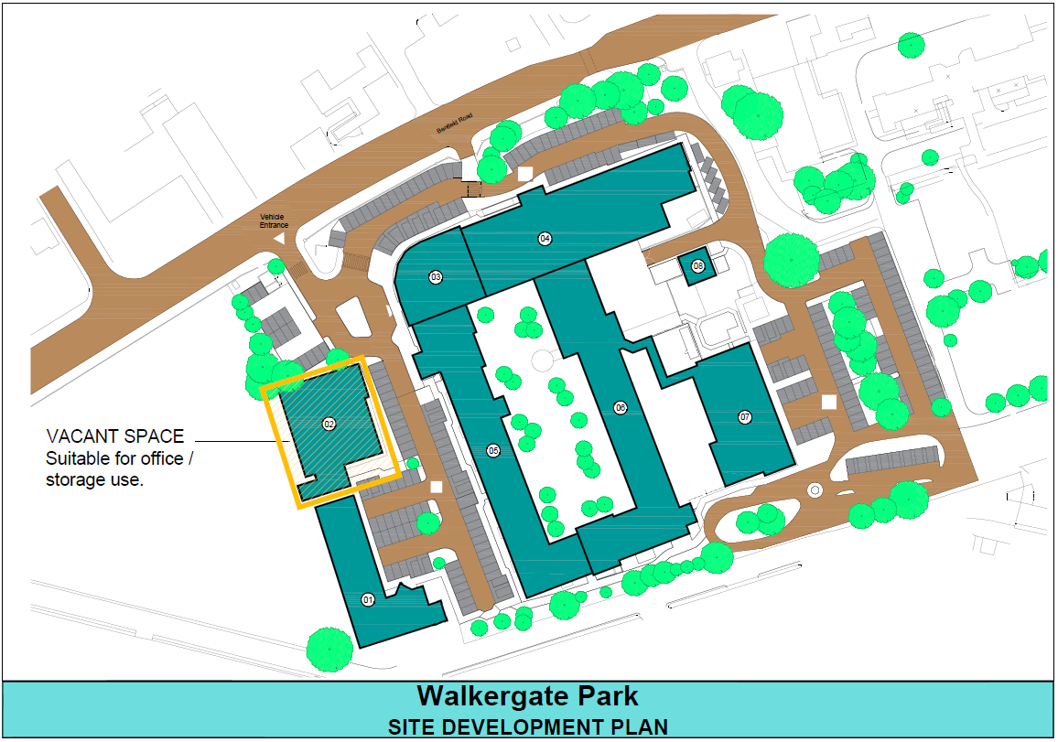
Figure 23

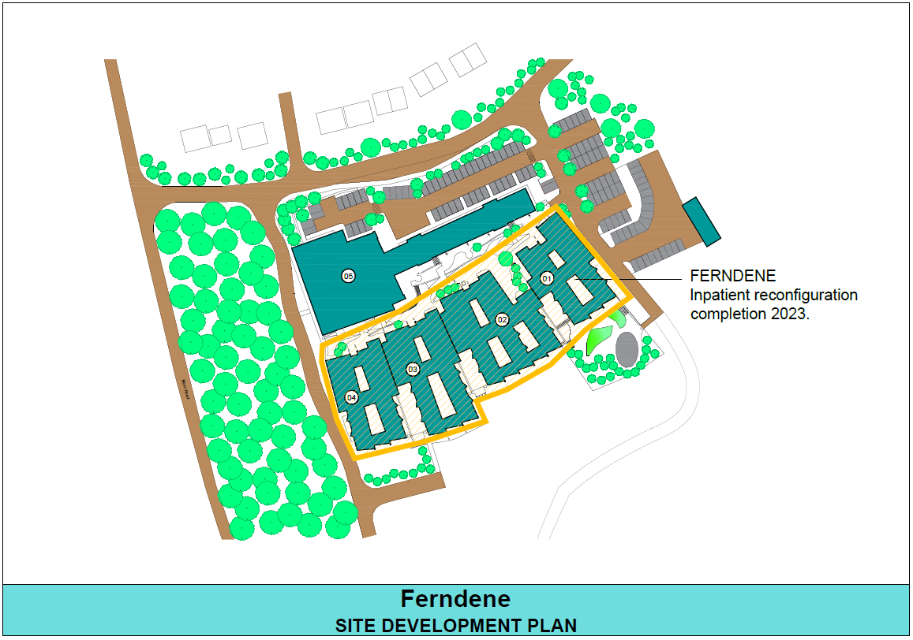
Figure 24

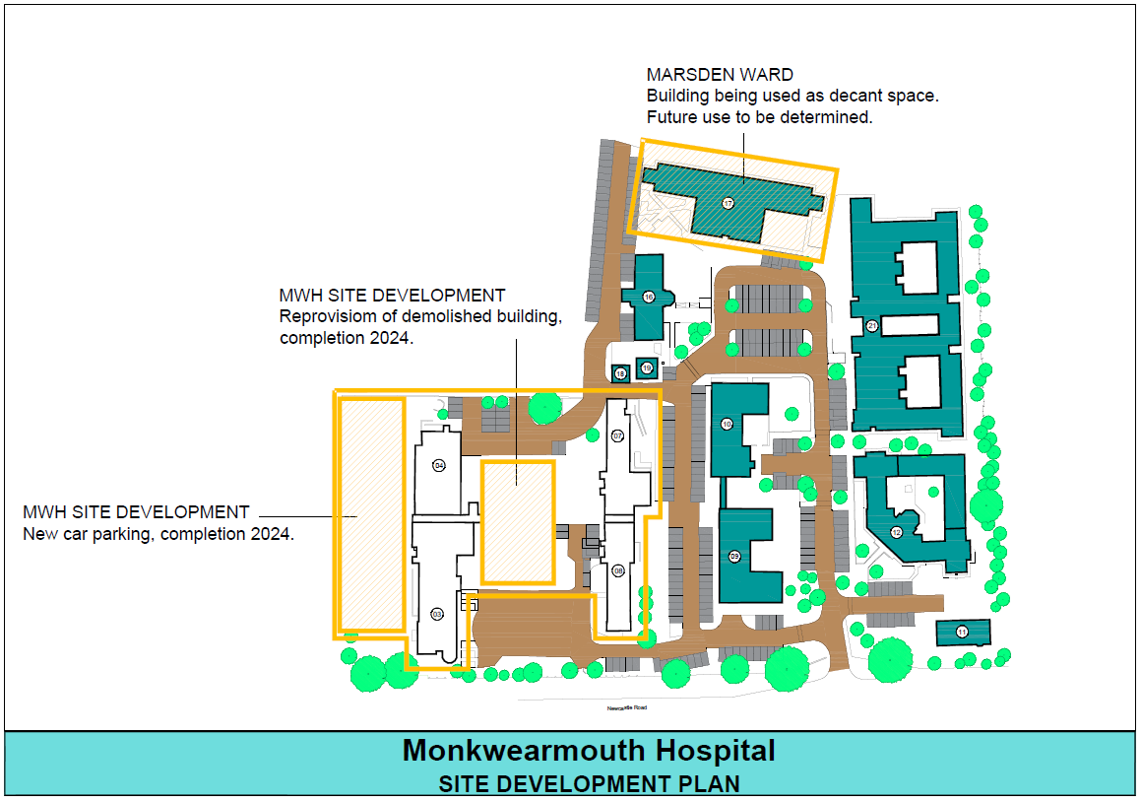
Figure 25

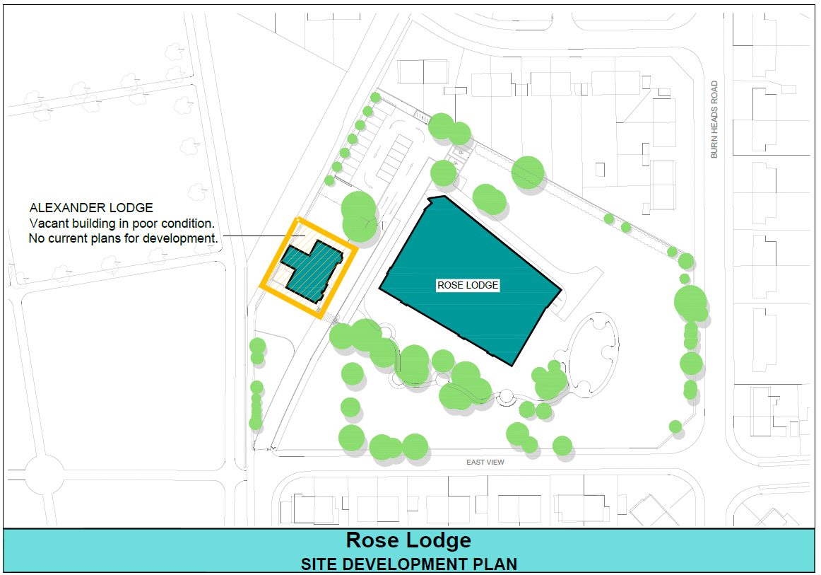
Figure 26

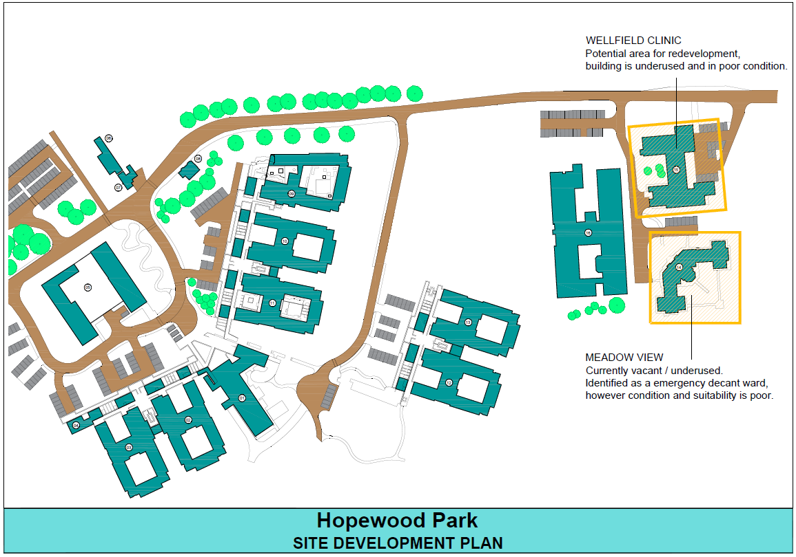
Figure 27

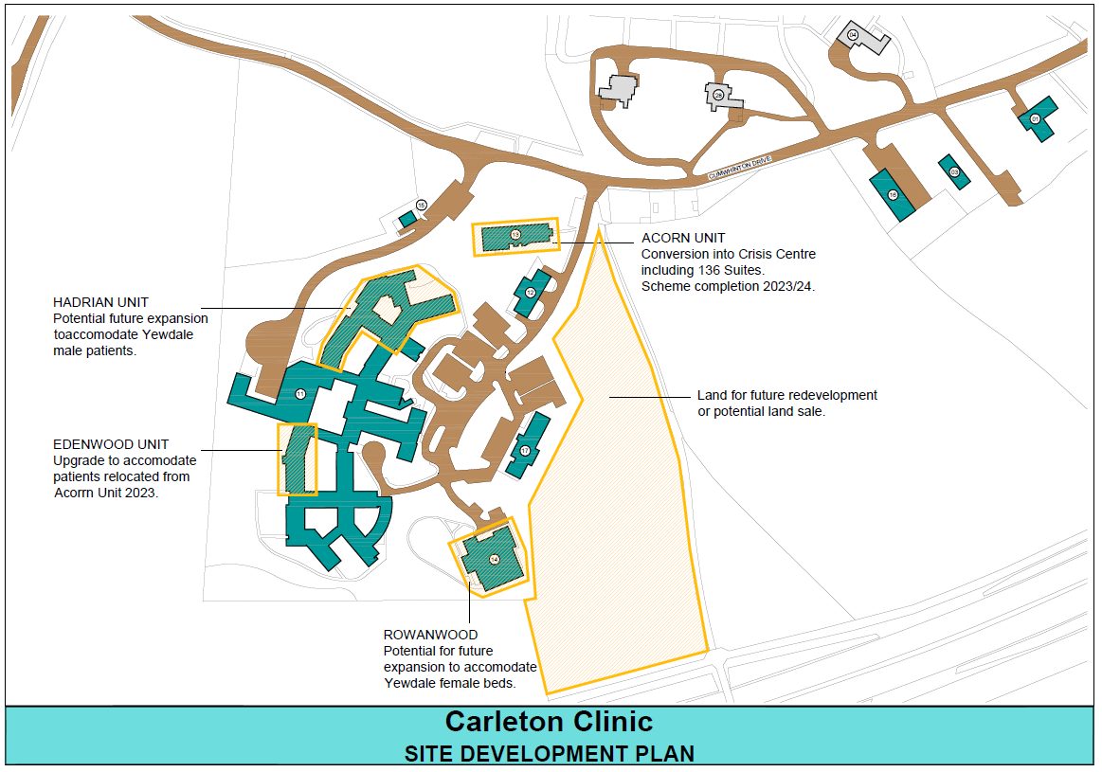
Figure 28 Site Development Plans

5.6 Delivery of the Estates Strategy
In order to deliver an ambitious capital program of work over the next 5 years, coupled with the planning required and the associated land sales, the Trust will require a number of elements to be in place, including:
- Expertise and team working
- Procurement framework
- Construction partner
- Capital funds

5.6.1 Expertise

The Trust has within its operating group the expertise within the Estates Department to deliver the specialist aspects associated with overseeing the construction contract. The Estates Department works with a wider team for the scheme development and delivery, including:
- Clinical staff
- Patients and carers
- Specific multi-disciplinary project boards and planning groups
- Architects
- Specialist designers and consultants
The Estates Department has been involved in the delivery of a continuous stream of capital projects over the last 18 years, building up experience and expertise that will
be invaluable in the delivery of the Estates Strategy over the next 5 years.

5.6.2 Construction Framework

The Trust is required to procure contracts over a certain value in a way that meets OJEU law. In order to achieve this, CNTW appointed PAGABO as their contract management agent for the National, OJEU-compliant framework for Major Construction Works (ref AVP-NTW-1002). It is intended to utilise this procurement framework for the delivery of the capital schemes with our construction partner Sir Robert McAlpine.

5.6.3 Construction Partner

The Trust recognises the benefits of partnering with a contractor to develop a long-term program of works as opposed to changing contractors on each scheme. Following a rigorous selection process Sir Robert McAlpine (SRM) were selected from the PAGABO framework. SRM have now successfully delivered a number of projects for NTW and are currently developing the CEDAR program.

5.6.4 Capital

The Trust’s operational plan included a capital programme totalling £82.2M over the next 6 financial years with planned spend of £17.1M in 2023/24. A revised plan is being developed at the time of writing this strategy to take into account slippage in the 22/23 FY and proposed changes to the CEDAR scheme.
The availability of capital funds in future years is constrained primarily by the Trusts lack of available cash, coupled with the need to operate within a CDEL that has been allocated to the ICS in which we operate. The demands on the capital across the ICS outstrip the allocated CDEL and hence the ability to simply spend on unplanned schemes or those not agreed within the ICS is not possible, unless some form of non CDEL allowance is forthcoming.

6.0 Summary
When formed in 2006, the new organisation inherited a large diverse property portfolio much of which was in a poor condition and had low levels of quality and functional suitability. That position has largely been reversed over the last 17 years as a result of sustained and targeted capital investment. The Trust is rightly proud of the significant advances in improving the quality of the patient environment it has made since its formation with many award-winning innovative capital developments which have been recognised for the contribution they make toward clinical care.

However, there still remains a range of accommodation which does not enhance the patient experience, and these are in need of improvement or replacement.
This section has detailed the works required to build on the previous Estates strategies, setting out the general scope of the work required over the next 5 years and how this will be delivered and what the expected outcomes will be. The key elements to ensure successful delivery are in place, including aligning the Estates Strategy to the clinical Strategy, delivery teams for bigger schemes have been established, a procurement strategy is in place, a construction partner identified and lastly a capital program has been established to provide funding.

The Trust remains committed to a program of continuous development and improvement in the services it provides and this needs to be reflected in the environments provided for both patients and staff. By ensuring the Estate Strategy is aligned with the Service Development Strategies, the Trust can be confident that its investment programme will deliver further improvements to ensure environments that are fit for purpose which will support the Trust in realising its vision.

The Estate Strategy has taken into account the Trust’s vision, core values and strategic objectives, in addition to the service-specific requirements as set out in the Trusts Strategy and to have ‘facilities fit for purpose’ that complement the service needs of the organisation.

The Estate Strategy provides a framework from which we will be able to monitor and measure our progress in ensuring that the Trust Estate performance meets the expectations of the organisation in line with the investment being made over the next 5 years. It will be imperative that the Trust ensures that future investment is in keeping with the Trust’s strategic objectives and goals, core service requirements, models of care and the capital funding envelope. The Strategy is a dynamic document outlining a programme of work that will be reviewed regularly as service priorities change and development opportunities arise.

