Name of meeting | Quality & Performance Committee
Date of Meeting | 1st May 2024
Title of report | Safer Staffing Report
Executive Lead | Sarah Rushbrooke, Executive Director Nursing, Therapies and Quality Assurance
Report author | Liz Hanley, Associate Director Nursing and Quality

Purpose of the report
To note | √
For assurance | √
For discussion
For decision

Strategic ambitions this paper supports (please check the appropriate box)

1. Quality care, every day | √
2. Person-led care, when and where it is needed

3. A great place to work

4. Sustainable for the long term, innovating every day

5. Working with and for our communities

Meetings where this item has been considered |  |  | Management meetings where this item has been considered
Quality and Performance |  |  | Executive Team
Audit |  |  | Executive Management Group
Mental Health Legislation |  |  | Business Delivery Group
Remuneration Committee |  |  | Trust Safety Group
Resource and Business Assurance |  |  | Locality Operational Management Group
Charitable Funds Committee
People
CEDAR Programme Board
Other/external (please specify)

Does the report impact on any of the following areas (please check the box and provide detail in the body of the report)

Equality, diversity and or disability |  | Reputational
Workforce | x | Environmental
Financial/value for money |  | Estates and facilities
Commercial |  | Compliance/Regulatory | x
Quality, safety and experience | x | Service user, carer and stakeholder involvement

Board Assurance Framework/Corporate Risk Register risks this paper relates to

SA1 Working together with service users and carers we will provide excellent care. Supporting people on their personal journey to wellbeing.
There is a risk that high quality, evidence based safe services will not be provided if there are difficulties accessing inpatient services in a timely manner due to bed pressures resulting in the inability to sufficiently respond to demands (SA1.4).

SA4 The Trust’s mental health and disability services will be sustainable and deliver real value to the people who use them.

A failure to develop flexible robust Community mental health services may well lead to quality and service failures which could impact on the people we serve and cause reputational harm (SA4).

Report to the Quality and Performance Committee
1st May 2024 (February 2024 data)
Safer Staffing Report

Executive Summary

The purpose of the report is to provide assurance on the position across all in-patient wards within CNTW, in accordance with the National Quality Board (NQB) Safer Staffing Requirements.

Care Hours Per Patient Day (CHPPD) planned and actual for registered and unregistered nursing information is submitted monthly via Unify. The narrative in the report reflects the staffing position for March 2024 and a summary of CHPPD information for this time period is incorporated into the attached report, at pages 11-14.
Safer Staffing issues to note
The following safer staffing issues are of particular note:
- Overall, the nursing workforce is considered inexperienced, with a high proportion of preceptees and Internationally Educated Nurses who are unable to take charge of the ward and band 5 nurses being appointed to band 6 roles immediately after completing preceptorship.
- Coexisting conditions and complex physical health needs increase patient dependency, acuity of need, monitoring requirements and the need for patients to be escorted away from CNTW sites to undergo diagnostic screening or testing and/or to receive treatment.
- Staffing pressures at Walkergate Park Hospital result from a high level of physical health needs and related care, treatment and interventions.
- Standalone units have been identified as being at increased risk of the effects of staffing pressures, including Yewdale ward; Elm House; Rose Lodge; Lotus ward and the Mitford unit.
- There is a significant vacancy rate in secure services and an increased incidence of violence and aggression.
- Positive feedback has been received relating to the improved environment of Children and Young People’s Services (CYPS) and there is increased support available from the wider CYPS services, following consolidation of services on the Ferndene site.

Risks and mitigations associated with the report

Risks and mitigations are summarised in the narrative pages of the attached safer staffing report.
A summary of work undertaken in South Locality to address the incidence of violence and aggression incidents is included as an appendix to this report.

Recommendation/summary

It is recommended that the Quality and Performance Committee accepts this report.

Name of author

Liz Hanley
Associate Director Nursing and Quality

Executive Lead

Sarah Rushbrooke
Executive Director Nursing, Therapies and Quality Assurance

Appendix
Aggression and Violence South Inpatients
As outlined in Positive and Safe Management of Post-Incident Support and Debrief Reference Number CNTW(C) 13, Cumbria Northumberland Tyne and Wear NHS Foundation Trust (the Trust/CNTW) does not accept the occurrence of incidents of aggression and violence, and the restrictive interventions required to manage such incidents, as inevitable in our mental health and learning disability services.

Despite this statement, we note that incidents of violence and aggression towards our staff is the highest type of reported incident.

- Violence and Aggression South Inpatient Data (taken from talk first dashboard)
Analysis of incidents in the last 6-month for South inpatients aggression and violence is the highest cause group reported by the wards.
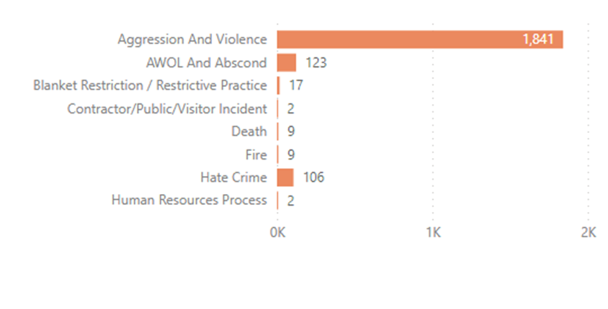
Roughly, 75% of the 1841 aggression and violence incidents is towards staff. The incidents by cause 1 is physical assault of staff by patient followed by threatening behaviour by patient to staff , aggressive behaviour to staff and inappropriate patient behaviour.
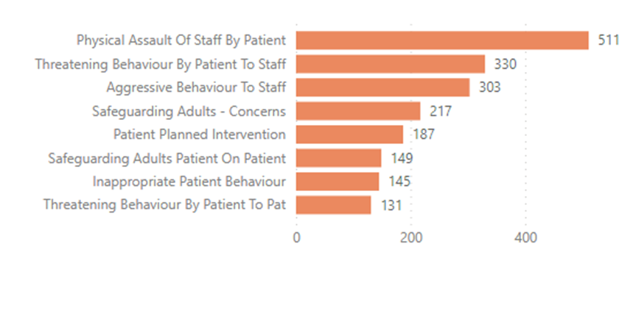
Aggression and violence towards staff whilst evident on all wards, there are wards with higher reporting of violence and aggression incidents. These wards are the Psychiatric Intensive Care Unit, Learning Disability and Treatment Unit followed by Adult Acute then the High Dependency Wards.
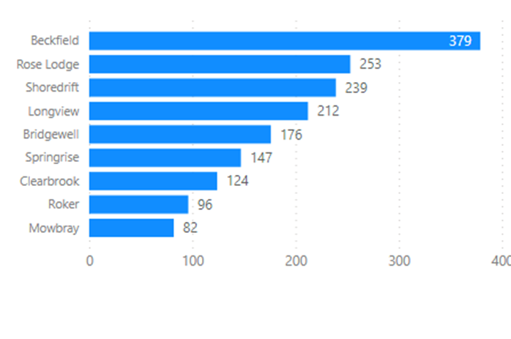
In the last six month, South Inpatients reported 1841 incidents of violence and aggression, 511 were physical assault of staff by patient. Of those incidents, 11 were moderate harm, 218 minor harm and 282 no harm.

- Themes- Cause of Violence and Aggression Learning
Upon review of incidents, the cause of violence and aggression derive from three key factors patient, environmental and clinical. The CBU looked at the factors in a recent Violence and Aggression Workshop. Those in attendance populated from experience the cause they find in practice that can prompt and lead to incidents of violence and aggression-

Patient Factors | Environmental Factors | Clinical Factors
Medication seeking behaviours/ self-soothing/ addictions  Substances / illicit substances  Mental state  Frustrations & boredom  Sensory needs  Feeling scared  Forensic patients / inappropriate admissions  Mixture of patients out of pathway  Mixed sex wards-PICU | Access to smoking areas  Noise levels: music, screaming  Temperature  Personal space: lack of  Environment: TV’s, lack of internet  Sleep: lack of / disturbed / over sleeping  Food choices  Arbitrary rules/ blanket restrictions  Lack of PET time  Lack of resources  Lack of routine / structured day  Low stimulation / boredom: lack of activities, OT’s, psychology etc. | Inconsistent approaches.  Lack of experience  Desensitisation to violence  Communication: negative language / vibes / false promises  Using authoritative approach  Delays in discharges  Preventing self-harm  Restrictions: freedom / lack of leave / waiting for leave to be agreed  Skill / ratio mix of staff  Staff shortages  Staffing changes / teams  Waiting to see a medic  Not responding to requests in a timely manner

The data from our workshop-mirrored findings from literature reviews on Aggression and Violence in inpatient settings. Weltens, etal (2021), outlined that the prevalence of aggressive behaviour on psychiatric wards varied (8–76%). Explanatory factors of aggressive behaviour were subdivided into patient, staff and ward factors. Patient risk factors were diagnosis of psychotic disorder or bipolar disorder, substance abuse, a history of aggression, younger age. Staff risk factors included male gender, unqualified or temporary staff, job strain, dissatisfaction with the job or management, burn-out and quality of the interaction between patients and staff. Staff protective factors were a good functioning team, good leadership and being involved in treatment decisions. Significant ward risk factors were a higher bed occupancy, busy places on the ward, walking rounds, an unsafe environment, a restrictive environment, lack of structure in the day, smoking and lack of privacy.

- Staff Safety and Support
Violence and aggression can affect all staff working on the ward inclusive of Medical, Nursing, the wider MDT, Facilities and Estates staff. To support prevention of violence and aggression on the wards we held a full one-day workshop. This was open to all disciplines departments and partner agencies it had good attendance and was productive about how we address prevention of aggression and violence on our wards together.
As an outcome of the Violence and Aggression workshop a dedicated Police Support Officer was allocated to the wards. The Officer links into MDT’s supporting staff, patients and carers. She is also a member of the Police and Partners group on site helping the other CBU’s work collaboratively with the Police and other partners.

Advances in technology- body worn videos
Staff alarms
Lone working devices- less used on inpatient wards but available if need
Positive and Safe Strategy
Partnership working with police
Induction process
Debrief process this occurs for incidents with higher impact, those with no harm unless flagged will be picked up in supervision.
Supervision structures in place with ward team or the wider MDT. Psychology often support around individual or group supervision following incidents.
Occupational health.
Thrive- a dedicated site for staff wellbeing.
Support to report to police as aggression in the workplace is not acceptable.
HATE crime pilot with Northumbria police Harm Reduction and Communities Team (HRCT). The aim of this is for CNTW staff and patients will feel more valued and supported as Victims of Hate Crime which will encourage them to report more offences and increase their trust and confidence in reporting Hate Crime.
Reasonable adjustments with work base. It is identified the wards with the higher levels of violence and aggression. If a staff member requests a change of base following an incident, we would look to support a move.
Training- managing violence and aggression.

Least Restrictive Preventative Approach
It is recognised that restrictions on occasions are required to maintain safety of patient staff and others. However these must be proportionate to risk and the rationale clearly outlined. Any restriction implemented will follow a governance process and be in place for the least time possible. It is also important that prior any restriction we clearly outline all the other methods of support we have used prior to a restriction.

The below list is not exhaustive but outlines some support strategies to assist the staff with providing least restrictive care-
Personalised care planning, formulation and risk assessment
Talk First
HOPEs
LTS Panel
Incident recording
Blanket restriction registers
Exercise tailored around care plan
Leave to access outdoor space
Micro Recovery College on site
Peer supporters

