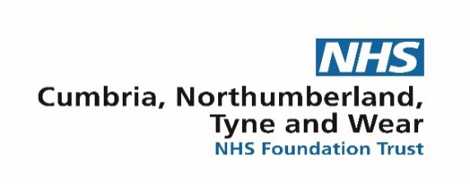

North Cumbria Children and Young People’s Attention Deficit Hyperactivity Disorder (ADHD) Service

Please be aware we have an extensive waiting list for initial assessments, and we are currently unable to give a timeframe for appointments. Where a Child or Young Person has an existing diagnosis of ADHD, we are required by NICE guidance to confirm the diagnostic criteria is met before considering treatment.
Our specialist ADHD service is made up of a team of experienced professionals from a range of backgrounds and disciplines. Together we provide assessment and treatment of ADHD for children and young people and their families in North Cumbria.

Before referring for an ADHD assessment
If there are concerns about symptoms of inattention, and/or impulsivity/hyperactivity having a negative effect on a child or young person’s quality of life, professionals should take the following steps before making a referral for further assessment-

- Implement reasonable adjustments
- Observe behaviour for 10 weeks and make notes, including any changes and patterns in behaviour
- Parents and carers should be encouraged to access support, guidance from the links available
- If the above steps have been taken and there are still concerns about inattention, and/or impulsivity/hyperactivity a referral for ADHD assessment should be considered

Referral criteria
- Aged between 5 and 17.5 years
- Evidence of 6 or more specific symptoms of ADHD
- Evidence that the symptoms are causing moderate to severe impact
- Evidence that the symptoms are present in home, educational, and social settings
- Symptoms have not improved when adaptations and environmental modifications have been implemented in educational settings
- Children and Young People who have an existing ADHD diagnosis
- We also consider if the symptoms can be explained by other health, social, or learning needs
Please note-
- Young people aged 17.5 years should be referred to Psychiatry UK
- If a child or young person is not reaching expected developmental social, or academic targets, we would recommend speaking to the education setting

How to access our service
Referrals should be sent electronically to CMB-ADHDNCumbria@cntw.nhs.uk and include:
- Fully completed referral form (parent/school/referrer sections)
- Supporting Parent/Carer Information pack (includes SNAP IV rating scale)
- Supporting Education Information pack (includes SNAP IV rating scale and Concentration Chart)
- Supporting evidence from additional settings, e.g clubs and hobbies
- Any relevant reports and documents (Early Help, Educational Psychology, etc.)

The referral form, supporting parent/carer information packs and information for schools booklet are available on our web pages-
North Cumbria Attention Deficit Hyperactivity Disorder (ADHD) Children and Young People's Service (West) - CNTW270 - Cumbria, Northumberland, Tyne and Wear NHS Foundation Trust
North Cumbria Attention Deficit Hyperactivity Disorder (ADHD) Children and Young People's Service (East) - CNTW270 - Cumbria, Northumberland, Tyne and Wear NHS Foundation Trust

How to contact us
If you would like further support to make a referral, please contact at CMB-ADHDNCumbria@cntw.nhs.uk or 01228 603810.

