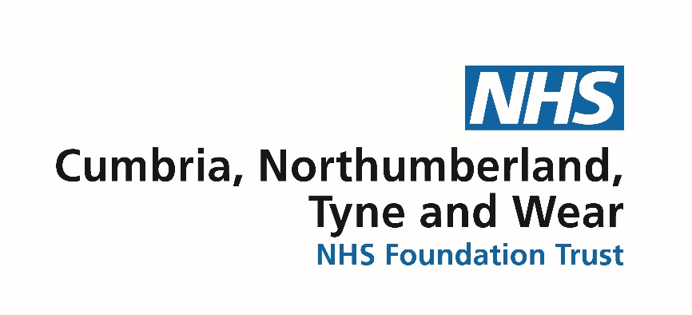



**Wi-Fi Information:**

**Network: NUFC**

**Password: weareunited**