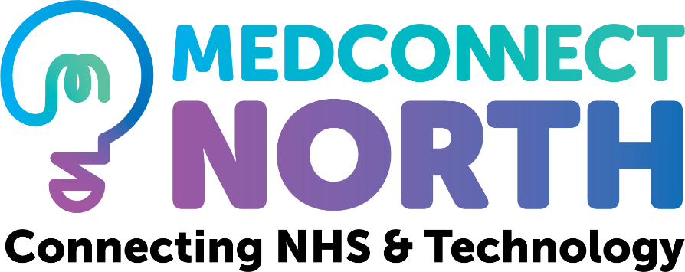

MedConnect North aims to offer a bespoke service to SMEs, National and International Medical Technology Companies, providing guidance and assistance throughout the Medical Technology Research and Innovation Pathway. The group supports companies to form partnerships with Academia and the NHS in the North East and North Cumbria region. In addition, MedConnect North supports NHS staff to encourage, drive and develop innovation, within their organisation.

Our vision is to provide this support in order to expedite the launch of new technologies and services to enhance and improve patient care and positively contribute to the regional economy.

MedConnect North is a joint initiative supported by National Institute for Health Research Clinical Research Network North East and North Cumbria and Academic Health Science Network North East and North Cumbria.



SUPPORTING THE FUTURE OF MENTAL HEALTH​

Beginning life as UKCRIS in 2009, Akrivia Health span out from the NHS and Oxford University in 2019 with one simple mission in mind. To accelerate and transform the trajectory of research within Mental Health and Dementias.

Our proprietary AI, NLP and data enrichment solution Akrivia Synapse delivers unprecedented depth in patient characterisation enabling our clients to better understand disease outcome, burden and intervention efficacy, identify potential targets for new molecules, and optimise patient outcomes through insights drawn from decades of medical history.

We work with healthcare organisations, researchers, drug developers, charities and many more.



The NIHR Research Support Service (RSS) provides free and confidential advice to develop funding applications within the remit of the NIHR, including clinical, applied health and social care research, and post-award advice to award holders. Access to support, advice and expertise is available for all researchers across England applying to NIHR research programmes or research training awards as well as to non-NIHR funders such as charities.

The NIHR Applied Research Collaboration North East and North Cumbria (ARC NENC) is a partnership that brings together six regional universities, health and social care providers, local authorities, the voluntary sector, community groups, members of the public and others.

Working together their vision is to deliver ‘better, fairer health and care at all ages and in all places’ with work organised around seven key research themes. Their work covers everything from exploring how to improve care for the most vulnerable, give children the very best start in life, keep people well for longer, support people to make healthier lifestyle choices, and tackle mental, physical and social health issues more holistically.



Health Innovation North East and North Cumbria (HI NENC) supports the health and care system to accelerate innovation which improves people’s health and the regional economy.

We work with industry too, by harnessing innovation at the source, we enable industry partners to access the expertise within the NHS that is so crucial to the development, testing and deployment of products and services that are the basis of the UK’s Life Sciences sector.

As part of a national network of 15, and with colleagues across the country, we collaborate to make nationally important innovation visible and accessible throughout the NHS.



We work alongside healthcare services and therapists to offer a virtual reality supported treatment which helps to reduce anxiety in children, young people and adults. By combining traditional Cognitive Behaviour Therapy (CBT) with Virtual Reality (VR), therapists can recreate scenes tailored to the patient’s individual needs. The unique treatment can be adapted by the therapist in real time, they have complete management of the rate of exposure to the anxiety trigger, controlling the volume or pace of the chosen scene.

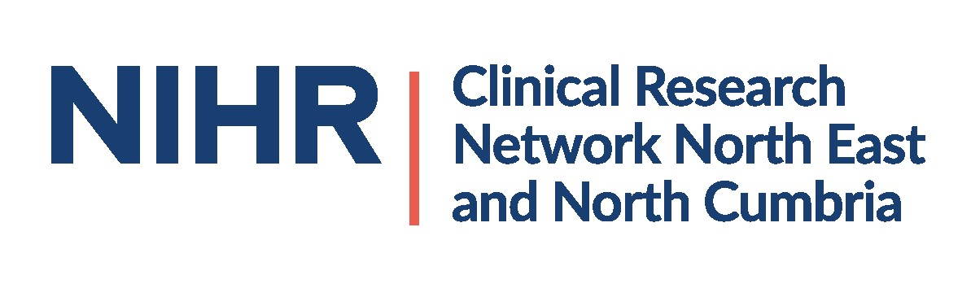

The NIHR Clinical Research Network North East and North Cumbria promotes opportunities for people to take part in health and care research, facilitates effective and efficient study setup and delivery, and supports [the Government’s Strategy for UK Life Sciences](https://www.gov.uk/government/publications/life-sciences-industrial-strategy) by improving the environment for commercial contract research in health and care settings. We are hosted by The Newcastle upon Tyne Hospitals NHS Foundation Trust.

Our vision is to improve health and care outcomes for local people through research

We are passionate about the contribution research can make to people's lives. By working collaboratively with NHS Trusts, primary care organisations and other qualified providers of health and social care services, we can translate that passion into the effective delivery of research studies. We make sure health and social research occupies the place it deserves in the day-to-day work of the NHS, care homes, and hospices, and we also support research in public health settings such as local authorities and schools.