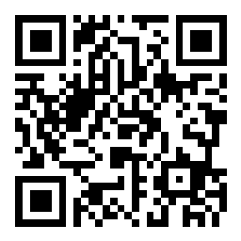

Join us on Slido today by either scanning the QR code to the right or following the link below and using our unique reference code.

Participants can join at **slido.com** with **#2785216**