North East Drive Mobility

Driving and Passenger Assessment Service

Thank you for taking the time to complete this questionnaire, it helps the team to prepare for your appointment and this information is strictly private and confidential. If you need any assistance completing or require any help filling in this form please contact the assessment centre on 0191 2875090.

Private and Confidential

Mr ☐ Mrs ☐ Miss ☐ Ms ☐ Doctor ☐ Other ☐ please state:
Name: Date of Birth:
Address:
Post code:
Telephone: Home: Mobile:
Email address:
Next of Kin/emergency contact: Telephone:
GP practice/address: Telephone:

(We may need contact your GP prior to your appointment)

I prefer to be contacted by: Telephone ☐ E-mail ☐ Letter ☐
I prefer to be assessed at: Newcastle ☐ Carlisle ☐ Teesside ☐
I prefer to be assessed in: A Manual Vehicle ☐ An Automatic Vehicle ☐

For your appointment
- Please remember to bring your national insurance number and driving licence with you.
- Check you can read a number plate from 20 meters (65 feet) away. If you struggle with this let us know.

Are there any days/times that you cannot attend:
Are you able to attend at short notice: Yes ☐ No ☐
Are you filling this form in on someone else’s behalf? If so please give your name and relationship to client:

About your general health/Medical condition(s) and Vision
Please tell us a bit about your health and the reason you are coming for a driving assessment.
Have you or are you experiencing any of the following?
(Please tick all of which apply to you)
☐ Epilepsy Speech problems Heart problems  ☐ Mental health issues  ☐ Allergies  ☐ Memory Changes  ☐ Difficulty reading  ☐ Blackouts/Absence | ☐Seizures  ☐Dizziness  ☐Fainting or loss of Consciousness  ☐Major operations  ☐Diabetes- insulin user Y/N
If you have ticked any of the above boxes, please give details in the box below:
Please provide a list of your medications(if any):

Your height (approx): | Your weight (approx):
Do you have any problems with your vision?
☐ Glasses for driving
☐ Cataracts
☐ Glaucoma
☐ Macular degeneration
☐ Other please state:

Do you have any problems with your mobility?
☐I have no problems with my mobility
☐I use a walking aid
☐I use a wheelchair/scooter
☐Other please state:

Can you get into and out of a car safely and independently?

About your licence.
Please tick ONE of the following that best applies to you:
☐ I am interested in learning to drive.

☐ I am currently driving.

☐ Due to my health, I am currently not driving.
Your Licence Status (tick one)
☐ I have not applied for my driving licence yet.
☐ I have a provisional licence.
☐ I have a full current licence.
☐ I have made an application to the DVLA for renewal- I am driving under section 88 provision.
☐ I have surrendered my licence to the DVLA because ……
☐ My licence was revoked due to……
☐ I have a full licence, but I have been advised not to drive until I have had an assessment.
☐ I have been given a PDAL (provisional disability assessment licence).

Have you informed the DVLA of your medical condition? Yes ☐ No ☐

If you are not sure if you need to notify the DVLA check the medical fitness to drive guidelines on the DVLA website- https://www.gov.uk/health-conditions-and-driving/find-condition-a-to-z

Do you have any codes on your licence? :
Codes can be found on the back of your licence under in section 12.
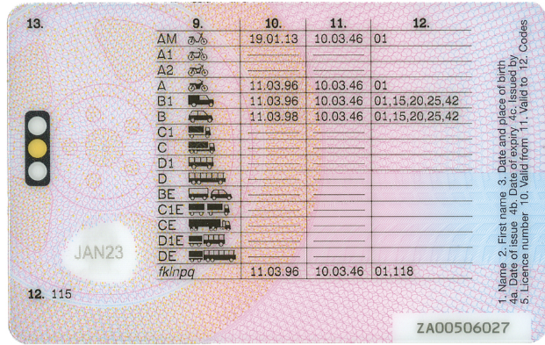

About your Driving
How many years of driving experience do you have? .

Has a health professional advised you not to drive? Yes ☐ No ☐
Who and for what reason?

When did you last drive?

What make and model is your car? Manual ☐ Automatic ☐

Do you have any adaptations fitted to your car? Yes☐ No☐
Details:

Do any of the following apply to you?
☐ I only drive to local familiar destinations.
☐ I avoid busy roads and would not drive long distance.
☐ I do not drive at night.
☐ I tend to drive with someone in the car with me
What are your driving habits?
How many times a week do you drive? .

Have you been convicted of a driving offence in the last 5 years including speeding?Yes☐ No☐
Details: .
Have you had a road traffic collision or any near misses in the last 3 years? Yes No☐
Details: .
What types of vehicles do you have experience driving?
✓ Car(s)  ☐ Motorbikes  ☐ Vans  ☐ LGV (7.5 tonnes or under) | ☐ Bus  ☐ Towed any Trailers/caravans  ☐ HGV  ☐ Mini Buses
Did you drive any of these professionally?

Part 4 – Consent Form
Your appointment will include:
- Asking you about your medical history and driving history.
- A clinical assessment including physical movements, vision and thinking skills.
- An assessment of your driving safety
If you feel unwell or want to stop the assessment for any reason you can do so.

The possible outcomes are:
- Safe drive
- Unsafe drive
- Tuition is required.
If the outcome is that you are unsafe to drive you must stop driving immediately and we will ask you to surrender your licence. From this point you will not be covered by your insurance and in the interests of road safety staff may contact the DVLA. If you are unsuccessful you will be offered support regarding going car free by the transport HUBs service.

Information will be shared with:
DVLA referrals: The DVLA will be notified of the outcome and a copy of your report will be forwarded. The final decision regarding your licence will be made by the DVLA.

All other referrals: The referrer will be notified of the outcome and a copy of your report may be forwarded to the person who referred you and your GP. You will be sent two copies of your report please send one to the DVLA.

Please read the following sentences and tick if you agree to them:
I consent to the appointment taking place as described above: ☐
I accept there is a possibility I will be advised to stop driving after today’s assessment. ☐
I am happy for my report to be forwarded to my GP, the DVLA and the referrer if needed. ☐
I accept the general risk of driving a car ☐
I am happy to be contacted regarding research or service developments. ☐
I am happy to have staff in training shadow the appointment for their learning. ☐
I understand the information I have been given and I agree to be assessed

Name: ……………..……………… Date: …………………..…
Signed: ………………..…………….

I have withdrawn consent:

Signed: ………………………………. Reason (optional):

Part 5 – Service monitoring

As part of our aim to reach everyone in the community, we would be grateful if you would complete these questions on the final page of this questionnaire. Please tick one of the following for monitoring purposes.
White Mixed
☐ British ☐ White and Black Caribbean
☐ Irish ☐ White and Black African
☐ Any other white background ☐ White and Asian
Please state: ☐ Any other Mixed background
Asian or Asian British Please state:
☐ Indian Black or Black British
☐ Pakistani ☐ Caribbean
☐ Bangladeshi ☐ African
☐ Any other Asian background Please state: ☐ Any other Black Background Please state:
Chinese or other ethnic group
☐ Chinese
☐ Any other
☐ Please state:

I do not wish to respond to the above information (part 6) ☐

If you decide/chose not to attend for a driving assessment you must contact the Centre as soon as possible, this is so we can re-allocate an appointment for a client that is/will be waiting for an appointment.

This completed form should be returned in the pre-addressed envelope provided and or with any further information included (a stamp/postage is required by yourselves and is not provided with the envelope). If you are completing this form by email (downloaded version) please copy and scan any further information you desire/additional information along with this APP1 application form to this email address northeast.drivemobility@cntw.nhs.uk

North East Drive Mobility
Walkergate Park
Centre for Neuro-rehabilitation and Neuro-psychiatry
Benfield Road
Newcastle upon Tyne
NE6 4QD

Tel: 0191 2875090
email: northeast.drivemobility@cntw.nhs.uk

