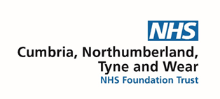

**North East and Cumbria Hubs Mobility Advice Service**

**Hubs Referral Form**

|  |  |  |
| --- | --- | --- |
| Please complete **all** sections of this form and return it to us as soon as possible. If you have any questions or need help completing the form, please contact us and we can complete it over the telephone. You can also ask family or friends to help you fill it in if you prefer. Tel: 0191 2875090, 07816129405 | | |
| **Section A: Personal details** | | |
| Full name: |  | |
| DOB: |  | |
| Address: |  | |
| Contact Information: | Home phone:    Mobile:  Email: | |
| How would you prefer to be contacted: | | Telephone  E-mail  Letter |
| **Please give a brief description on how the Hubs Mobility advice service can help you.** | | |
|  | | |

Once you have completed the form either:

1. **Print off and send by post to: Mobility Clinician, North East Drive Mobility, Walkergate Park, Benfield Road, Newcastle upon Tyne, NE6 4QD**
2. **Send the form electronically as an attachment and a covering email to North East Drive Mobility at: transporthub@cntw.nhs.uk**