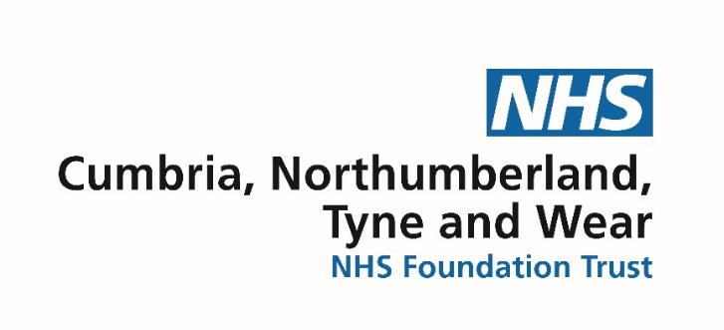
CNTW Practice Education Team

Welcome to the Practice Education Team.
We are a team of 13 made up of Nursing, AHP and admin staff, based at St Nicholas Hospital in Gosforth.
Our 4 Education Support Nurses (ESN’s) work with the Practice Education Team and CNTW Academy to support the trusts Nursing Apprentices and Trainee Nursing Associates.
The practice education team (PET) has 3 main functions:
1. We are here to support Nursing and AHP students whilst they are on their clinical placements in CNTW.
2. We support our clinical placements with their allocated students.
3. We work directly with each university in the region with student placements.
In addition to this we deliver practice assessor and practice supervisor training to registrants in CNTW. Currently this is delivered via Microsoft Teams and update training is available online.
We audit clinical areas on behalf of our HEI’s, this helps to keep ARCPEP and PARE information up to date and determine the capacity each placement has for students.
We can support clinical areas to implement new models of coaching which will allow for increased numbers of students without increased demands on clinicians.
For further, more detailed information please have a look on the intranet site where you will find our contact details. If there is anything we can support you with please get in touch with us – we will be happy to help.

New intranet page Professional Nursing - Home (sharepoint.com)
Current intranet page Practice Learning Team - Home

