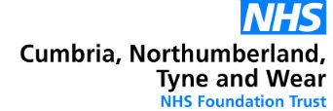
Annual Members’ Meeting/Annual General Meeting
‘All in this Together’
Wednesday, 22 September 2021, from 3pm - 5pm
Crown Plaza, Stephenson Quarter, Hawthorn Square, Forth St, Newcastle, NE1 3SA

AGENDA

1. Welcome and Introductions Ken Jarrold CBE, Chairman

2. Minutes of the Annual Members’ Meeting Ken Jarrold CBE, Chairman
15 September 2021

4. Chief Executive’s Update John Lawlor, OBE, Chief
Executive

5. A Governors’ Story Allan Brownrigg, Staff Governor –
Clinical

6. ‘All in this Together’ Adam Crampsie, Chief Executive
of Mental Health Concern

7. Annual Magazine 2021 Ken Jarrold, Chairman

8. Annual Report and Annual Accounts 2020/21 James Duncan, Deputy Chief
(including External Audit Management Letter) Executive/Director of Finance
Campbell Dearden, Mazars LLP

9. Questions from the public Ken Jarrold, Chairman

10. Meeting close Ken Jarrold, Chairman

The Annual Report and Annual Accounts 2020/21 are available on the Trust’s website by clicking here

or on request from the Corporate Affairs Office on CorporateAffairs@ntw.nhs.uk

