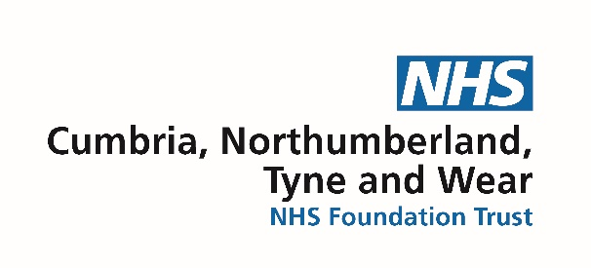

Consultant Connect within the adult mental health pathway for
medication and general advice

Following feedback from and discussion with GPs, Northumberland CCG has commissioned a pilot of Consultant Connect within the adult mental health pathway for medication advice. Each day there are Psychiatrists and Non-Medical Prescribers rostered to respond to queries, weekdays 9-5 p.m. In addition there is a general advice line within the adult mental health pathway for discussion about potential referrals into the service.

This is an app based service and each GP should have access to the app through which they can choose to be connected to either the medication or general advice line. There are also dedicated telephone numbers for each individual surgery within Northumberland which can be used as an alternative to the app function. Each practice has been sent their own dedicated telephone number and these can be accessed from the practice manager.

The aim of the medication advice line is for GPs to receive a swift response in relation to service users not currently open to CNTW. The outcome of this advice may prevent a referral being sent into CNTW. However if the presentation is considered too complex to provide medication advice on the phone by the CNTW prescriber, the likely advice will be to make a referral to the service which will be triaged as usual followed by a response in writing.

Equally, the general advice line serves to support referrals being made to the most appropriate service in a timely way.

If there are any difficulties with accessing or using Consultant Connect, please call the Northumberland Referral Hub on 01670 844758 who will be able to assist.

This service is currently only for Northumberland GPs wishing to discuss issues that fall within the adult mental health pathway.

