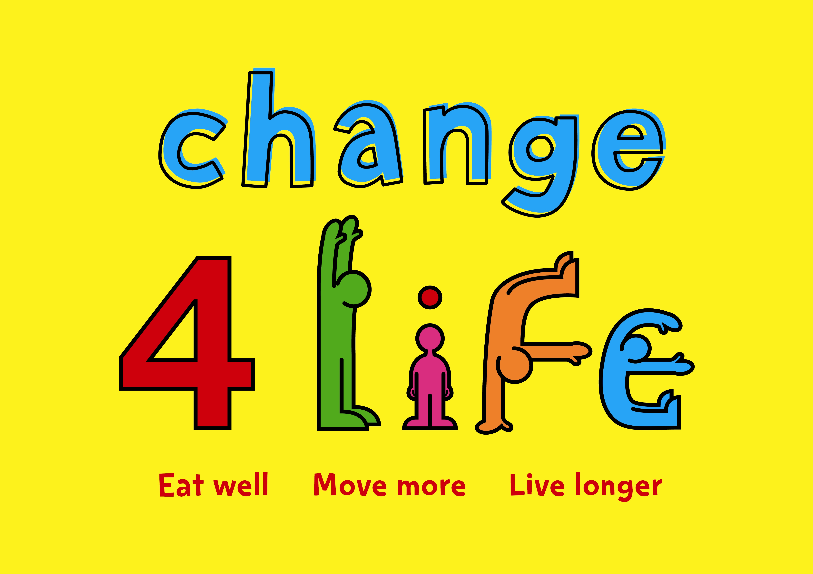
Referral for GYM
For young people aged 14-17 years with weight concerns

We will use the information provided here to contact the parent/guardian. We will not give this personal information to anyone outside the CHAT staff without parental permission

Name of Child................................................ ...... Gender.................... Date of Birth .................................

Address: ......................................................................................................................................................................

Postcode: ..................................................................Email: .......................................................................................

NHS Number....................................................................

School/School Nurse.................................................................................................................................................

GP & Surgery............................................................................................................................................................

Home Telephone Number: ............................................. Mobile: ...........................................................................

Name of parent / carer Relationship to
(who will attend with child) .............................................................the child: ........................................................

Address (if different than Child’s): .........................................................................................................................

Has parent/carer agreed to referral and contact from CHAT team? Yes □ No □

Is there a child protection plan in place for the child? Yes □ No □

Social Worker/ Professionals
currently involved with the family:.......................................................................................................................

Measurements Height (cm)........................................... Centile........................................

Weight (kg) ......................................... Centile........................................

BMI (kg/m²) ........................................Centile .......................................

Referrer Details
Name and Job title of referrer: .......................................................................................................................
Address of referrer: ........................................................................................................................................
Contact number(s): ........................................................................................................................................
Referrer Signature_______________________________ Date_____________________
Please send form to: Children’s Health and Activity Team (CHAT), Quadrant East-Second Floor Left, The Silverlink North, Cobalt Business Park, North Tyneside NE27 0BY
Tel: 0191 643 7454

