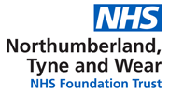

Equality, Diversity and Human Rights
Annual Report 2018/19



Introduction
This is a report about what Northumberland Tyne and Wear NHS Foundation Trust has done during 2018 and 2019 to make the NHS a better and fairer place for patients and staff. It is called an ‘Equality, Diversity and Human Rights’ report because it shows the work we have done to:
- Help all people, whoever they are, to receive high quality health care – we call this equality
- Recognise and celebrate the fact that every person is an individual - we call this diversity
- Make sure every person is treated with dignity and respect - we call this human rights

Northumberland, Tyne & Wear NHS FoundationTrust works from more than 60 sites across Northumberland, Newcastle, North Tyneside, Gateshead, South Tyneside and Sunderland. We also run a number of regional and national specialist services. Along with partners, we deliver support to people in their own homes, and from community and hospital-based premises.

We have more than 6,000 people working for us and a budget of over £300million.

The services we provide are divided into three locality care groups”- North, Central, and South.

Our main sites are:
•St. Nicholas Hospital, Newcastle upon Tyne
•St. George’s Park, Morpeth, Northumberland
•Northgate Hospital, Morpeth, Northumberland
•Ferndene, Prudhoe, Northumberland
•Walkergate Park, Newcastle upon Tyne
•Hopewood Park, Sunderland
•Monkwearmouth Hospital, Sunderland

We also provide services from a number of smaller units, including Benton House, Plummer Court and the Campus of Ageing and Vitality in Newcastle upon Tyne.

What have we done to promote equality, diversity and human rights within Northumberland Tyne and Wear NHS Trust during 2018-2019?
Equality. Diversity and Inclusion Strategy 2018-2022
The strategy is part of our legal obligations under the Public Sector of the Equality Duty. As part of the development of this strategy we have aligned our actions to EDS2 goals and have mapped EDS2 Goals and Outcomes against the Trust’s overall strategy. The Strategy was developed during the summer and early autumn of 2018, with consultation events through August and September and was approved by Trust Board in November 2018.

We have aligned our Trust-wide equality, diversity and inclusion objectives for the next four years to the four EDS2 goals.
During the life of this strategy we will set and review actions on a yearly basis using the Equality Delivery System to work towards achieving:
- Better health outcomes for our service users.
- Improved patient access and experience.
- A representative and supported workforce.
- Inclusive leadership.
The detailed actions for the first year of this strategy largely consist of ‘must do’ actions to fulfil our statutory duties. In many ways these are ‘setting the stall’ for future years of this strategy by putting mechanisms in place around key issues – for example the Accessible Information Standard and the Workforce Disability Equality Standard. For 2019-2022 we will engage in consultation with all of our stakeholders (employees, patients, local interest groups, governors, trust members and any other interested parties.) on a yearly basis to set and review our actions using EDS2 (or any successive NHS England Equality Measure during the Strategy’s life).

In addition to these Trust-wide objectives our operational localities and corporate departments will be using EDS2 to set local objectives towards improving equality diversity and inclusion for those we serve and to make the Trust a great place to work.
Because this is a ‘live’ strategy which will be reviewed on a regular basis, we anticipate that objectives may be modified or indeed may be replaced to reflect new requirements or obligations within the life of the strategy

A Refreshed Equality Diversity and Inclusion Steering Group

To coincide with the launch of the new strategy we also took a close look at how we provide assurance on Equality, Diversity and Inclusion issues within the Trust. We recognised that our previous group provided good assurance around workforce issues but needed better representation regarding issues around service representation. To achieve this we looked at the Terms of Reference and membership of the group and gained service delivery representatives from each of the localities in which we deliver services. We also changed the chair of meeting. Previously the meeting had been chaired by the Equality and Diversity Lead, but now the lead acts as an advisor to the group and the localities and the Steering Group is now jointly chaired by the Acting Executive Director of Workforce and Organisational Development and the Director of our South Locality. At each meeting progress against the Strategy Action Plans is monitored and issues that need to be raised are escalated through the Trust’s Business Delivery Group and the Corporate Decisions Team Workforce Group. Introductory workshops to relaunch to Steering Group in February and April and from April the meeting is held monthly rather than bi-monthly.

Stonewall Diversity Champions

At the start of 2019 we signed a three year agreement to be Diversity Champions with Stonewall. The Diversity Champions programme is the leading employers' programme for ensuring all LGBT staff are accepted without exception in the workplace. Stonewall work with over 750 organisations, all of whom share a core belief in the power of a workplace that is truly equal. As part of our work with Stonewall we will be taking part in the Workplace Equality Index, which will provide us with a good assessment of our performance in this area. We will also be able to benchmark our policies, procedures and practices to ensure that they are LGBT+ inclusive and friendly. This work complements that of our LBBT+ Staff Network who this year have developed and rolled out an LGBT+ awareness half-day training programme and LGBT+ Allies Training. In addition to this our LGBT+ Staff Network will have a presence at Pride Festivals throughout the region we serve in 2019.

Regional BAME Recruitment Event

As part of our Workforce Race Equality Standard actions in 2018 we identified the need to aim to better engage with the BAME population and promote employment opportunities in the region. Discussions with Equality and Diversity Leads at a regional level established that this was an action that appeared as a priority for a number of Trusts. In December 2018 a group of us met for the first time to plan a recruitment event. The event took place at the end of April 2019. Gateshead Health NHS Foundation Trust, Newcastle upon Tyne Hospitals NHS Foundation Trust, NHS Leadership Academy North East, North East Ambulance Service NHS Foundation Trust, Northumberland Tyne and Wear NHS Foundation Trust and Northumbria Healthcare NHS Foundation Trust came together to hold a recruitment event designed to attract black, Asian and minority ethnic people to work for the NHS, the first of its kind in the region. The BAME Recruitment Event took place on the 27th April at the Royal Victoria Infirmary, Newcastle.
The day offered:
• the chance to meet people from each organisation,
• an outline of NHS employee benefits,
• an introduction to job roles in the NHS,
• interview skills and application processes, and
• job matching.
We created a bespoke 8 minutes film showing the NHS as the Employer of Choice and 5 separate 2 minute snapshots for use on Twitter, Facebook and other social media
We created bespoke publicity material aimed at attracting our BAME community, engaged effectively and we achieved a successful outcome with over 400 attendees on the day
Perhaps of greatest value we engaged with our BAME staff to ensure they were part of the event, promotional material and sought volunteers to be available on the day. This enabled additional engagement with those attending, enabled staff to talk openly about what it’s like to work for the NHS providing credibility but we also benefited from having attendees who had additional language skills available on the day.
We collated a list of people that expressed an interest in the Trust on the day with their email contact details which the Transactional HR team are following up. The event providers all pledged to follow up all contacts were made. A number of people made requests for information about particular pathways, apprenticeships were the most common on the day. The event is likely to become a yearly event and talks are taking place for a similar event to attract disabled people to consider a career in the NHS.

Equality as a Quality Priority

A major new quality priority is proposed in 2019/20, relating to the new Equality, Diversity & Inclusion Strategy. This has been developed in conjunction with stakeholders (including staff), locality groups and the Equality & Diversity Lead at engagement events in December 2018 and April 2019. By removing the barriers that people with protected characteristics face in accessing our services, we will improve the quality of care for all. This Quality Priority complements Equality, Diversity & Inclusion Strategy 2018-2022. The initial phase of the quality priority will allow locality groups time to establish local needs before deciding what actions are necessary to meet them. Progress against this quality priority will be monitored via the Trust Equality, Diversity & Inclusion Steering Group.

Workforce Disability Equality Standard

The Standard was introduced on 1st April 2019 and collects data on ten evidence based metrics from the 2018/19 financial year data. We have raised awareness about the standard through presentations at corporate and locality level and scoped the work that needed initially to be done as part of our workshop activities for the relaunch of our Equality Diversity and Inclusion Steering Group. In addition our Equality and Diversity Lead has been asked to chair a national meeting of ‘Disability Pioneers’ by NHS Employers and has been asked to present at a webinar by them to support the introduction of the Standard.

A Great Place to Work

The Trust will be taking part in a region-wide approach to workplace equality from 2019-2020 onwards. We anticipate that this will build upon the good practice that we have been proud to be part of within the region.
WRES Submission 2018

Our WRES Submission goes to Trust Board in July/August each year. The figures below went to Trust Board in July 2018

Indicator 1 Percentage of staff in each of the AfC Bands 1-9 and VSM (including executive Board members) compared with the percentage of staff in the overall workforce (NB Whilst the indicator is in % terms the prepopulated template from NHS England has staff numbers

 |  |  | 31st MARCH 2017 |  |  | 31st MARCH 2018
INDICATOR |  |  | White | BME | Unknown | White | BME | Unknown
1 | Percentage of staff in each of the AfC Bands 1-9 OR Medical and Dental subgroups and VSM (including executive Board members) compared with the percentage of staff in the overall workforce | 1a) Non Clinical workforce
1 |  | Under Band 1 | 30 | 0 | 1 | 22 | 0 | 2
1 |  | Band 1 | 1 | 0 | 0 | 1 | 0 | 0
1 |  | Band 2 | 562 | 7 | 62 | 476 | 6 | 59
1 |  | Band 3 | 358 | 5 | 29 | 308 | 4 | 28
1 |  | Band 4 | 282 | 5 | 44 | 221 | 3 | 35
1 |  | Band 5 | 92 | 2 | 18 | 91 | 1 | 16
1 |  | Band 6 | 80 | 1 | 22 | 98 | 1 | 22
1 |  | Band 7 | 51 | 1 | 9 | 57 | 1 | 8
1 |  | Band 8A | 30 | 0 | 10 | 31 | 0 | 11
1 |  | Band 8B | 41 | 1 | 3 | 22 | 0 | 4
1 |  | Band 8C | 2 | 0 | 1 | 3 | 0 | 1
1 |  | Band 8D | 7 | 0 | 2 | 1 | 0 | 1
1 |  | Band 9 | 4 | 0 | 0 | 1 | 0 | 0
1 |  | VSM | 5 | 0 | 0 | 5 | 0 | 0
1 |  | 1b) Clinical workforce  of which Non Medical
1 |  | Under Band 1 | 0 | 0 | 0 | 2 | 0 | 0
1 |  | Band 1 | 1 | 0 | 0 | 1 | 0 | 0
1 |  | Band 2 | 54 | 2 | 1 | 78 | 0 | 2
1 |  | Band 3 | 1575 | 86 | 150 | 1589 | 106 | 137
1 |  | Band 4 | 161 | 3 | 12 | 225 | 4 | 17
1 |  | Band 5 | 703 | 30 | 94 | 710 | 40 | 78
1 |  | Band 6 | 968 | 23 | 115 | 1005 | 27 | 107
1 |  | Band 7 | 419 | 10 | 55 | 438 | 10 | 48
1 |  | Band 8A | 143 | 8 | 29 | 153 | 11 | 27
1 |  | Band 8B | 62 | 0 | 10 | 64 | 0 | 8
1 |  | Band 8C | 43 | 1 | 3 | 44 | 1 | 2
1 |  | Band 8D | 25 | 0 | 5 | 24 | 0 | 4
1 |  | Band 9 | 2 | 0 | 1 | 5 | 0 | 0
1 |  | VSM | 1 | 0 | 0 | 1 | 1 | 0
1 |  | Of which Medical & Dental
1 |  | Consultants | 83 | 42 | 63 | 83 | 41 | 60
1 |  | of which Senior medical manager | 8 | 1 | 2 | 8 | 1 | 1
1 |  | Non-consultant career grade | 14 | 5 | 17 | 20 | 5 | 16
1 |  | Trainee grades | 3 | 0 | 8 | 6 | 5 | 11
1 |  | Other | 0 | 0 | 0 | 0 | 0 | 0

- 1540 non-clinical staff. Of the 1353 where ethnicity is known 98.8% White, 1.2% BME.(2017 98.5% 1.5%)
- For non-clinical staff no known BME representation for under Band 1, Band 1 and above Band 7 – similar picture to 2017 though have lost a BME member of staff at 8B in the last year
- Best non-clinical % representation Band 7 1.7%
- Ethnicity is not known for 12% of non-clinical workforce (11.4% 2017)
- Work generally needs to be undertaken to try to improve the profile of BME staff in non-clinical roles across all bands.
- 4969 Clinical Staff. Of the 4539 where ethnicity is known 95.5% is White, 4.5% BME (2017 96.2% 3.8%)
- Ethnicity not known for 8.65% of clinical workforce (10% 2017)
- No BME representation in Clinical Roles at Bands <1, 1, 2,8B,D & 9.
- Best clinical % representation at VSM (50%)

INDICATOR 2: Likelihood of appointment from shortlisting

 | 2013-14 |  | 2014-15 |  | 2015-16 |  | 2016-17 |  | 2017-18
 | White | BME | White | BME | White | BME | White | BME | White | BME
Shortlisted applicants* | n/a | n/a | 3798 | 347 | 4980 | 413 | 3942 | 358 | 5056 | 624
Appointed* | n/a | n/a | 686 | 47 | 754 | 43 | 765 | 45 | 636 | 56
Likelihood of appointment from shortlisting | n/a | n/a | 0.18 | 0.14 | 0.15 | 0.10 | 0.19 | 0.13 | 0.13 | 0.09
Relative likelihood (white/BME) |  | n/a |  | 1.33 |  | 1.45 |  | 1.54 |  | 1.44

- A relative likelihood of 1.44 is better than the 2017 national average (1.57), but worse than the 2017 regional median, (1.21)
- Rolling average since 2014/15 = 1.44.
- Figures suggest a standstill picture rather than an improvement.

INDICATOR 3: Likelihood of entering a formal disciplinary process

 | 2014-15 |  | 2015-16 |  | 2016-17 |  | 2017-18
 | White | BME | White | BME | White | BME | White | BME
Staff entering formal process | 107 | 6 | 72 | 2 | 97 | 8 | 158 | 12
Staff in workforce | 5439 | 195 | 5630 | 205 | 5830 | 232 | 5843 | 267
Likelihood | 0.020 | 0.031 | 0.01 | 0.01 | 0.017 | 0.034 | 0.027 | 0.045
Relative likelihood (BME/White) |  | 1.55 |  | 1.00 |  | 2 |  | 1.66
Two year rolling relative likelihood) |  |  |  | 1.28 |  | 1.50 |  | 1.83

- A slight improvement over 2016/17, though still above both the national average and the regional median for 2016/17.
- The E&D Lead has asked Capsticks for a quarterly report on this so that the trend may be better monitored but also the impact of initiatives such as the Cultural Ambassadors’ programme be assessed.

INDICATOR 4: Relative likelihood of accessing non-mandatory training and CPD

 | 2013-14 |  | 2014-15 |  | 2015-16 |  | 2016-17 |  | 2017-18
 | White | BME | White | BME | White | BME | White | BME | White | BME
Staff who have accessed non-mand training/CPD* | 72 | 15 | 28 | 4 | 87 | 8 | 139 | 5 | 46 | 1
Staff in workforce | 5423 | 175 | 5439 | 195 | 5630 | 205 | 5830 | 232 | 5843 | 267
Likelihood | 0.013 | 0.086 | 0.005 | 0.021 | 0.015 | 0.039 | 0.024 | 0.022 | 0.008 | 0.004
Relative likelihood (white/BME) |  | 0.15 |  | 0.25 |  | 0.40 |  | 1.11 |  | 2.10

- During the course of WRES reporting we have gone from BME members of staff being more likely to access non-mandatory training, to a position roughly of parity in 2016-17, to one now where white staff are more than twice as likely to access non-mandatory training compared to BME members of staff.
- Work needs to take place in the next year to understand this shift. It is suggested as a starting point that we make sure that the recording of non-mandatory training and CPD is as accurate as possible, followed an analysis of appraisal outcomes to assess whether there is disparity between the outcomes of requests to access non-mandatory training.

INDICATORS 5,6,7,8, Staff Survey Metrics

- Marginal improvement for KF25 and below average performance
- Marginal deterioration for KF26 figures around the average for mental health trusts
- Marginal deterioration for KF21, but above national average
- Improvement closing the gap for Q17b and results better than national average.
- A deep dive of these indicators has taken place, whilst this cannot be analysed by ethnicity we will be able to match ‘hotspots’ from the analysis to the staff demographic to develop a picture where the disparity between BME and White members of staff is likely to problematic.

INDICATOR 9: Voting board members

 | 2013-14 (N=14) |  | 2014-15 (N=14) |  | 2015-16 |  |  | 2016-17 |  |  | 2017-18
 | Board | Trust | Board | Trust | Count | Board | Trust | Count | Board | Trust | Count | Board | Trust
BME | 0.0% | 2.7% | 0.0% | 3.0% | 1 | 7.1% | 3.1% | 1 | 6.3% | 3.3% | 1 | 6.3% | 3.89%
WHITE | 54.5% | 84.4% | 50.0% | 83.6% | 8 | 35.7% | 84.5% | 14 | 87.5% | 84.6% | 14 | 87.5% | 85.10%
Chose not to state | 36.4% | 11.8% | 42.9% | 12.1% | 5 | 35.7% | 11.3% | 1 | 6.3% | 11.0% | 1 | 6.3% | 10.87%
No info recorded | 9.1% | 1.1% | 7.1% | 1.3% | 0 | 0.0% | 1.2% | 0 | 0.0% | 1.1% | 0 | 0.0% | 0.15%
Board BME % compared to Trust BME% (+/- %) |  | -2.7% |  | -3.0% |  |  | 4.10% |  |  | 3. 0% |  |  | 2.41%

- No change at Board level for 2017/18 compared to 2016/17
- Slight narrowing of gap between representativeness of the workforce compared to the Board.

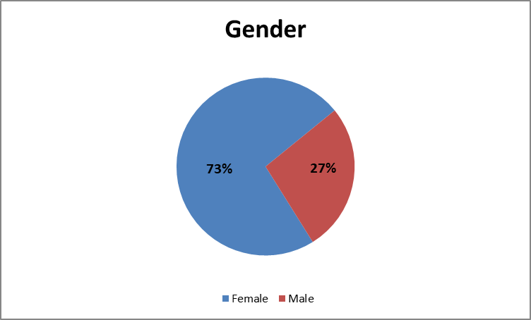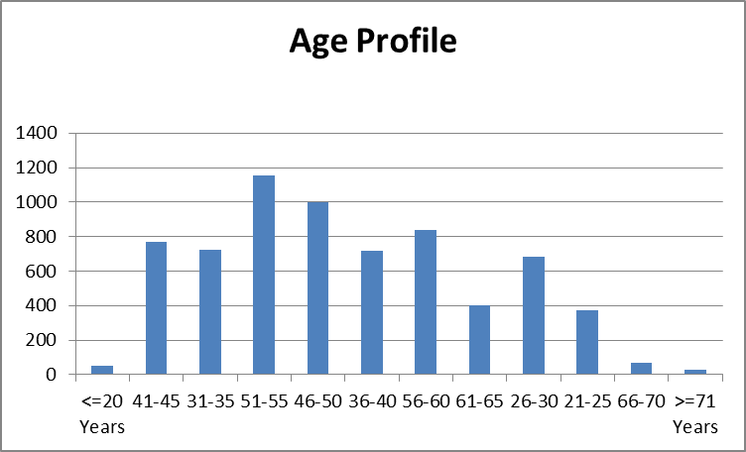
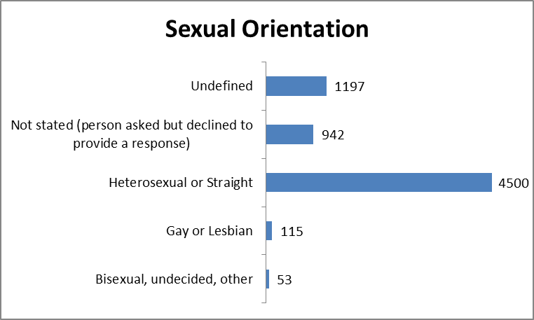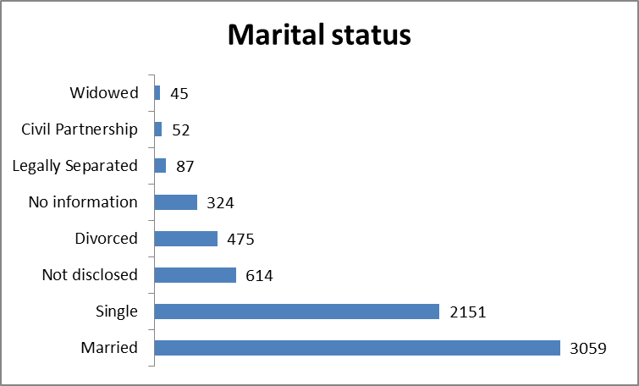

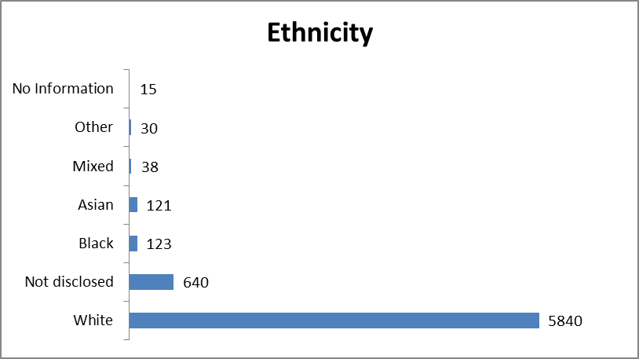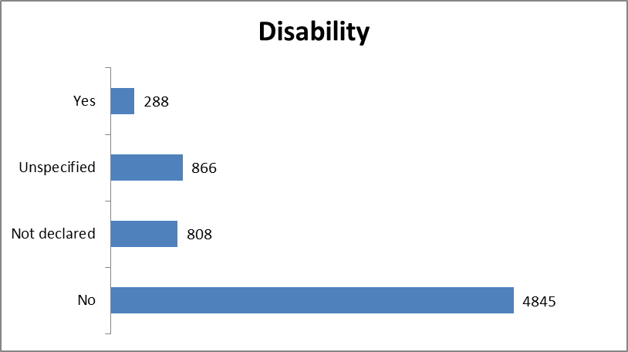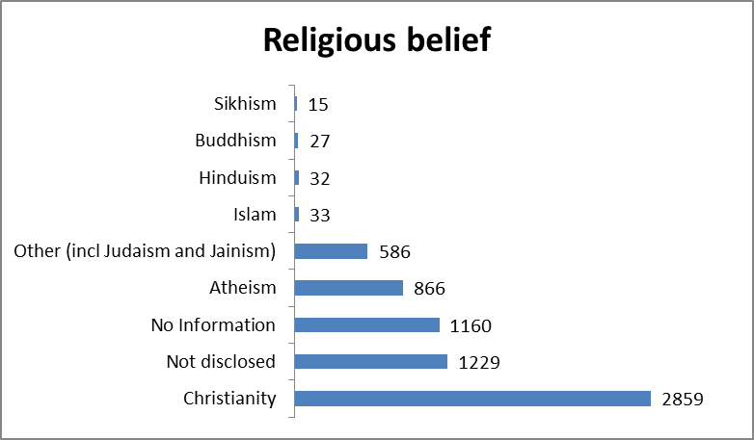

 | Service Users
Ethnicity Description | Number of current service users | % of current service users | Number of current (detained) service users | % of current (detained) service users
Any other ethnic group | 247 | 0.6% | 6 | 0.8%
 |  | 0.0% |  | 0.0%
 |  | 0.0% |  | 0.0%
 |  | 0.0% |  | 0.0%
Asian - Other | 276 | 0.6% | 12 | 1.7%
Bangladeshi | 116 | 0.3% | 5 | 0.7%
Indian | 102 | 0.2% | 2 | 0.3%
Pakistan | 142 | 0.3% | 8 | 1.1%
 |  | 0.0% |  | 0.0%
 |  | 0.0% |  | 0.0%
Black - African | 141 | 0.3% | 15 | 2.1%
Black - Other | 53 | 0.1% | 4 | 0.6%
Black - Caribbean | 25 | 0.1% | 1 | 0.1%
Chinese | 55 | 0.1% | 2 | 0.3%
 |  | 0.0% |  | 0.0%
Mixed - Any Other Background | 384 | 0.9% | 10 | 1.4%
Mixed - White and Asian | 119 | 0.3% | 2 | 0.3%
Mixed - White and Black African | 57 | 0.1% | 1 | 0.1%
Mixed - White and Black Caribbean | 64 | 0.1% | 2 | 0.3%
Not Known | 934 | 2.1% | 2 | 0.3%
Not Stated | 883 | 2.0% |  | 0.0%
 |  | 0.0% |  | 0.0%
White - Other Background | 559 | 1.3% | 14 | 1.9%
White British | 39,301 | 90.2% | 636 | 87.8%
White Irish | 111 | 0.3% | 2 | 0.3%
 |  | 0.0% |  | 0.0%
 |  | 0.0% |  | 0.0%
 |  | 0.0% |  | 0.0%
 |  | 0.0% |  | 0.0%
Total | 43,569 | 100.0% | 724 | 100.0%

Gender | Number of current service users
Female | 19,829
Male | 23,578
Other | 162
Total | 43,569
Age Band | Number of current service users
0 - 16 | 9,040
17 | 841
18 | 680
19 | 724
20 - 24 | 3,279
25 - 29 | 3,150
30 - 34 | 3,134
35 - 39 | 3,148
40 - 44 | 2,693
45 - 49 | 2,833
50 - 54 | 2,790
55 - 59 | 2,459
60 - 64 | 1,900
65+ | 6,898
Total | 43,569

Ethnicity Description | Number of current service users
Any other ethnic group | 247
Asian - Other | 276
Bangladeshi | 116
Black - African | 141
Black - Caribbean | 25
Black - Other | 53
Chinese | 55
Indian | 102
Mixed - Any Other Background | 384
Mixed - White and Asian | 119
Mixed - White and Black African | 57
Mixed - White and Black Caribbean | 64
Not Known | 934
Not Stated | 883
Pakistan | 142
White - Other Background | 559
White British | 39,301
White Irish | 111
Total | 43,569

PART 2 - Detained Patients Only
Gender | Number of current (detained) service users
Female | 197
Male | 527
Total | 724
Age Band | Number of current (detained) service users
0 - 16 | 15
17 | 8
18 | 9
19 | 5
20 - 24 | 47
25 - 29 | 74
30 - 34 | 85
35 - 39 | 79
40 - 44 | 67
45 - 49 | 68
50 - 54 | 66
55 - 59 | 62
60 - 64 | 46
65+ | 93
Total | 724

Ethnicity Description | Number of current (detained) service users
Any other ethnic group | 6
Asian - Other | 12
Bangladeshi | 5
Black - African | 15
Black - Caribbean | 1
Black - Other | 4
Chinese | 2
Indian | 2
Mixed - Any Other Background | 10
Mixed - White and Asian | 2
Mixed - White and Black African | 1
Mixed - White and Black Caribbean | 2
Not Known | 2
Pakistan | 8
White - Other Background | 14
White British | 636
White Irish | 2
Total | 724

Acknowledgement

Northumberland Tyne and Wear NHS Foundation Trust would like to thank all the individuals, groups and organisations who gave their time and expertise to contribute to contribute to the work detailed Annual Report. We look forward to continuing to work with them to help us move further towards equality for all people in the area which we serve.

Contact details

Northumberland Tyne and Wear NHS Trust
St Nicholas Hospital
Jubilee Road Gosforth
Newcastle upon Tyne
NE3 3XT

www.ntw.nhs.uk
equality@ntw.nhs.uk

