Simple Set of Sleep Related Vector Line Icons. 
Contains such Icons as Insomnia, Pillow, Sleeping Pills and more.
Editable Stroke. 48x48 Pixel Perfect.Simple Set of Sleep Related Vector Line Icons. 
Contains such Icons as Insomnia, Pillow, Sleeping Pills and more.
Editable Stroke. 48x48 Pixel Perfect.Simple Set of Sleep Related Vector Line Icons. 
Contains such Icons as Insomnia, Pillow, Sleeping Pills and more.
Editable Stroke. 48x48 Pixel Perfect.

Simple Set of Sleep Related Vector Line Icons. 
Contains such Icons as Insomnia, Pillow, Sleeping Pills and more.
Editable Stroke. 48x48 Pixel Perfect.Simple Set of Sleep Related Vector Line Icons. 
Contains such Icons as Insomnia, Pillow, Sleeping Pills and more.
Editable Stroke. 48x48 Pixel Perfect.Simple Set of Sleep Related Vector Line Icons. 
Contains such Icons as Insomnia, Pillow, Sleeping Pills and more.
Editable Stroke. 48x48 Pixel Perfect.Simple Set of Sleep Related Vector Line Icons. 
Contains such Icons as Insomnia, Pillow, Sleeping Pills and more.
Editable Stroke. 48x48 Pixel Perfect.Simple Set of Sleep Related Vector Line Icons. 
Contains such Icons as Insomnia, Pillow, Sleeping Pills and more.
Editable Stroke. 48x48 Pixel Perfect.

Simple Set of Dish and Plates Related Vector Line Icons. 
Contains such Icons as Plate Stack, Wineglass, Detergent, Unbreakable Dishes and moreSimple Set of Dish and Plates Related Vector Line Icons. 
Contains such Icons as Plate Stack, Wineglass, Detergent, Unbreakable Dishes and more

Simple Set of Sport Supplements Related Vector Line Icons. 
Contains such Icons as Protein, Vitamin, Full Stack Supplements and more.
Editable Stroke. 48x48 Pixel Perfect.Simple Set of Sport Supplements Related Vector Line Icons. 
Contains such Icons as Protein, Vitamin, Full Stack Supplements and more.
Editable Stroke. 48x48 Pixel Perfect.Simple Set of Alcohol Related Vector Line Icons. 
Contains such Icons as Champagne, Whiskey, Cocktail, Shots and more.
Editable Stroke.
Simple Set of Alcohol Related Vector Line Icons. 
Contains such Icons as Champagne, Whiskey, Cocktail, Shots and more.
Editable Stroke.


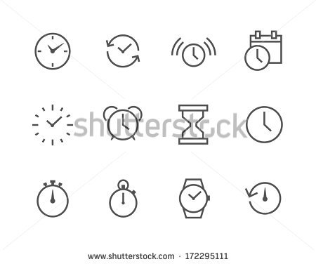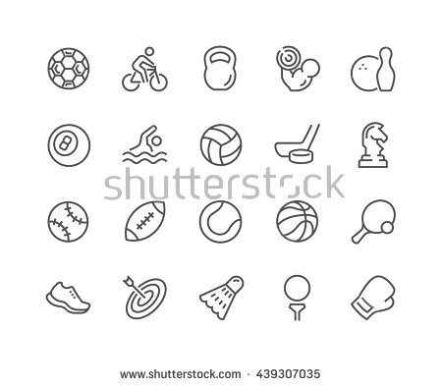Simple Set of Social Networks Related Vector Line Icons. 
Contains such Icons as Profile Page, Rating, Social Links and more.
Editable Stroke. 48x48 Pixel Perfect.Simple Set of Social Networks Related Vector Line Icons. 
Contains such Icons as Profile Page, Rating, Social Links and more.
Editable Stroke. 48x48 Pixel Perfect.Simple Set of Social Networks Related Vector Line Icons. 
Contains such Icons as Profile Page, Rating, Social Links and more.
Editable Stroke. 48x48 Pixel Perfect.Simple Set of Social Networks Related Vector Line Icons. 
Contains such Icons as Profile Page, Rating, Social Links and more.
Editable Stroke. 48x48 Pixel Perfect.Simple Set of Games Related Vector Line Icons. 
Contains such Icons as Joystick, Console, Virtual Reality Helmet, Tower Defence and more.
Editable Stroke. 48x48 Pixel Perfect.Simple Set of Games Related Vector Line Icons. 
Contains such Icons as Joystick, Console, Virtual Reality Helmet, Tower Defence and more.
Editable Stroke. 48x48 Pixel Perfect.Simple Set of Games Related Vector Line Icons. 
Contains such Icons as Joystick, Console, Virtual Reality Helmet, Tower Defence and more.
Editable Stroke. 48x48 Pixel Perfect.