Report to the Board of Directors
Wednesday 1 March 2023

Title of report | Gender Pay Gap Reporting 2021-22
Purpose of the report | For information
Executive Lead | Lynne Shaw - Executive Director of Workforce & OD
Report author(s) (if different from above) | Christopher Rowlands - Equality, Diversity and Inclusion Lead

Strategic ambitions this paper supports (please check the appropriate box)
Work with service users and carers to provide excellent care and health and wellbeing |  | Work together to promote prevention, early intervention and resilience
To achieve “no health without mental health” and “joined up” services |  | Sustainable mental health and disability services delivering real value
To be a centre of excellence for mental health and disability |  | The Trust to be regarded as a great place to work | X

Board Sub-committee meetings where this item has been considered (specify date) |  |  | Management Group meetings where this item has been considered (specify date)
Quality and Performance |  |  | Executive Team
Audit |  |  | Trust Leadership Team (TLT) | 23.1.23
Mental Health Legislation |  |  | Trust Safety Group (TSG)
People Committee | 25.1.23 |  | Other i.e. external meeting
Resource and Business Assurance
Charitable Funds Committee

Provider Collaborative, Lead Provider Committee

Board Assurance Framework/Corporate Risk Register risks this paper relates to (please insert risk reference number and risk description)

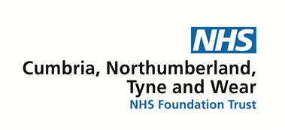
Report to the Board of Directors
Wednesday 1 March 2023
Gender Pay Gap Reporting 2021-2022

- Executive Summary

Organisations with 250 employees or more are required to report on gender pay gaps using six different measures. This has been a requirement since April 2018 and the legislation underpins the Public Sector Equality Duty.

The gender pay gap shows the difference in the average pay between all men and women in the workplace. This is different to equal pay. Equal pay deals with the pay differences between men and women who carry out the same jobs, similar jobs, or work of equal value.

This report fulfils legislative requirements and sets out what the Trust is doing to close the gender pay gap. The figures for the 6 metrics we are required to report on for 2021-2022 (based on 31 March snapshot) are as follows:

- Mean gender pay gap is 12.4% - a decrease of 0.8% points on 2020-2021
- Median gender pay gap is 2.2% - a decrease of 1.2% points on 2020-2021
- Percentage of men and women receiving bonus pay is 2.0% men and 0.5% women (a reduction from 2.2% and 0.60% respectively on 2021-2021)
- Mean (average) gender pay gap using bonus pay is 9.6% - down from 22.3% in 2020-21
- Median gender pay gap using bonus pay is 31.3% - down from 55.9% in 2020-2021
- Percentage of men and women in each hourly pay quartile

 | CNTW Figures of 2021- 2022 |  | CNTW Figures for 2020-2021 |  | CNTW Figures for 2019-2020
 | Male | Female | Male | Female | Male | Female
Top quartile | 27.7% | 72.3% | 29.0% | 71.0% | 30.4% | 69.6%
Upper middle | 20.0% | 80.0% | 21.6% | 78.4% | 22.2% | 77.8%
Lower middle | 27.4% | 72.6% | 26.6% | 73.4% | 25.5% | 74.5%
Lower quartile | 19.3% | 80.7% | 20.6% | 79.4% | 21.0% | 79.0%

- Key issues, significant risks and mitigations

There are no specific risks associated with this report.

- Recommendation/summary

The Board of Directors is asked to note the content of the report and the actions outlined.

Chris Rowlands Lynne Shaw
Equality and Diversity Lead Executive Director of Workforce & OD
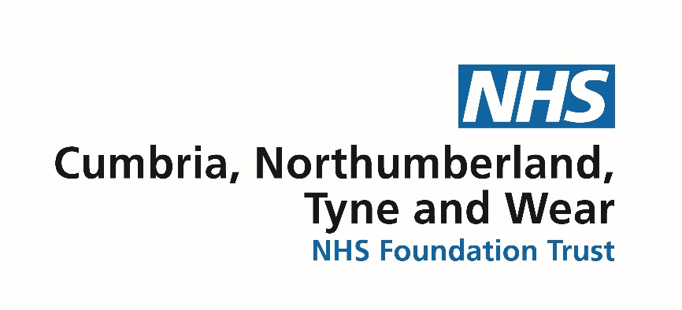

Gender Pay Gap Report 2021-2022

What is gender pay gap reporting?

Gender pay gap reporting compares the average hourly earnings of male and female staff. The regulations require employers with over 250 staff to publish six metrics each year which are calculated from a snapshot date. Data in this report is calculated from a snapshot taken on 31 March 2022. The report analyses the pay disparities between the binary sexes of men and women. At Cumbria, Northumberland, Tyne and Wear NHS Foundation Trust we recognise that gender identity is non-binary and commit to increasing our understanding of the barriers faced by minority groups.

The six metrics we are reporting on are:
Gender pay gap vs equal pay

The gender pay gap measures the differences in hourly pay between men and women, no matter what their role in an organisation.

Equal pay is the right of men and women to be paid the same for the same work or work of equal value. Cumbria, Northumberland, Tyne and Wear NHS Foundation Trust is committed to ensuring that it remains an Equal Pay Employer.

The gender pay gap and Cumbria, Northumberland Tyne and Wear NHS FT

For 2021-2022, we are reporting a mean gender pay gap, based on our March 31 snapshot of 12.4% and a median gap of 2.2%. That is a slight decrease on 2020-21 reporting – down 0.8% points for the mean and a decrease of 1.2% points for the median.

Metric | CNTW Figures of 2021- 2022 | CNTW Figures for 2020-2021 | CNTW Figures for 2019-2020
Mean gender pay gap | 12.4% | 13.2% | 14.6%
Median gender pay gap | 2.2% | 3.4% | 4.6%

Over the past three reporting periods the gaps for both mean and median have closed approximately a percentage point, year on year.

Proportion of gender in each pay band

 | CNTW Figures of 2021- 2022 |  | CNTW Figures for 2020-2021 |  | CNTW Figures for 2019-2020
 | Male | Female | Male | Female | Male | Female
Top quartile | 27.7% | 72.3% | 29.0% | 71.0% | 30.4% | 69.6%
Upper middle | 20.0% | 80.0% | 21.6% | 78.4% | 22.2% | 77.8%
Lower middle | 27.4% | 72.6% | 26.6% | 73.4% | 25.5% | 74.5%
Lower quartile | 19.3% | 80.7% | 20.6% | 79.4% | 21.0% | 79.0%

On 31 March 2022 we employed 7,482 members of staff, 5,715 (76%) of those were female. Whilst staff numbers have grown since 2019-20 the 76/24 percentage profile remains the same. 1,785 (31%) of female staff work on a part time basis, compared to 332 (19%) of male staff who work on a part time basis. 2,117 members of staff work on a part time basis for the Trust, 84% of those are female. This is the single biggest factor in explaining our gender pay gap.

In the past three years the proportions of male and female staff across each quartile have broadly remained the same. Differences of note that may explain the decrease in the gender pay gap are:

- Growth of female representation in top quartile from 69.6% to 72.3% during the three year period.
- Growth of female representation in the upper middle quartile from 77.8% to 80% during the three year period.

Bonus payment gender pay gap

Metric | CNTW Figures of 2021- 2022 | CNTW Figures for 2020-2021 | CNTW Figures for 2019-2020
The mean gender bonus gap: the % difference in average bonus payments made to male and female employees during the 12 month period to 31 March | 9.6% | 22.3% | 15.2%
The median gender bonus gap: the % difference between the mid-point value of bonus payments made to male and female employees during the 12 month period to 31 March | 31.3% | 55.9% | 33.3%
The proportions of relevant male and female employees who received bonus payments during the 12 month period to 31st March | 2.0% Men | 2.2% Men | 2.7% Men
 | 0.5% Women | 0.6% Women | 0.7% Women

Bonus payments for staff in the Trust are entirely accounted for by doctors in receipt of Clinical Excellence Award Scheme payments. 65 doctors were in receipt of the award on the 31 March, of those 29 (45%) were female and 36 (55%) were male. 17 of the 29 female doctors worked part time, compared to 17 of the 36 male doctors. This, along with the small numbers explains the gap – though it should be noted that both the mean and median have decreased this year.

There have been important changes to the National Clinical Excellence Award scheme (NCEAs) during 2022. These will now be known as the National Clinical Impact Award scheme (NCIAs) and the eligibility criteria for their award has changed. In future doctors in receipt of the award who work part time will receive the award in full, rather than a pro-rata amount. This is will significantly reduce the bonus gender pay gap.

How are we tackling the gender pay gap?

Actions we have taken to close the gender pay gap

Commitment to paying the UK Living Wage: Cumbria, Northumberland, Tyne and Wear NHS Foundation Trust became an accredited Living Wage Employer in 2013. We were the first NHS Trust in the North-East of England to accredit with the Living Wage Foundation and have continued to champion the Living Wage during Living Wage Week each November.
The Real Living Wage is worked out independently and takes into account rising bills and costs. Paying a Living Wage means that all staff are appointed on at least Band 2 of the Agenda for Change pay scales for NHS staff.

Encouraging flexible working: the Trust promotes a supportive and flexible working culture. We recognise that flexible working helps employees to achieve a better balance between their work and home life, as well as improve service delivery through a flexible workforce. It can help the Trust become an employer of choice, aid recruitment and retention, reduce sickness absence and improve employee engagement, leading to an improved patient experience.

Inclusive recruitment: the Trust has undertaken a substantial piece of work examining our recruitment processes, with the objective of removing any barriers to entry by protected characteristics as defined by the Equality Act 2010. Many of the measures we have adopted have recently been implemented. The next key piece of work that follows on from this will be a review of job descriptions. As part of this we will carefully examine and remove any gender bias that may affect the numbers of men and women applying for jobs with the Trust.

Springboard for women pilot: across society, the NHS, and here in the Trust, people who identify as having a protected characteristic tell us they do not always have the same opportunities as others to learn, develop and progress. Springboard for Women, one of several development programmes offered by Springboard Consultancy, provides women with the inspiration, tools and confidence boost to enable them to choose what they want to do and to take their next steps (at work, in life) when the time is right for them. The programme seeks to enable women to thrive, helping them to feel more confident, self-aware and assertive. Twenty-one women, from all areas of the Trust, participated in the pilot programme which completed in September. In a break from the usual Springboard format the Trust also engaged with participants’ Line Managers to help them actively support their members of staff whilst on programme. The pilot was evaluated, key findings from the evaluation were reported, including:

- 94% felt more confident in
  - productivity
  - development needs
  - positivity
- 88% feel more confident in
  - goal setting
  - communicating
  - assertiveness

Establishment of a group to consider proactive work around gender issues: at the end of the Springboard Pilot a focus group was set up to consider issues relating to the gender pay gap. The next meeting will take place in February to consider the information contained in this report.

Actions we plan to take to close the gender pay gap

Remove barriers: to challenge ourselves to identify barriers to addressing the gap and to seek, where we can close them. This will involve the development of the following:

Monitoring and reporting: part of our inclusive recruitment work is the need to identify the success of the measures we take and have the ability to change our approach, where data suggests that we need to. We are developing our approach to this and will implement during 2023-24. Monitoring of these measures will be received regularly by the Trust’s Equality, Diversity and Inclusion Steering Group, with reports to be received by The People Committee.

Grow and encourage the group examining gender issues: as described above we need to harness the enthusiasm from the initial meeting in October 2022 to enable this group to flourish. The work of this group will be key in identifying and removing barriers to help close the gender pay gap.

Integrated planning: ensuring that the actions we need to take are included in our yearly review of our equality objectives.

Our Equality, Diversity and Inclusion Strategy

We believe that any modern organisation has to reflect all the communities and people it serves, in both service delivery and employment, and tackle all forms of discrimination. We need to remove inequality and ensure there are no barriers to health and wellbeing. We aim to implement this by:

- becoming a leading organisation for the promotion of Equality, Diversity and Inclusion, for challenging discrimination, and for promoting equalities in service delivery and employment
- identifying and removing barriers that prevent people we serve from being treated equally
- treating all people as individuals respecting and valuing their own experiences and needs
- ensuring that Cumbria, Northumberland, Tyne and Wear NHS FT is regarded as a great place to work - an organisation which recognises the contribution of all staff, and which is supportive, fair and free from discrimination.

