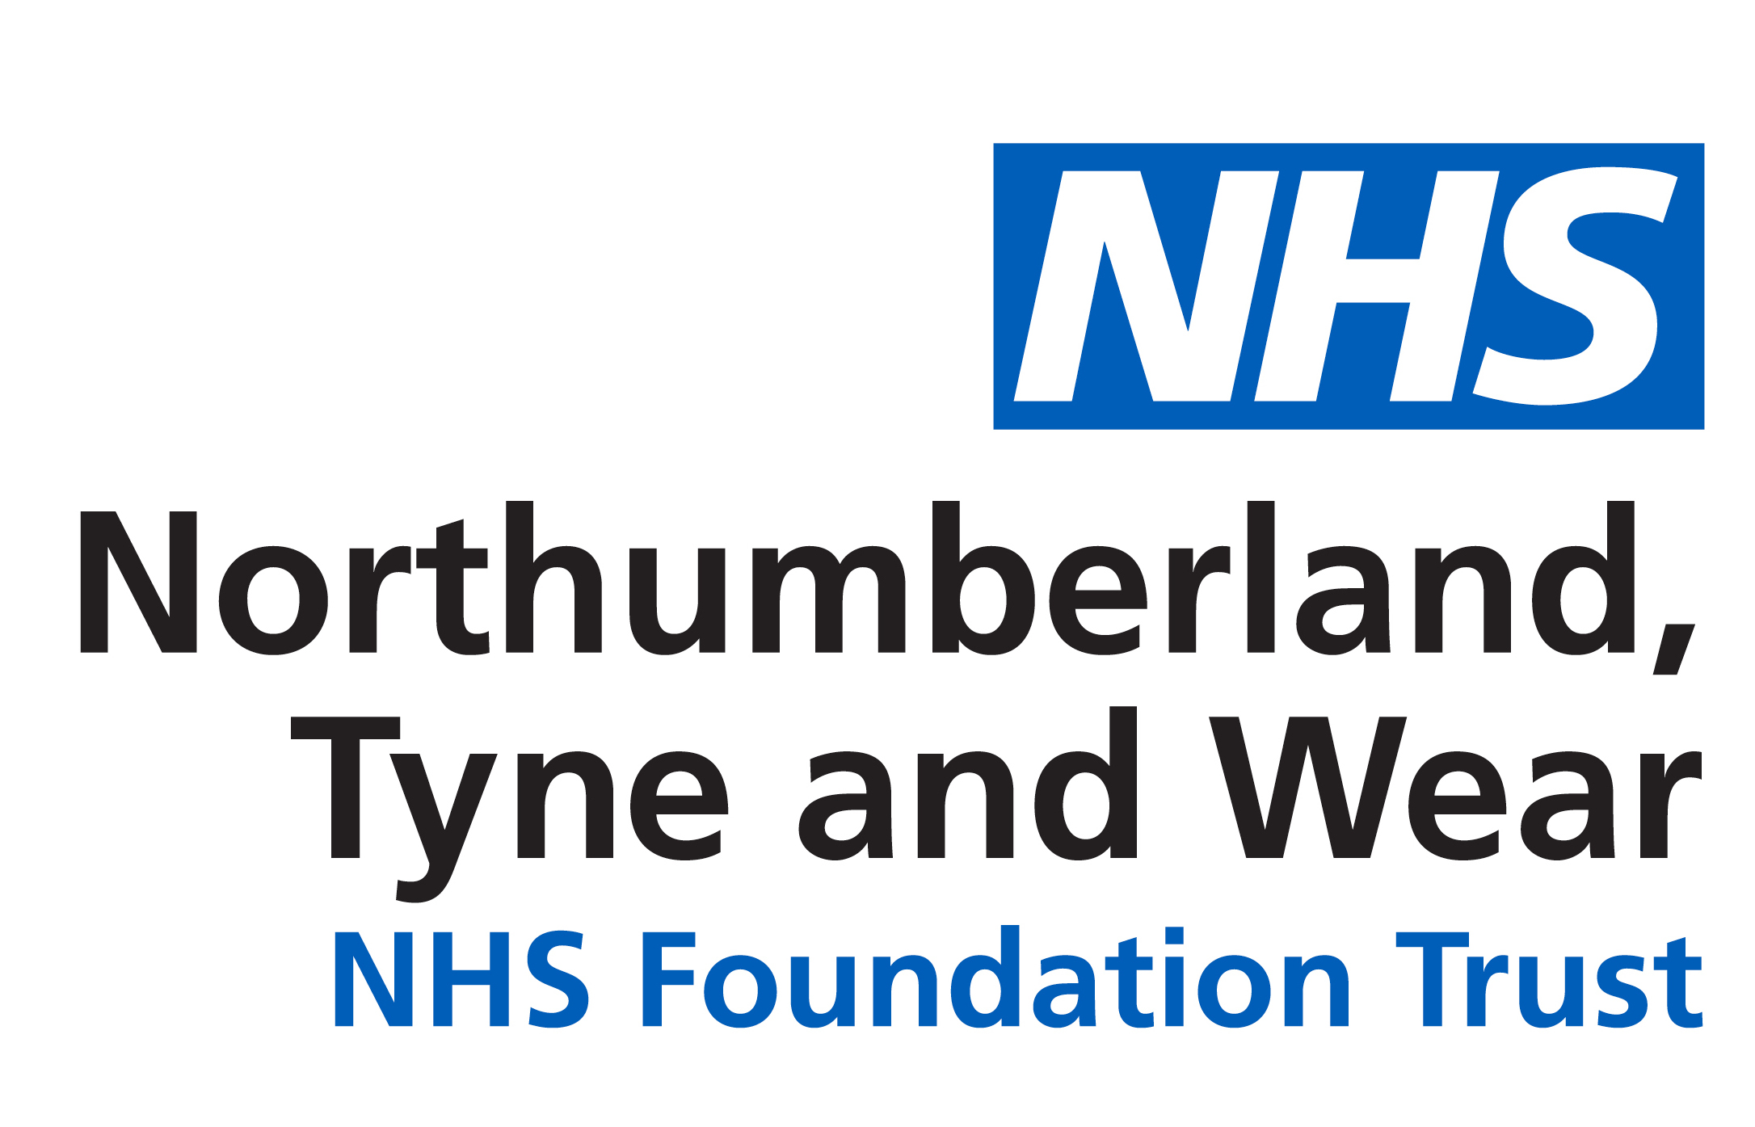


PATIENT LED ASSESSMENT OF THE CARE ENVIRONMENT (PLACE) 2017

PLACE assessments provide a snapshot of how an organisation is performing against a range of non-clinical activities which impact on the patient experience of care.

Between March and May 2017 a total of 67 NTW locations were visited at 13 sites and the results are summarised in the tables below.

 | Cleanliness | Food | Privacy and Dignity | Condition, Appearance and Maintenance | Dementia | Disability
NTW Average | 99.3% | 91.1% | 93.6% | 95.8% | 88.1% | 85.8%
National Average | 98.4% | 89.7% | 83.7% | 94.0% | 76.7% | 82.6%
Variation | + 0.9% | + 1.4% | + 9.9% | + 1.8% | + 11.4% | + 3.2%

NTW’s overall organisation scores

NTW Individual Site % Scores set against the National Average and 2016 results

Summary

Overall the Trust has scored higher than the national average in all of the domains, although it did score slightly below the national average for organisational food. In four out of the five categories where comparison could be made with the previous year, there has been an increase in the score achieved.

A key factor in the process is to ensure each ward and department devises its own action plan to address any exceptions identified and that appropriate monitoring arrangements are in place both in the clinical groups and the supporting services.

The assessment process ran extremely well and it should be noted that this was due to the input of the patient assessors, NTW assessors, admin support and the co-operation of ward staff during the visits.

Compiled by:

Paul McCabe, Head of Estates and Facilities
Julie Rearden, Facilities Administrator

October 2017

